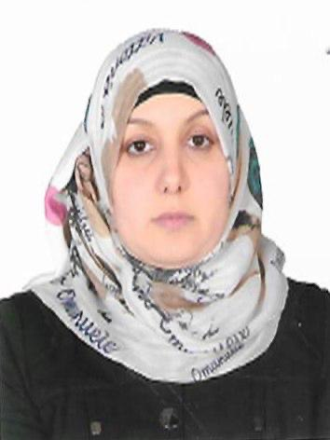

resume or CV
Name and Title: Entidhar Sahib Mohamed Kadum Al-Yasiry
Date of Birth: 1982
Province of Residence: Karbala
Email: entaly2018@gmail.com
Academic Title: Lecturer Doctor
Degree: Ph.D
General Specialty: biochemistry
Specific Specialty: clinical and molecular biochemistry
Country of Last Degree: Iraq
Date of Last Degree: 2023
Bachelor's Degree University: University of Karbala
Master's Degree University: University of Kufa
Ph.D. Degree University: University of Kufa
Courses Taught: clinical biochemistry – advanced biochemistry
Places of Employment (From - To): Karbala Health Department(2006 -2022) - collage of Alsafwa (from 2022 - at present )
Administrative Positions Held: Laboratory Manager and Quality Control Program Officer at Karbala Health Department
Research Publications: Association of ANGPTL8 gene polymorphism with the occurrence of coronary artery disease in Iraqi patients
Google Scholar Link
https://scholar.google.com/citations?user=_P3o85UAAAAJ&hl=ar:

