resume or CV 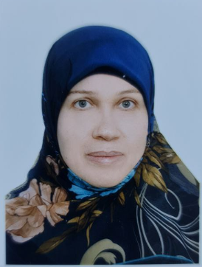 Name and Title: Ibtihaj Malik AbdulMuhsin Faisal Alhasawi
Date of Birth: 24/5/1974
Province of Residence: Karbala
Email: ibtihaj.alfadly74@gmail.com
Academic Title: Asst.Lecturer
Degree: Masterv
General Specialty: Microbiology
Specific Specialty: Medical microbiology
Country of Last Degree: Iraq
Date of Last Degree: 21/11/2021
Bachelor's Degree University: Babylon university
Master's Degree University: Karbala university
Ph.D. Degree University:
Courses Taught: Microbiology
Places of Employment (From - To):
Administrative Positions Held: AL Safwa college 10/9/2023 and Im still going on
Research Publications: Antimicrobial resistance in oral microbiota :straightforward explanation
Google Scholar Link:

