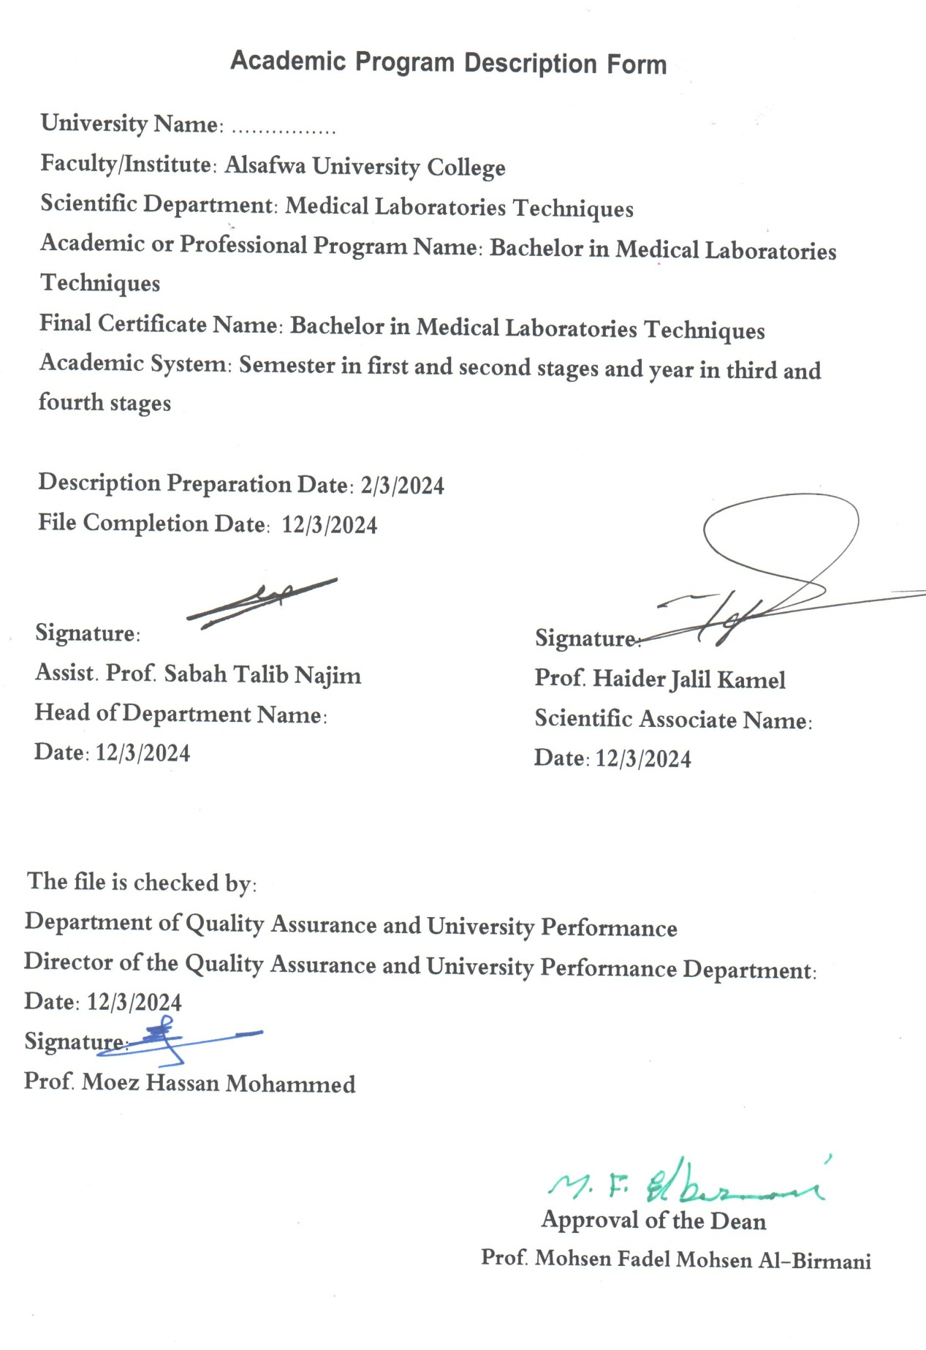

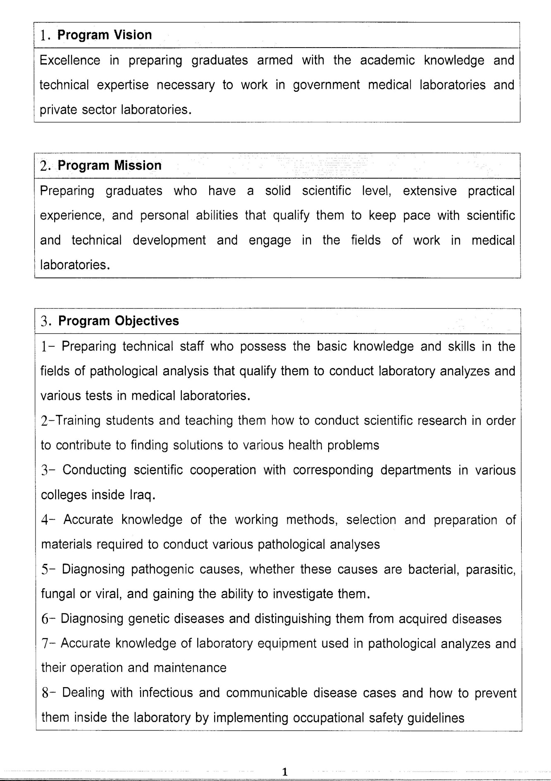

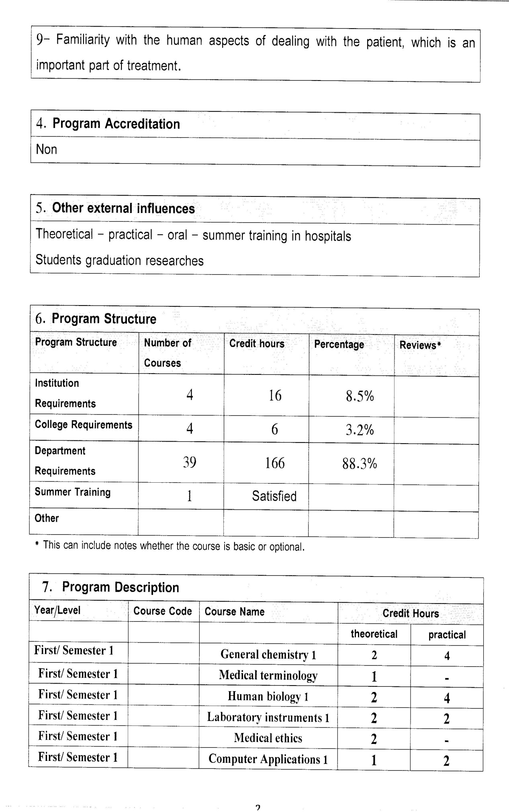

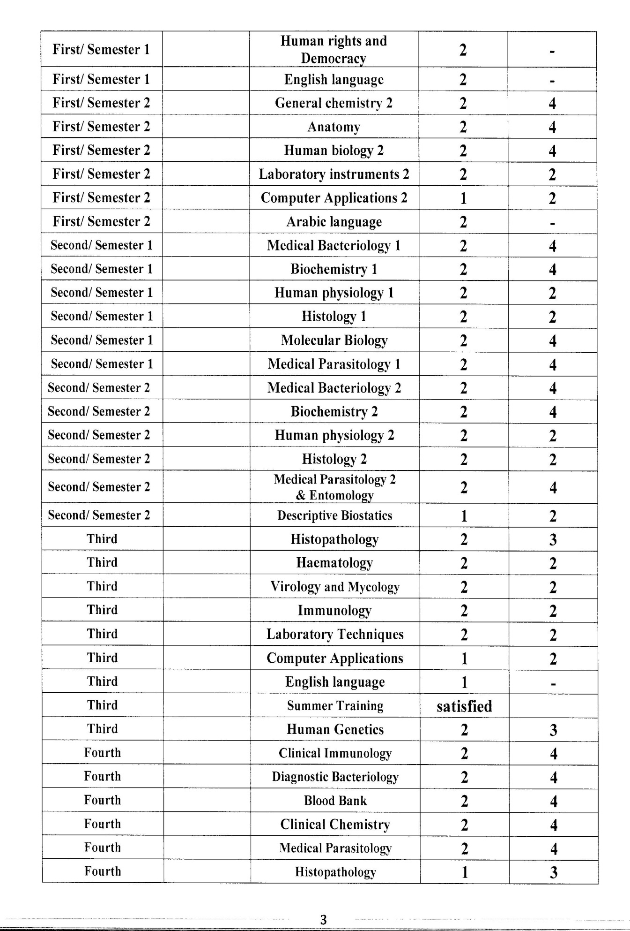

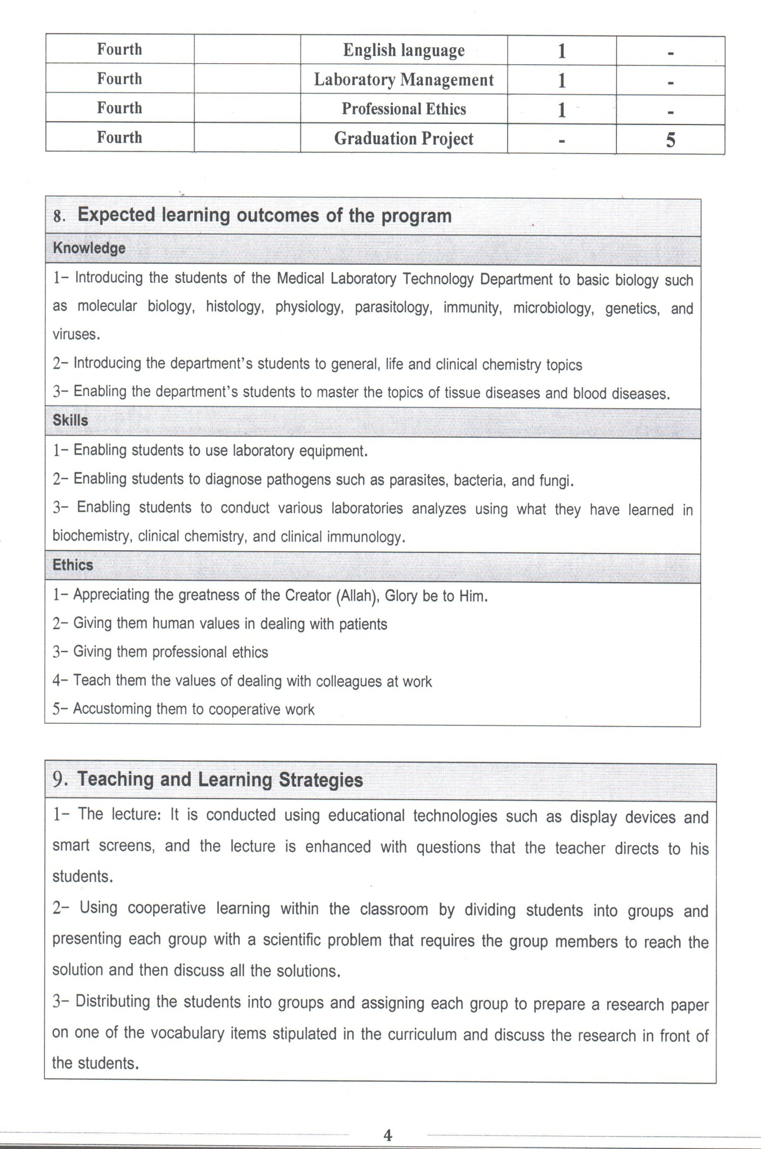

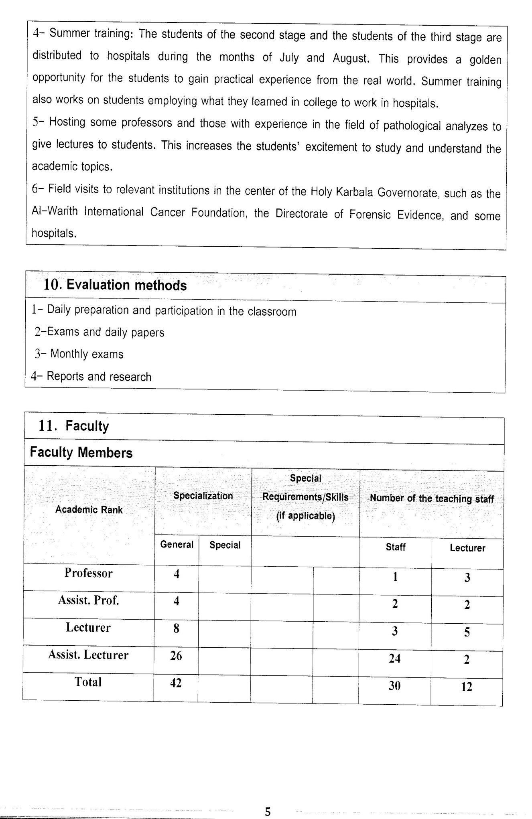

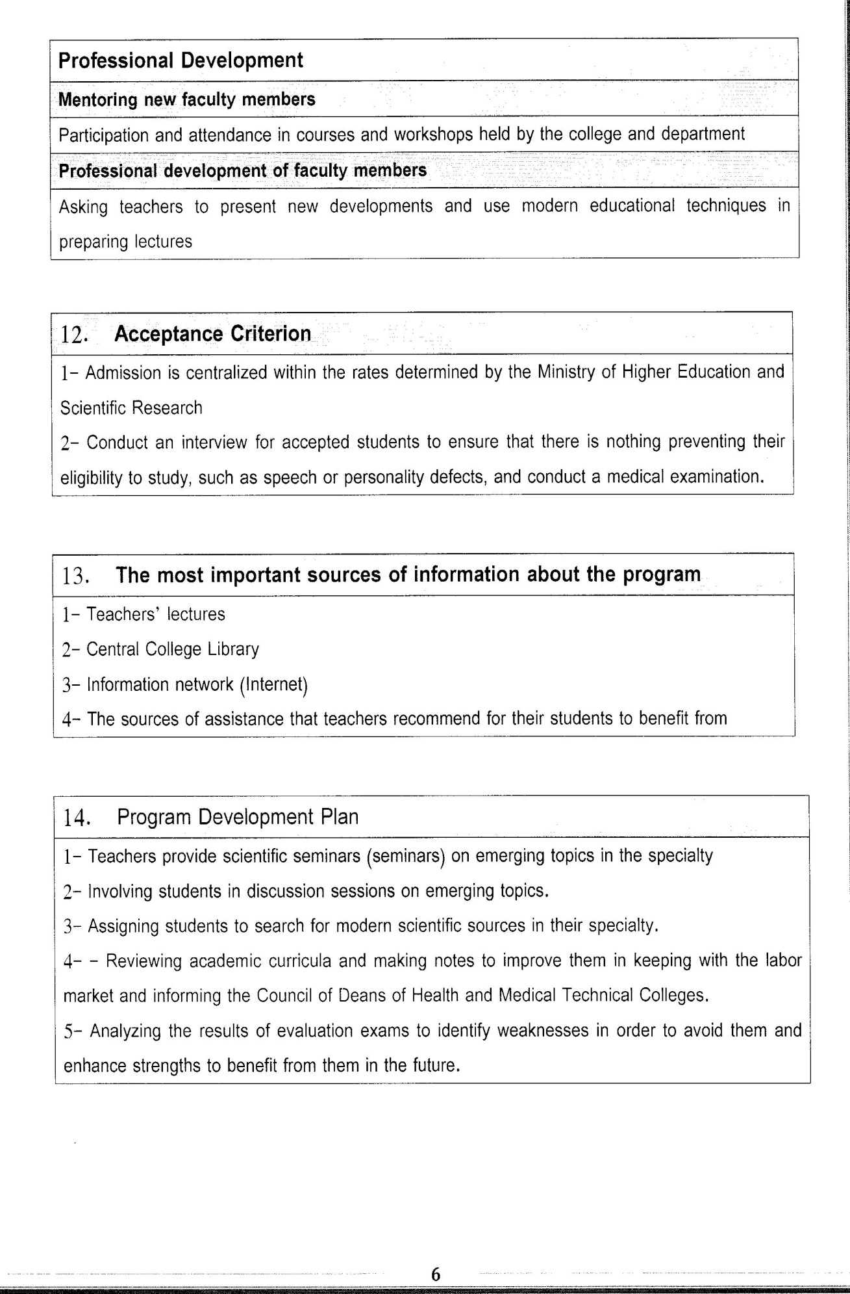

Course Description Form(2023-2024)
- Course Name:
Histopathology
- Course Code:
- Semester / Year:
Third Year (Year)
- Description Preparation Date:
6 / 3 / 2024
- Available Attendance Forms:
- Number of Credit Hours (Total) / Number of Units (Total)
120 Hours
- Course administrator's name (mention all, if more than one name)
Name: Jassim Mohammed Khalaf
Email: jasim.khalaf@uokerbala.edu.iq
- Course Objectives
Course Objectives
At the end of the academic year, the student should be able to:
1. Know and understand histological changes of respiratory system disease.
2. Know and understand histological changes of urinary system disease.
3. Know and understand histological changes of digestive system disease.
4. Knowing and understanding histological changes of male reproductive system disease.
5. Knowledge and understanding histological changes of female reproductive system 6. 6-Knowing and understanding histological changes of breast cancer.
7. Knowledge and understanding histological changes of skin disease.
8.Knowing and understanding histological changes of bone tumors
9. Knowing and understanding histological changes of nervous system disease.
- Teaching and Learning Strategies
Strategy |  | 1. Providing students with the basics and supporting topics related to the pre-skills learning outcomes.  2. Applying the topics studied in theoretical lessons on the practical level.  3. Asking students to identify the types of histological changes for variation body system disease.
- Course Structure
Week | Hours |  | Required Learning Outcomes | Unit or subject name |  | Learning method | Evaluation method
First Semester
1 | 2practical+2 theoretical |  | Understand  the lecture | Atelectasis |  | Lecture  Laboratory | Attendance  Daily exam
2 | 2practical+2 theoretical |  | Understand  the lecture | Chronic obstructive pulmonary disease |  | Lecture  Laboratory | Attendance  Daily exam
3 | 2practical+2 theoretical |  | Understand  the lecture | Pulmonary embolism |  | Lecture  Laboratory | Attendance  Daily exam
4 | 2practical+2 theoretical |  | Understand  the lecture | Tumors of kidney |  | Lecture  Laboratory | Attendance  Daily exam
5 | 2practical+2 theoretical |  | Understand  the lecture | Tumors in the oral soft tissues |  | Lecture  Laboratory | Attendance  Daily exam
6 | 2practical+2 theoretical |  | Understand  the lecture | Hematemesis of esophageal |  | Lecture  Laboratory | Attendance  Daily exam
7 | 2practical+2 theoretical |  | Understand  the lecture | Gastritis and Peptic ulcer |  | Lecture  Laboratory | Attendance  Daily exam
8 | 2practical+2 theoretical |  | Understand  the lecture | Inflammatory bowel disease |  | Lecture  Laboratory | Attendance  Daily exam
9 | 2practical+2 theoretical |  | Understand  the lecture | Malabsorptin syndrome |  | Lecture  Laboratory | Attendance  Daily exam
10 | 2practical+2 theoretical |  | Understand  the lecture | Haemorrhois (piles) |  | Lecture  Laboratory | Attendance  Daily exam
11 | 2practical+2 theoretical |  | Understand  the lecture | Hepatic failure |  | Lecture  Laboratory | Attendance  Daily exam
12 | 2practical+2 theoretical |  | Understand  the lecture | Cholecystitis |  | Lecture  Laboratory | Attendance  Daily exam
13 | 2practical+2 theoretical |  | Understand  the lecture | Tumors of biliary system |  | Lecture  Laboratory | Attendance  Daily exam
14 | 2practical+2 theoretical |  | Understand  the lecture | Pancreatitis |  | Lecture  Laboratory | Attendance  Daily exam
15 | 2practical+2 theoretical |  | Understand  the lecture | Carcinoma of Pancreas |  | Lecture  Laboratory | Attendance  Daily exam
Second Semester
1 | 2practical+2 theoretical |  | Understand  the lecture | Prostatitis |  | Lecture  Laboratory | Attendance  Daily exam
2 | 2practical+2 theoretical |  | Understand  the lecture | Testicular tumors |  | Lecture  Laboratory | Attendance  Daily exam
3 | 2practical+2 theoretical |  | Understand  the lecture | Cervicitis |  | Lecture  Laboratory | Attendance  Daily exam
4 | 2practical+2 theoretical |  | Understand  the lecture | Endometritis and Myometritis |  | Lecture  Laboratory | Attendance  Daily exam
5 | 2practical+2 theoretical |  | Understand  the lecture | Endometriosis |  | Lecture  Laboratory | Attendance  Daily exam
6 | 2practical+2 theoretical |  | Understand  the lecture | Fibrocystic change |  | Lecture  Laboratory | Attendance  Daily exam
7 | 2practical+2 theoretical |  | Understand  the lecture | Carcinoma of the breast |  | Lecture  Laboratory | Attendance  Daily exam
8 | 2practical+2 theoretical |  | Understand  the lecture | Paget’s disease of the nipple |  | Lecture  Laboratory | Attendance  Daily exam
9 | 2practical+2 theoretical |  | Understand  the lecture | Dermatitis (Eczema) |  | Lecture  Laboratory | Attendance  Daily exam
10 | 2practical+2 theoretical |  | Understand  the lecture | Scaling dermatoses |  | Lecture  Laboratory | Attendance  Daily exam
11 | 2practical+2 theoretical |  | Understand  the lecture | Tumours and cysts of the epidermis |  | Lecture  Laboratory | Attendance  Daily exam
12 | 2practical+2 theoretical |  | Understand  the lecture | Bone tumors |  | Lecture  Laboratory | Attendance  Daily exam
13 | 2practical+2 theoretical |  | Understand  the lecture | Hyperpituitarism |  | Lecture  Laboratory | Attendance  Daily exam
14 | 2practical+2 theoretical |  | Understand  the lecture | Pituitary tumors |  | Lecture  Laboratory | Attendance  Daily exam
15 | 2practical+2 theoretical |  | Understand  the lecture | Thyroiditis |  | Lecture  Laboratory | Attendance  Daily exam
- Course Evaluation
The following evaluation methods are adopted:
1. Theoretical and practical tests.
2. Reports.
3. Attendance and discussion.
The grades are distributed as follows:
1- Two monthly exams with a score of 20 points.
2-5 marks for activity and attendance.
3- 15 marks for the practical part, so the pursuit mark is 40.
4- The final exam score is distributed (35) points for the theoretical part and (25) points for the practical part, so the final score is 100.
- Learning and Teaching Resources
Required textbooks (curricular books, if any) |  |  |  |  | Not found
Main references (sources) |  |  |  |  | Basic and Advanced Laboratory Techniques in Histopathology and Cytology
Recommended books and references (scientific journals, reports...)
Electronic References, Websites

