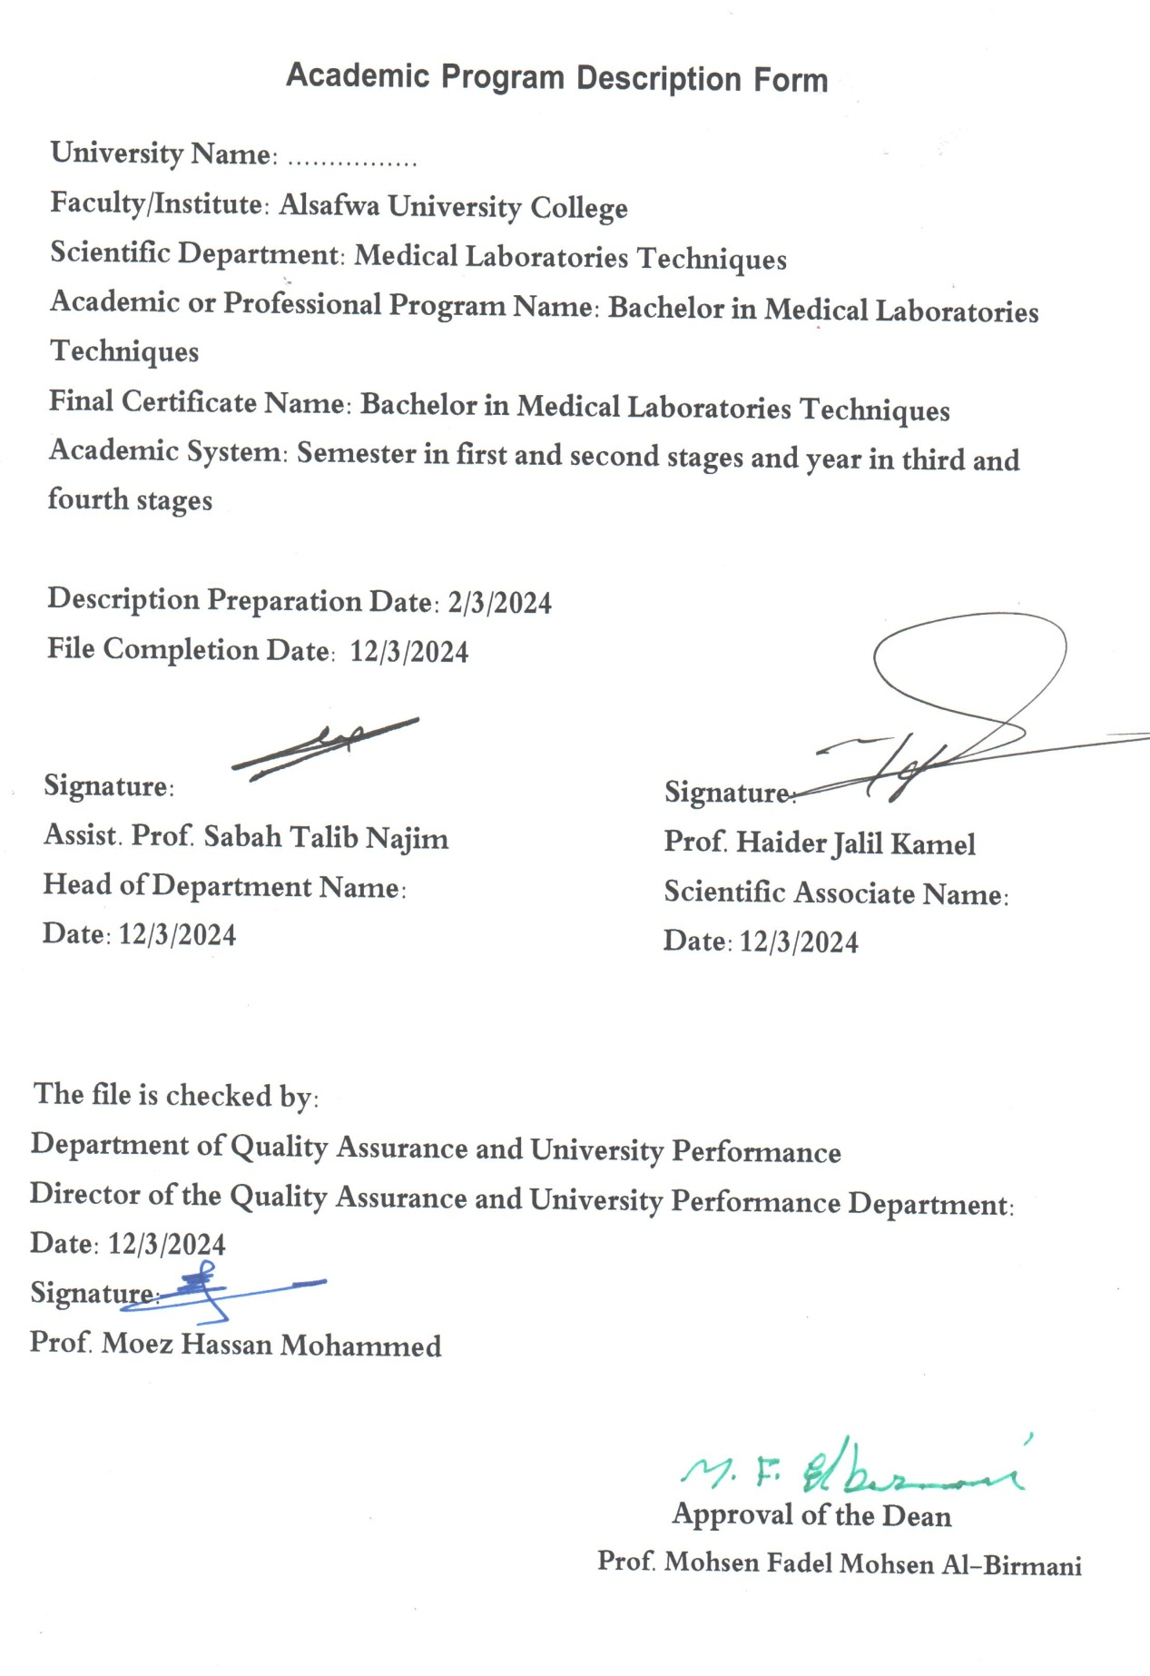

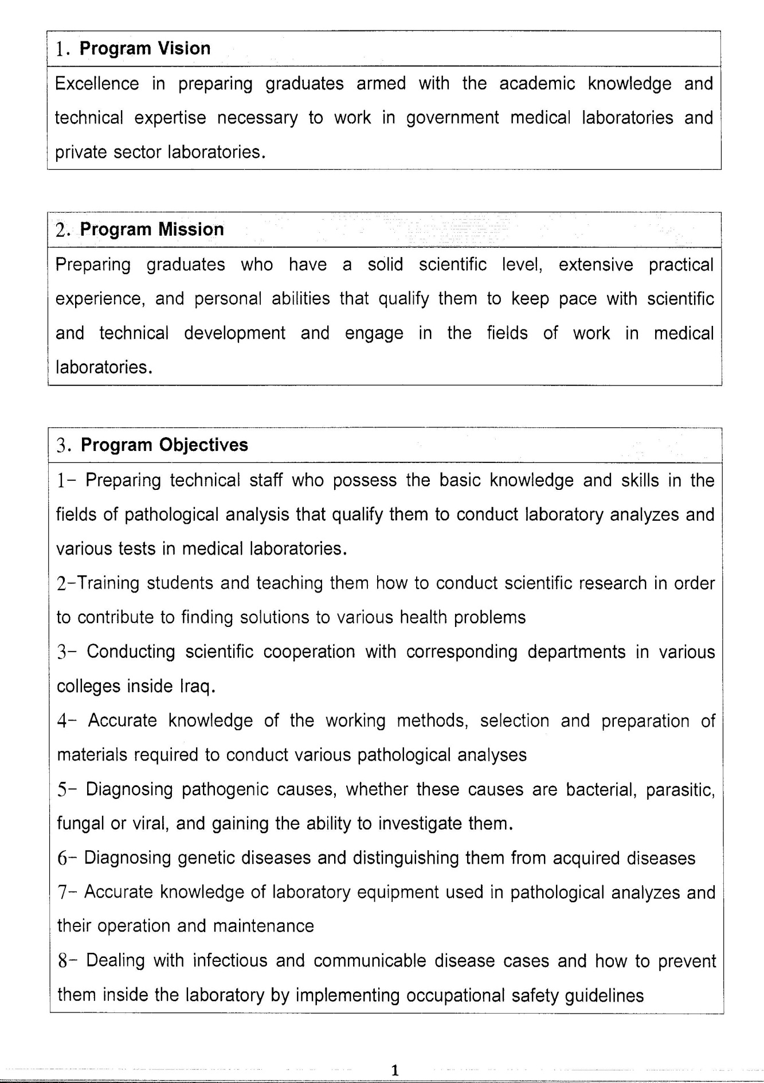

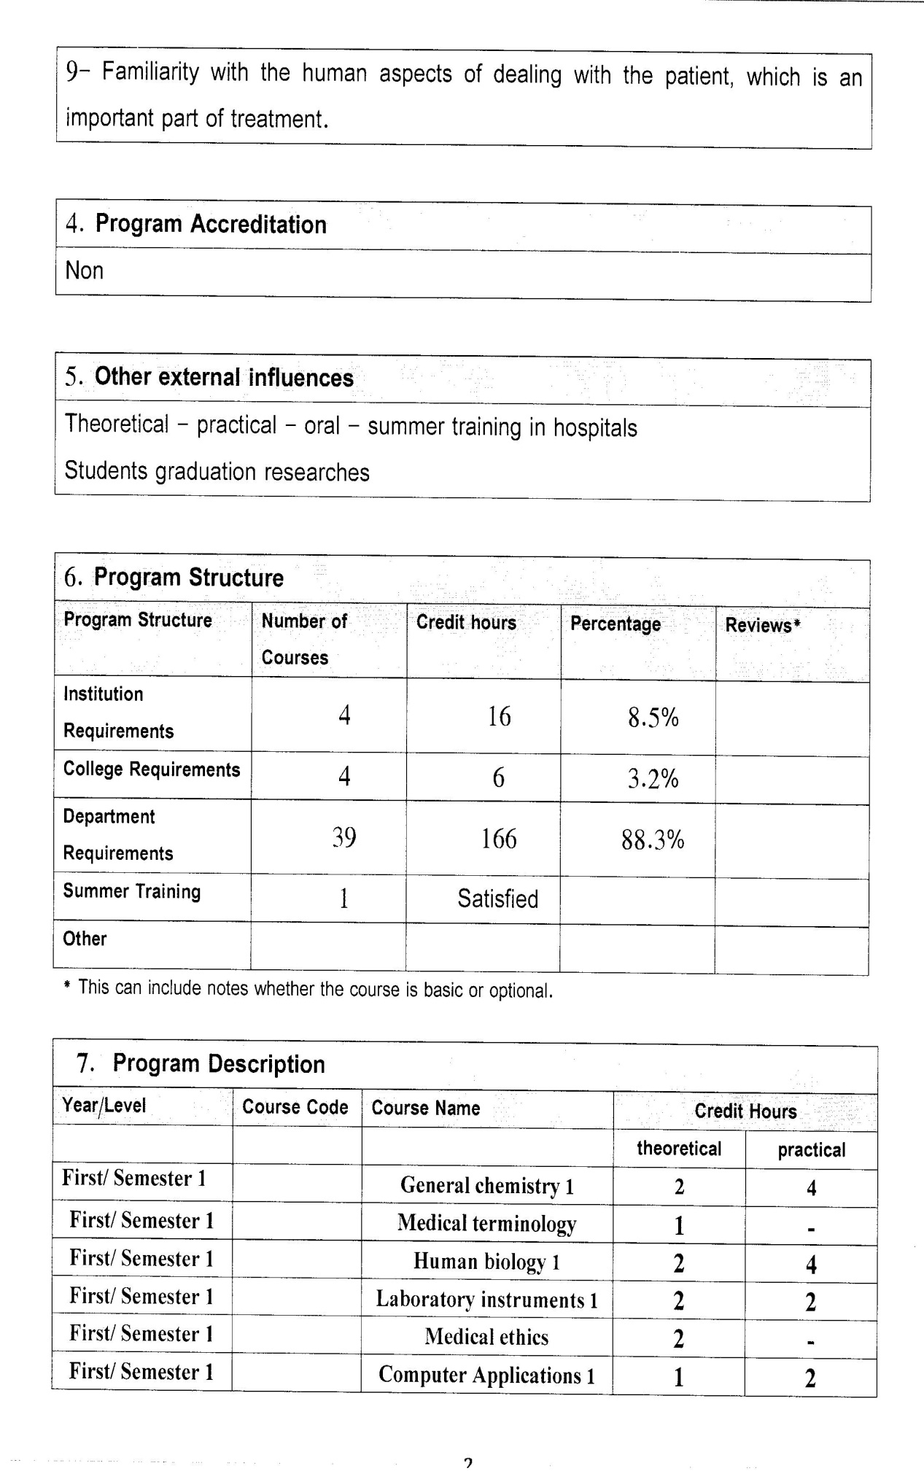

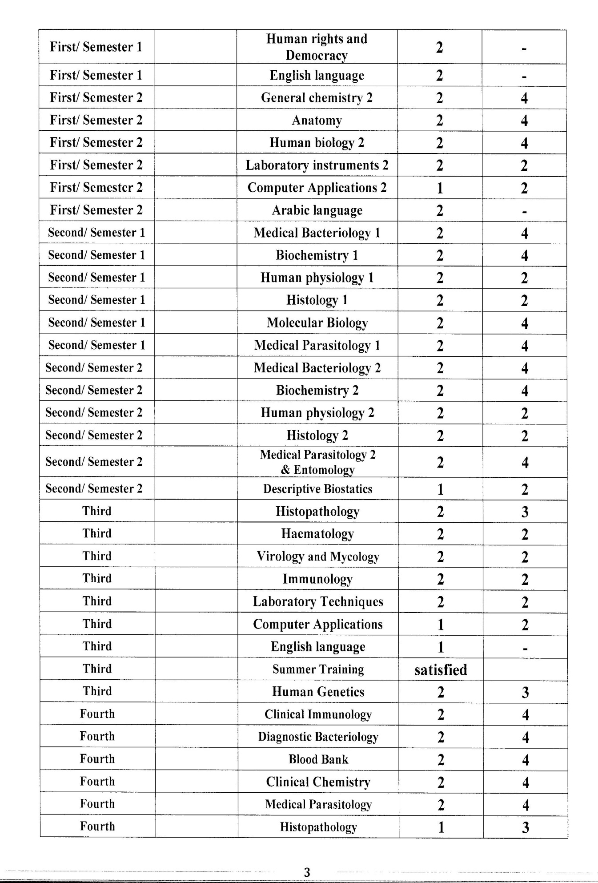

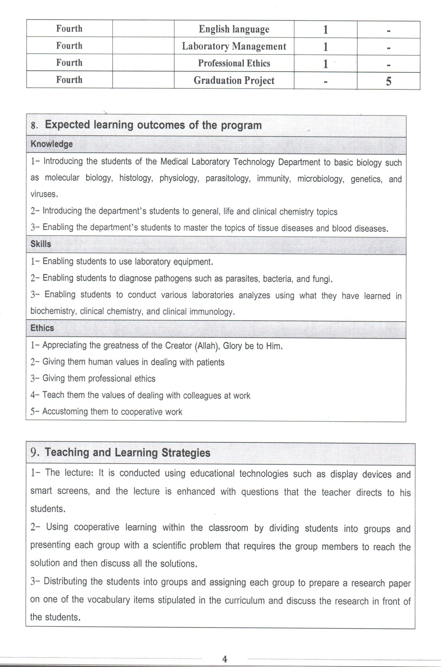

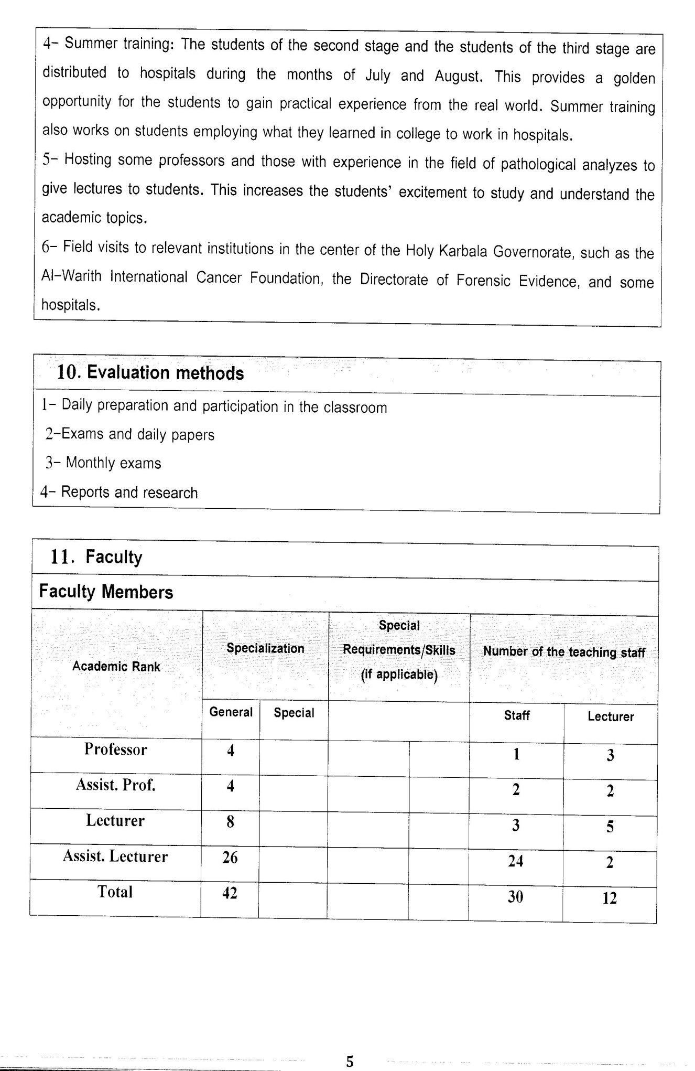

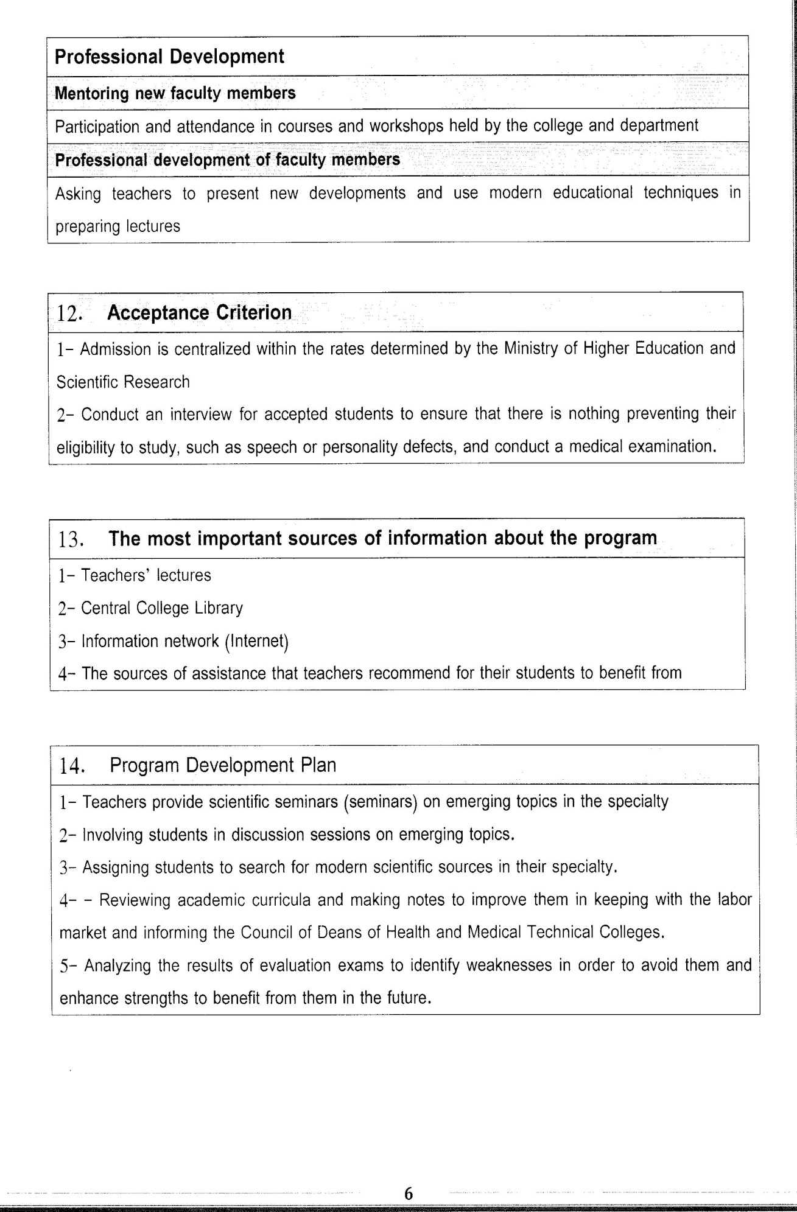

Course Description Form(2023- 2024)
- Course Name:
Histopathology
- Course Code:
- Semester / year:
Third year (Year)
- Description Preparation Date:
6 / 3 / 2024
- Available Attendance Forms:
- Number of Credit Hours (Total) / Number of Units (Total)
120 Hours
- Course administrator's name (mention all, if more than one name)
Name: Jihad Talib Obead
Email: jihad.talob@alsafwa.edu.iq
- Course Objectives
Course Objectives
At the end of the academic year, the student should be able to:
1. Know and understand Pathology .
2. Know and understand the cell .
3. Know and understand inflammation .
4. Knowing and understanding repire .
5. Knowledge and understanding atrophy and necrosis
6. Knowing and understanding gangerne .
7. Knowledge and understanding of tumers and classification .
8. Knowing and understanding Tissues sectioning
- Teaching and Learning Strategies
Strategy |  | 1. Providing students with the basics and supporting topics related to the pre-skills learning outcomes.  2. Applying the topics studied in theoretical lessons on the practical level.  3. Asking students to identify the types of mutations and types of inheritance patterns.
- Course Structure
Week | Hours |  | Required Learning Outcomes | Unit or subject name |  | Learning method | Evaluation method
First Semester
1 | 2practical+2 theoretical |  | Understand  the lecture | ,introduction  cell constituents |  | Lecture  Laboratory | Attendance  Daily exam
2 | 2practical+2 theoretical |  | Understand  the lecture | inflammation,repair, acut inflammation |  | Lecture  Laboratory | Attendance  Daily exam
3 | 2practical+2 theoretical |  | Understand  the lecture | chronic infalmaation |  | Lecture  Laboratory | Attendance  Daily exam
4 | 2practical+2 theoretical |  | Understand  the lecture | healing and regeneration |  | Lecture  Laboratory | Attendance  Daily exam
5 | 2practical+2 theoretical |  | Understand  the lecture | rettrograde and degeneration |  | Lecture  Laboratory | Attendance  Daily exam
6 | 2practical+2 theoretical |  | Understand  the lecture | atrophy necrosis |  | Lecture  Laboratory | Attendance  Daily exam
7 | 2practical+2 theoretical |  | Understand  the lecture | Gangrene |  | Lecture  Laboratory | Attendance  Daily exam
8 | 2practical+2 theoretical |  | Understand  the lecture | Criteria used for cytopathological diagnosis |  | Lecture  Laboratory | Attendance  Daily exam
9 | 2practical+2 theoretical |  | Understand  the lecture | Change in cytoplasma in malignancy |  | Lecture  Laboratory | Attendance  Daily exam
10 | 2practical+2 theoretical |  | Understand  the lecture | Changes in cell as general in malignancy |  | Lecture  Laboratory | Attendance  Daily exam
11 | 2practical+2 theoretical |  | Understand  the lecture | Nomenclature of tumors |  | Lecture  Laboratory | Attendance  Daily exam
12 | 2practical+2 theoretical |  | Understand  the lecture | Classification of tumer |  | Lecture  Laboratory | Attendance  Daily exam
13 | 2practical+2 theoretical |  | Understand  the lecture | Fixation and fixative theoretical aspects of fixation |  | Lecture  Laboratory | Attendance  Daily exam
14 | 2practical+2 theoretical |  | Understand  the lecture | Most common fixative inn common use |  | Lecture  Laboratory | Attendance  Daily exam
15 | 2practical+2 theoretical |  | Understand  the lecture | Tissue processting fixation, dehydration, clearing, embding |  | Lecture  Laboratory | Attendance  Daily exam
Second Semester
1 | 2practical+2 theoretical |  | Understand  the lecture | Cestoda  Factors influencing rate of impregnation |  | Lecture  Laboratory | Attendance  Daily exam
2 | 2practical+2 theoretical |  | Understand  the lecture | Microtomy and paraffin |  | Lecture  Laboratory | Attendance  Daily exam
3 | 2practical+2 theoretical |  | Understand  the lecture | Staining of tissue section , eosin , hematoxylin |  | Lecture  Laboratory | Attendance  Daily exam
4 | 2practical+2 theoretical |  | Understand  the lecture | Special stains for protein, chabohydrates, lipid |  | Lecture  Laboratory | Attendance  Daily exam
5 | 2practical+2 theoretical |  | Understand  the lecture | Preparation of sections |  | Lecture  Laboratory | Attendance  Daily exam
6 | 2practical+2 theoretical |  | Understand  the lecture | Demonstration of cytoplasmic granules organells |  | Lecture  Laboratory | Attendance  Daily exam
7 | 2practical+2 theoretical |  | Understand  the lecture | Neuropathological technues |  | Lecture  Laboratory | Attendance  Daily exam
8 | 2practical+2 theoretical |  | Understand  the lecture | Enzyme histochemstery and application |  | Lecture  Laboratory | Attendance  Daily exam
9 | 2practical+2 theoretical |  | Understand  the lecture | Immunohistochemistry and application |  | Lecture  Laboratory | Attendance  Daily exam
10 | 2practical+2 theoretical |  | Understand  the lecture | Resin embedding media |  | Lecture  Laboratory | Attendance  Daily exam
11 | 2practical+2 theoretical |  | Understand  the lecture | Electron microscopy techniques |  | Lecture  Laboratory | Attendance  Daily exam
12 | 2practical+2 theoretical |  | Understand  the lecture | Electron microscopy diagnostic uses |  | Lecture  Laboratory | Attendance  Daily exam
13 | 2practical+2 theoretical |  | Understand  the lecture | Histometry and diagnostic |  | Lecture  Laboratory | Attendance  Daily exam
14 | 2practical+2 theoretical |  | Understand  the lecture | Immunofluoresence techniques |  | Lecture  Laboratory | Attendance  Daily exam
15 | 2practical+2 theoretical |  | Understand  the lecture | Museum and demonstration techniques |  | Lecture  Laboratory | Attendance  Daily exam
- Course Evaluation
The following evaluation methods are adopted:
1. Theoretical and practical tests.
2. Reports.
3. Attendance and discussion.
The grades are distributed as follows:
1- Two monthly exams with a score of 20 points.
2-5 marks for activity and attendance.
3- 15 marks for the practical part, so the pursuit mark is 40.
4- The final exam score is distributed (35) points for the theoretical part and (25) points for the practical part, so the final score is 100.
- Learning and Teaching Resources
Required textbooks (curricular books, if any) |  |  |  |  | Not found
Main references (sources) |  |  |  |  | Robbins. Basic. Pathology
Recommended books and references (scientific journals, reports...)
Electronic References, Websites

