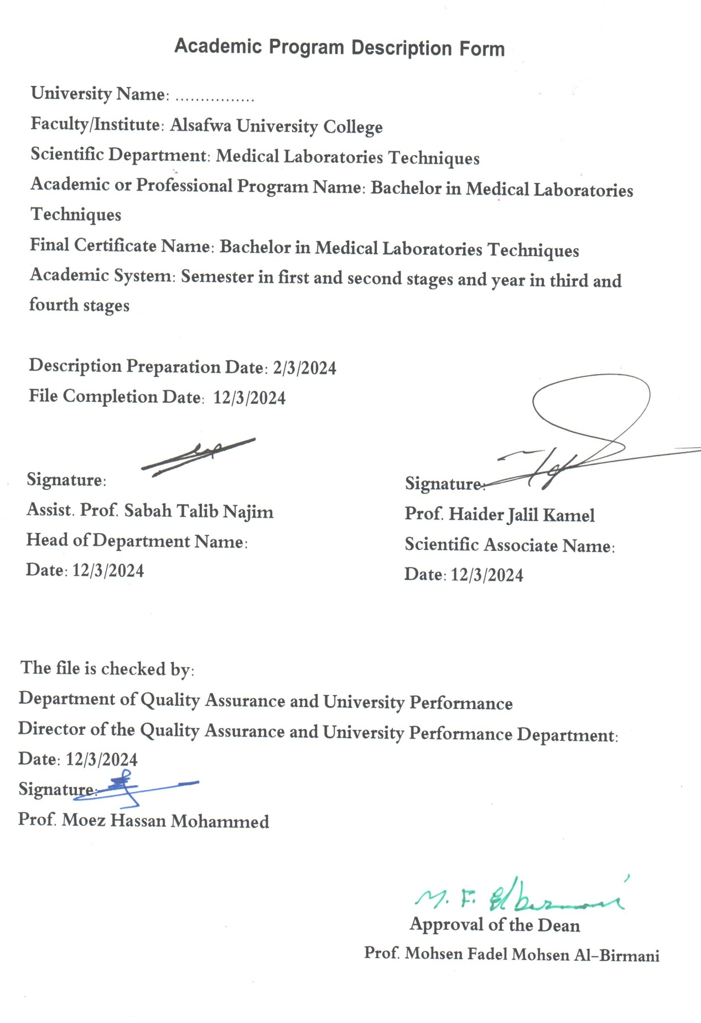

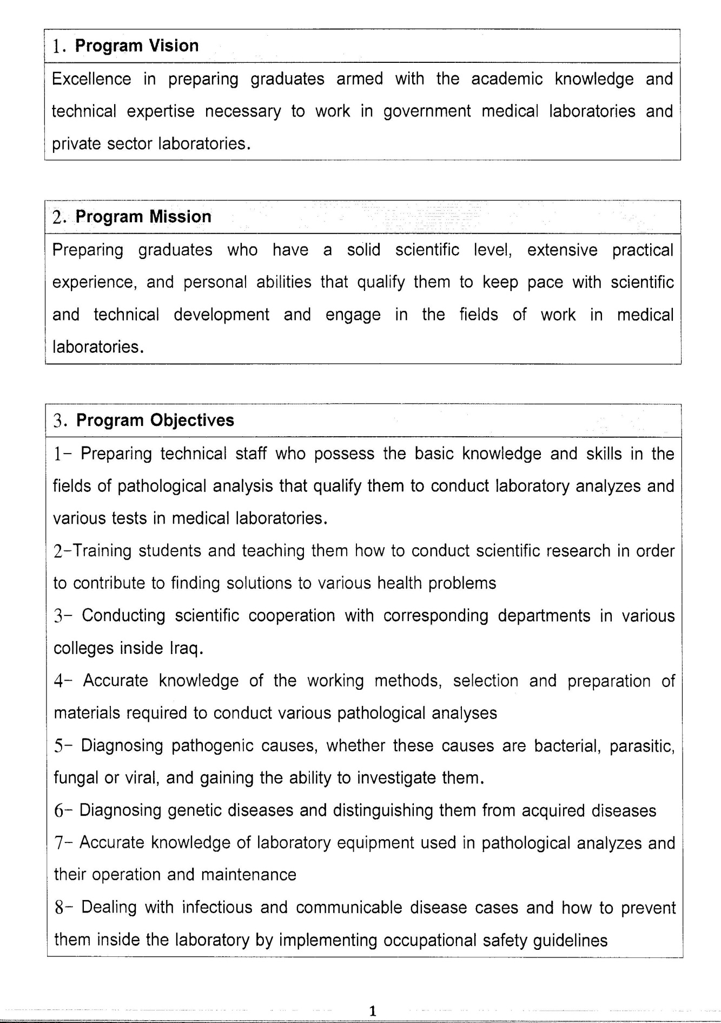

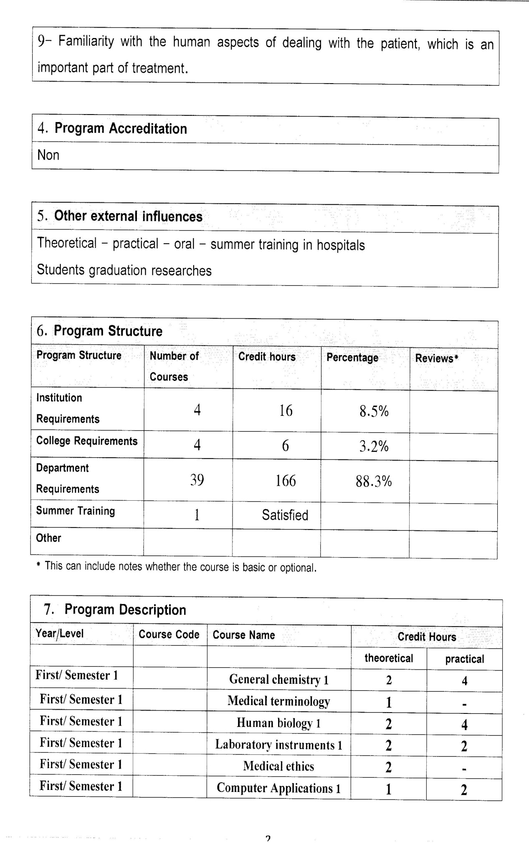

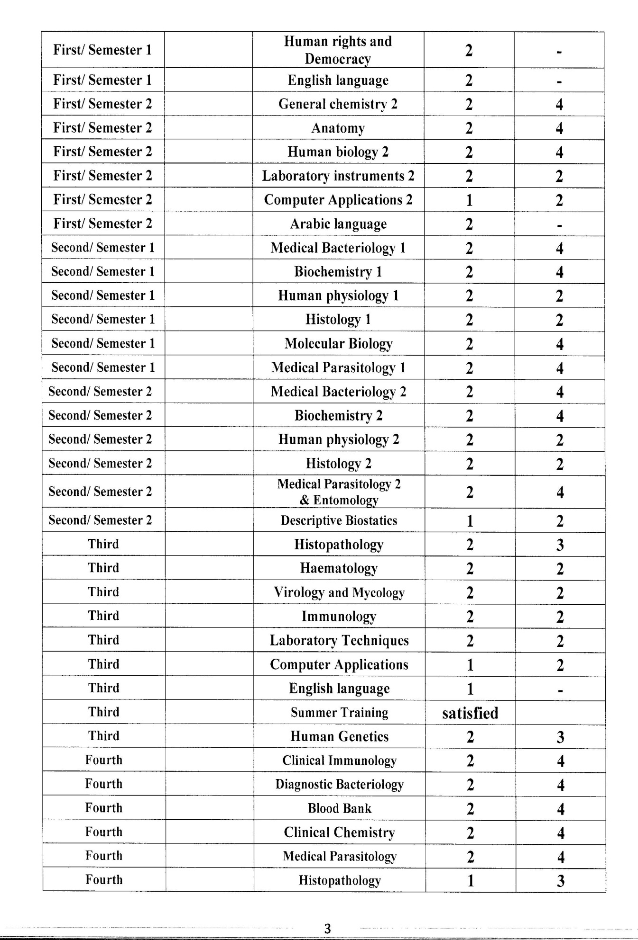

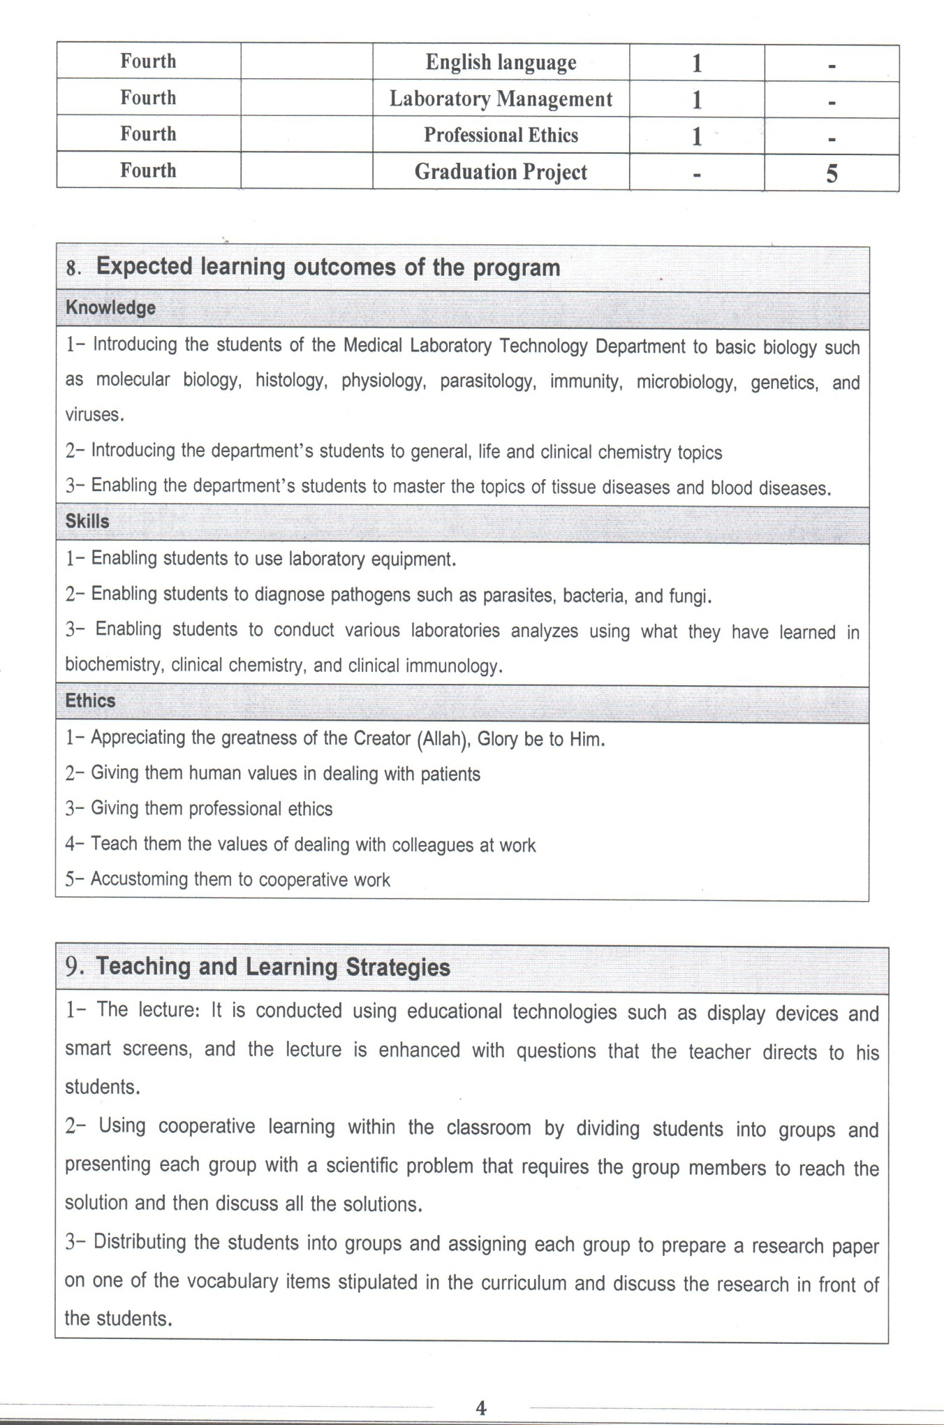

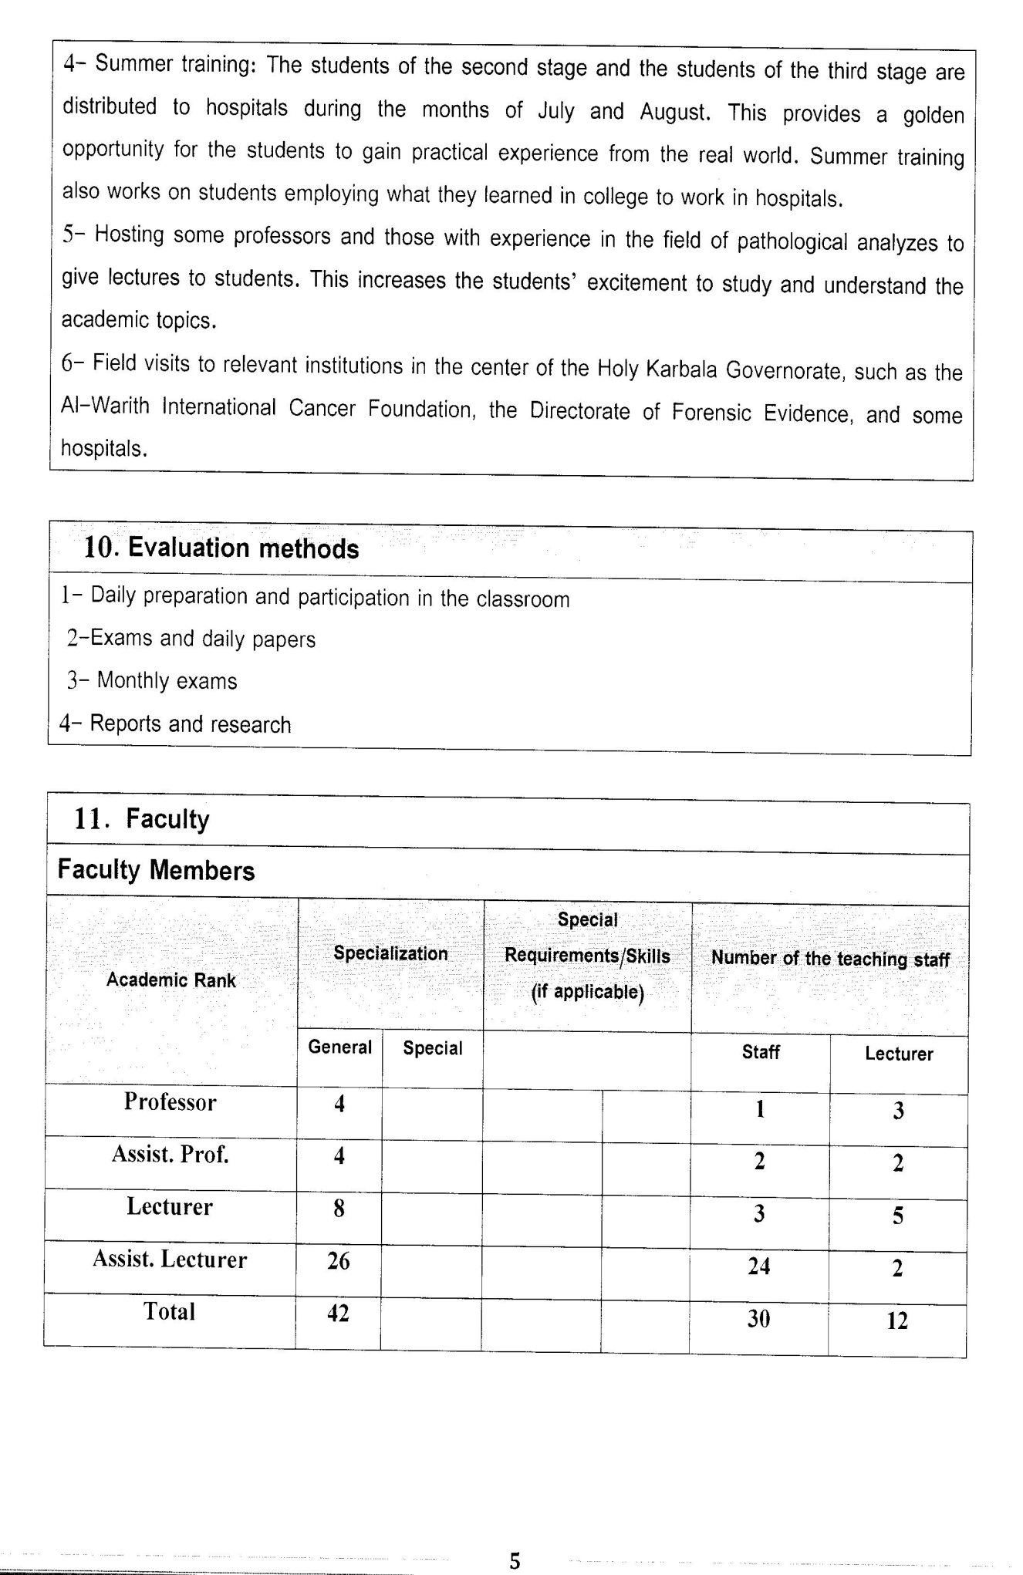

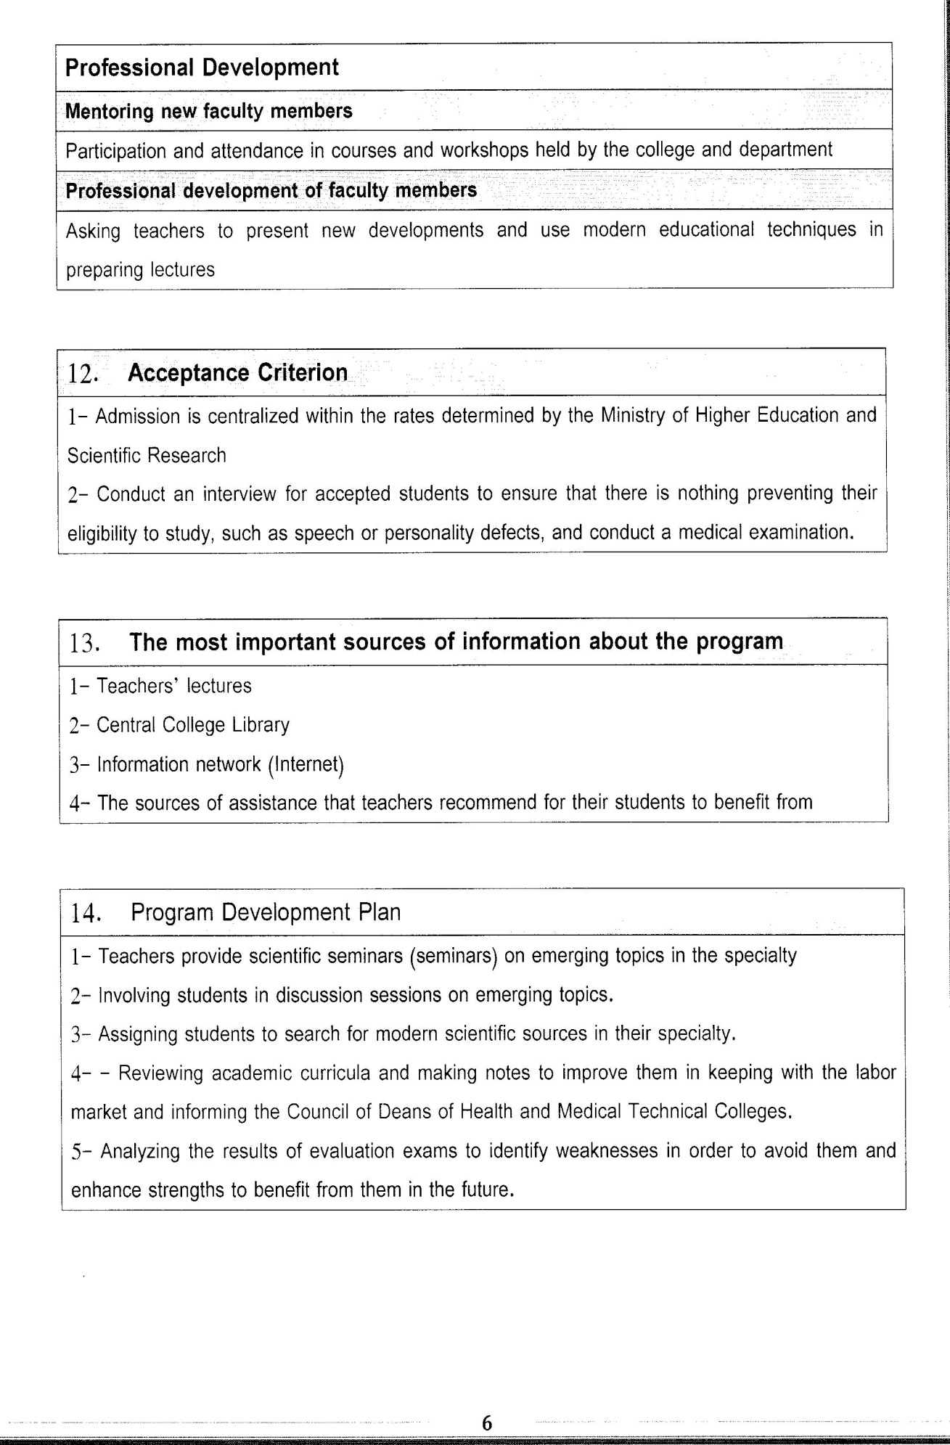

Course Description Form*2023-2024
- Course Name:
Clinical immunology
- Course Code:
- Semester / Year:
Third Year (Year)
- Description Preparation Date:
6 / 3 / 2024
- Available Attendance Forms:
- Number of Credit Hours (Total) / Number of Units (Total)
120 Hours
- Course administrator's name (mention all, if more than one name)
Name: Hayder Ali muhammid
Email: Haydr.Ali29@alsafwa.edu.iq
- Course Objectives
Course Objectives
At the end of the academic year, the student should be able to:
1. Knowledge and understanding of immune diseases.
2. Knowledge and understanding of clinical immunological diseases.
3. Knowledge and understanding of immune genetic changes.
4. Knowledge and understanding of immune diseases transmitted through generations.
5. Knowledge and understanding of the immunological treatment of cancerous diseases.
6. Knowledge and understanding of erythropoietic disease.
7. Know and understand rheumatoid arthritis.
- Teaching and Learning Strategies
Strategy |  | 1. Providing students with the basics and supporting topics related to the pre-skills learning outcomes.  2. Applying the topics studied in theoretical lessons on the practical level.  3. Asking students to identify the types of immunity and types of Innate and adaptive immunity.
- Course Structure
Week | Hours |  | Required Learning Outcomes | Unit or subject name |  | Learning method | Evaluation method
First Semester
1 | 2practical+2 theoretical |  | Understand  the lecture | General immunity |  | Lecture  Laboratory | Attendance  Daily exam
2 | 2practical+2 theoretical |  | Understand  the lecture | Basic principles of immunity |  | Lecture  Laboratory | Attendance  Daily exam
3 | 2practical+2 theoretical |  | Understand  the lecture | acquired immunity |  | Lecture  Laboratory | Attendance  Daily exam
4 | 2practical+2 theoretical |  | Understand  the lecture | Humoral immunity |  | Lecture  Laboratory | Attendance  Daily exam
5 | 2practical+2 theoretical |  | Understand  the lecture | Illiterate immunity |  | Lecture  Laboratory | Attendance  Daily exam
6 | 2practical+2 theoretical |  | Understand  the lecture | The complement |  | Lecture  Laboratory | Attendance  Daily exam
7 | 2practical+2 theoretical |  | Understand  the lecture | organ transplantation |  | Lecture  Laboratory | Attendance  Daily exam
8 | 2practical+2 theoretical |  | Understand  the lecture | cancer |  | Lecture  Laboratory | Attendance  Daily exam
9 | 2practical+2 theoretical |  | Understand  the lecture | Hemolytic septicemia |  | Lecture  Laboratory | Attendance  Daily exam
10 | 2practical+2 theoretical |  | Understand  the lecture | Erythromelalgia |  | Lecture  Laboratory | Attendance  Daily exam
11 | 2practical+2 theoretical |  | Understand  the lecture | Rheumatoid arthritis |  | Lecture  Laboratory | Attendance  Daily exam
12 | 2practical+2 theoretical |  | Understand  the lecture | Purulent inflammation |  | Lecture  Laboratory | Attendance  Daily exam
13 | 2practical+2 theoretical |  | Understand  the lecture | Psoriasis |  | Lecture  Laboratory | Attendance  Daily exam
14 | 2practical+2 theoretical |  | Understand  the lecture | Behçet's disease |  | Lecture  Laboratory | Attendance  Daily exam
15 | 2practical+2 theoretical |  | Understand  the lecture | Lymphadenitis |  | Lecture  Laboratory | Attendance  Daily exam
Second Semester
1 | 2practical+2 theoretical |  | Understand  the lecture | Lever Inflammation |  | Lecture  Laboratory | Attendance  Daily exam
2 | 2practical+2 theoretical |  | Understand  the lecture | Cholecystitis |  | Lecture  Laboratory | Attendance  Daily exam
3 | 2practical+2 theoretical |  | Understand  the lecture | Chronic pneumonia |  | Lecture  Laboratory | Attendance  Daily exam
4 | 2practical+2 theoretical |  | Understand  the lecture | Acute pneumonia |  | Lecture  Laboratory | Attendance  Daily exam
5 | 2practical+2 theoretical |  | Understand  the lecture | Acquired pneumonia |  | Lecture  Laboratory | Attendance  Daily exam
6 | 2practical+2 theoretical |  | Understand  the lecture | Chronic colitis |  | Lecture  Laboratory | Attendance  Daily exam
7 | 2practical+2 theoretical |  | Understand  the lecture | Acute colitis |  | Lecture  Laboratory | Attendance  Daily exam
8 | 2practical+2 theoretical |  | Understand  the lecture | cancer |  | Lecture  Laboratory | Attendance  Daily exam
9 | 2practical+2 theoretical |  | Understand  the lecture | Allergies |  | Lecture  Laboratory | Attendance  Daily exam
10 | 2practical+2 theoretical |  | Understand  the lecture | Blood transfusion and its aggregates |  | Lecture  Laboratory | Attendance  Daily exam
11 | 2practical+2 theoretical |  | Understand  the lecture | Clinical immune complex |  | Lecture  Laboratory | Attendance  Daily exam
12 | 2practical+2 theoretical |  | Understand  the lecture | comps |  | Lecture  Laboratory | Attendance  Daily exam
13 | 2practical+2 theoretical |  | Understand  the lecture | Passive immunity |  | Lecture  Laboratory | Attendance  Daily exam
14 | 2practical+2 theoretical |  | Understand  the lecture | Antitoxins |  | Lecture  Laboratory | Attendance  Daily exam
15 | 2practical+2 theoretical |  | Understand  the lecture | Neoplastic dermatitis |  | Lecture  Laboratory | Attendance  Daily exam
- Course Evaluation
The following evaluation methods are adopted:
1. Theoretical and practical tests.
2. Reports.
3. Attendance and discussion.
The grades are distributed as follows:
1- Two monthly exams with a score of 20 points.
2-5 marks for activity and attendance.
3- 15 marks for the practical part, so the pursuit mark is 40.
4- The final exam score is distributed (35) points for the theoretical part and (25) points for the practical part, so the final score is 100.
- Learning and Teaching Resources
Required textbooks (curricular books, if any) |  |  |  |  | Not found
Main references (sources) |  |  |  |  | Basic Immunology: Functions and Disorders of the Immune System 6th Edition
Recommended books and references (scientific journals, reports...)
Electronic References, Websites

