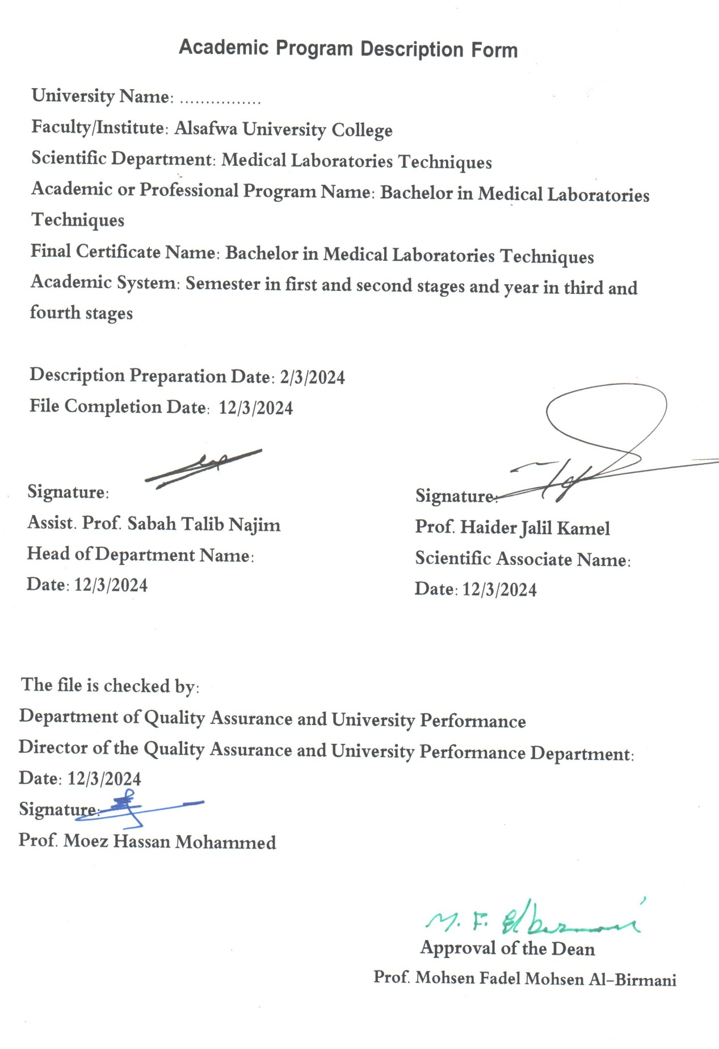

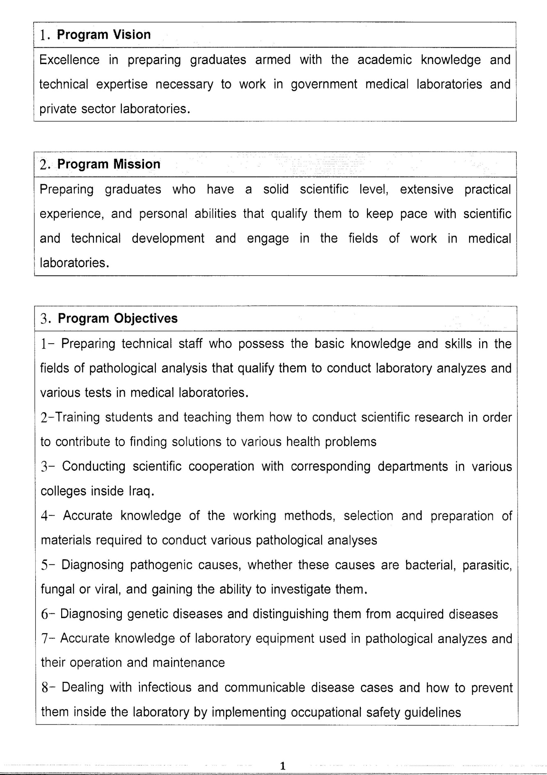

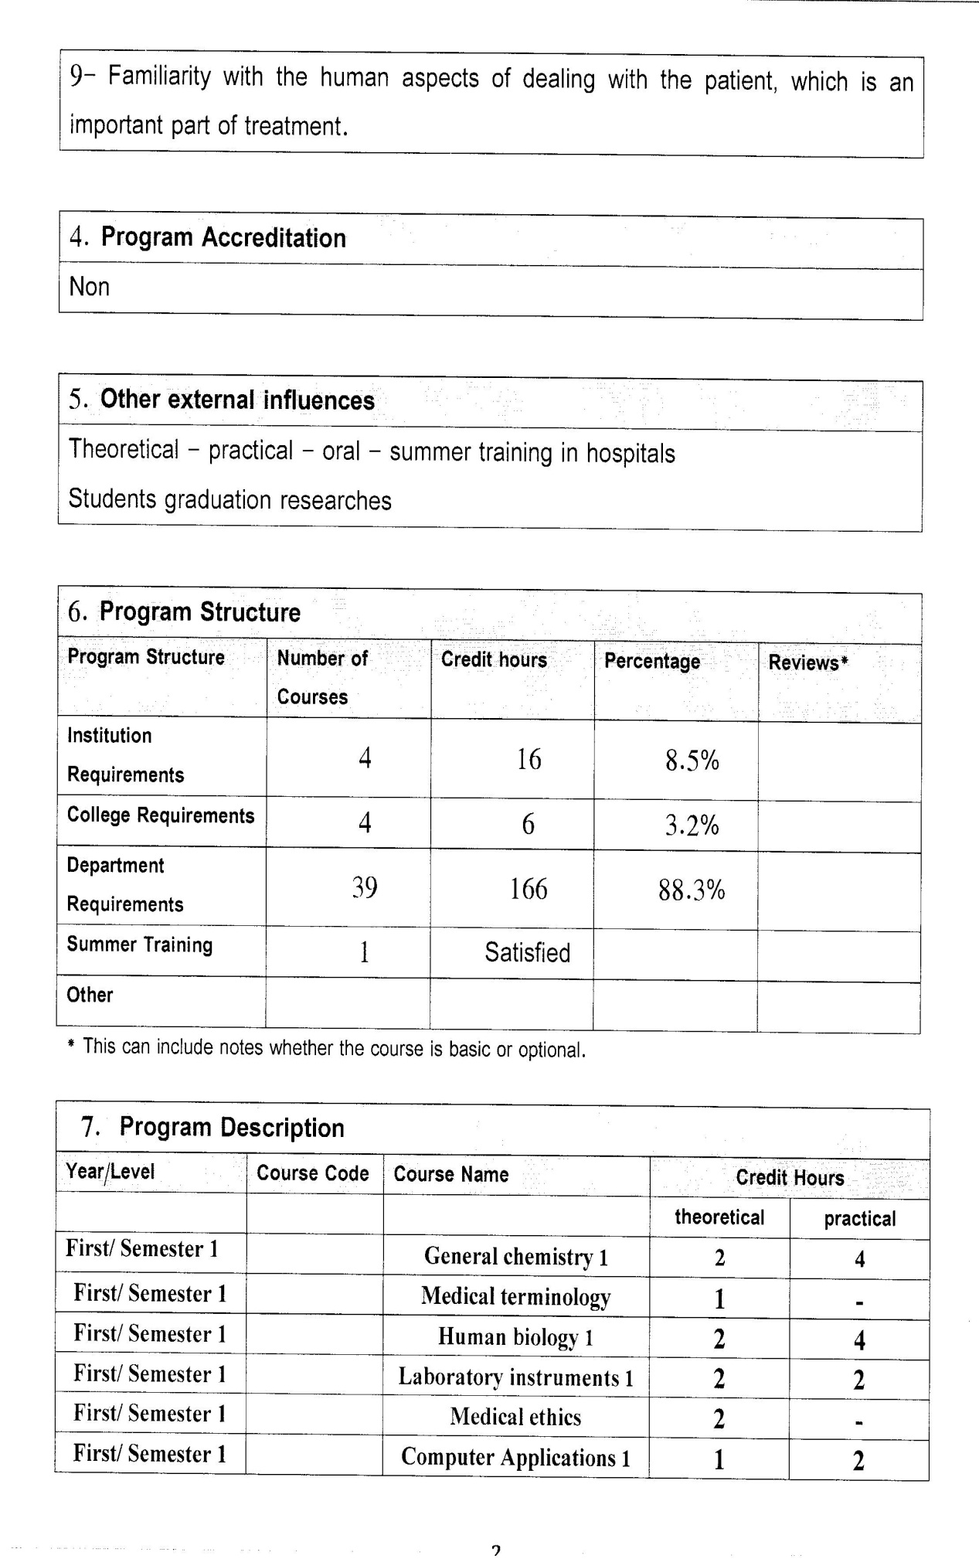

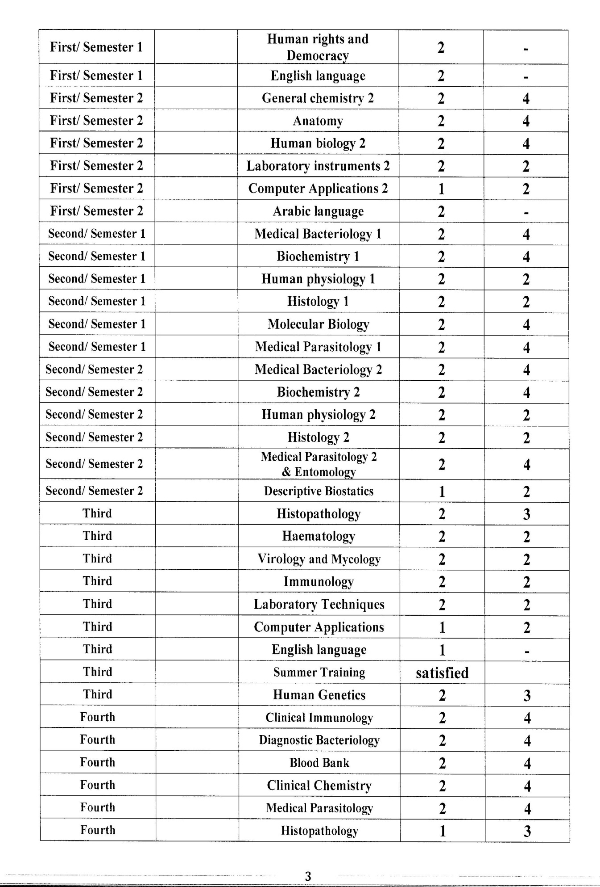

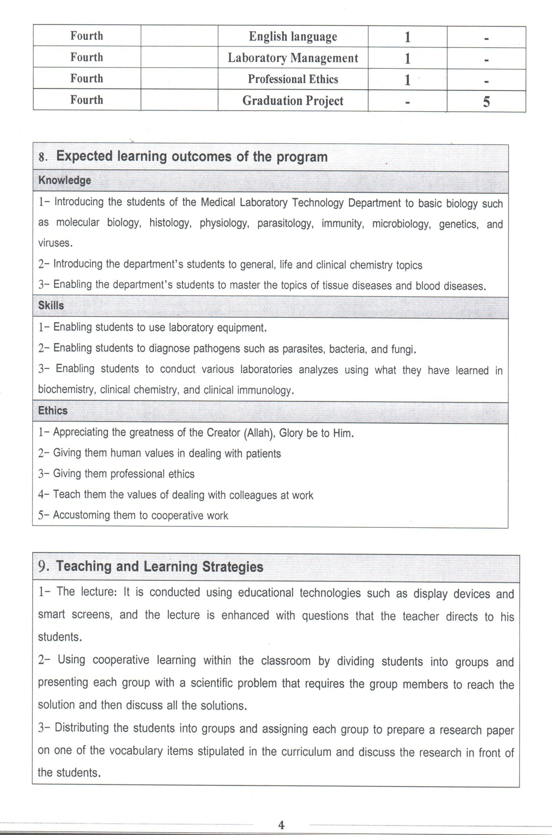

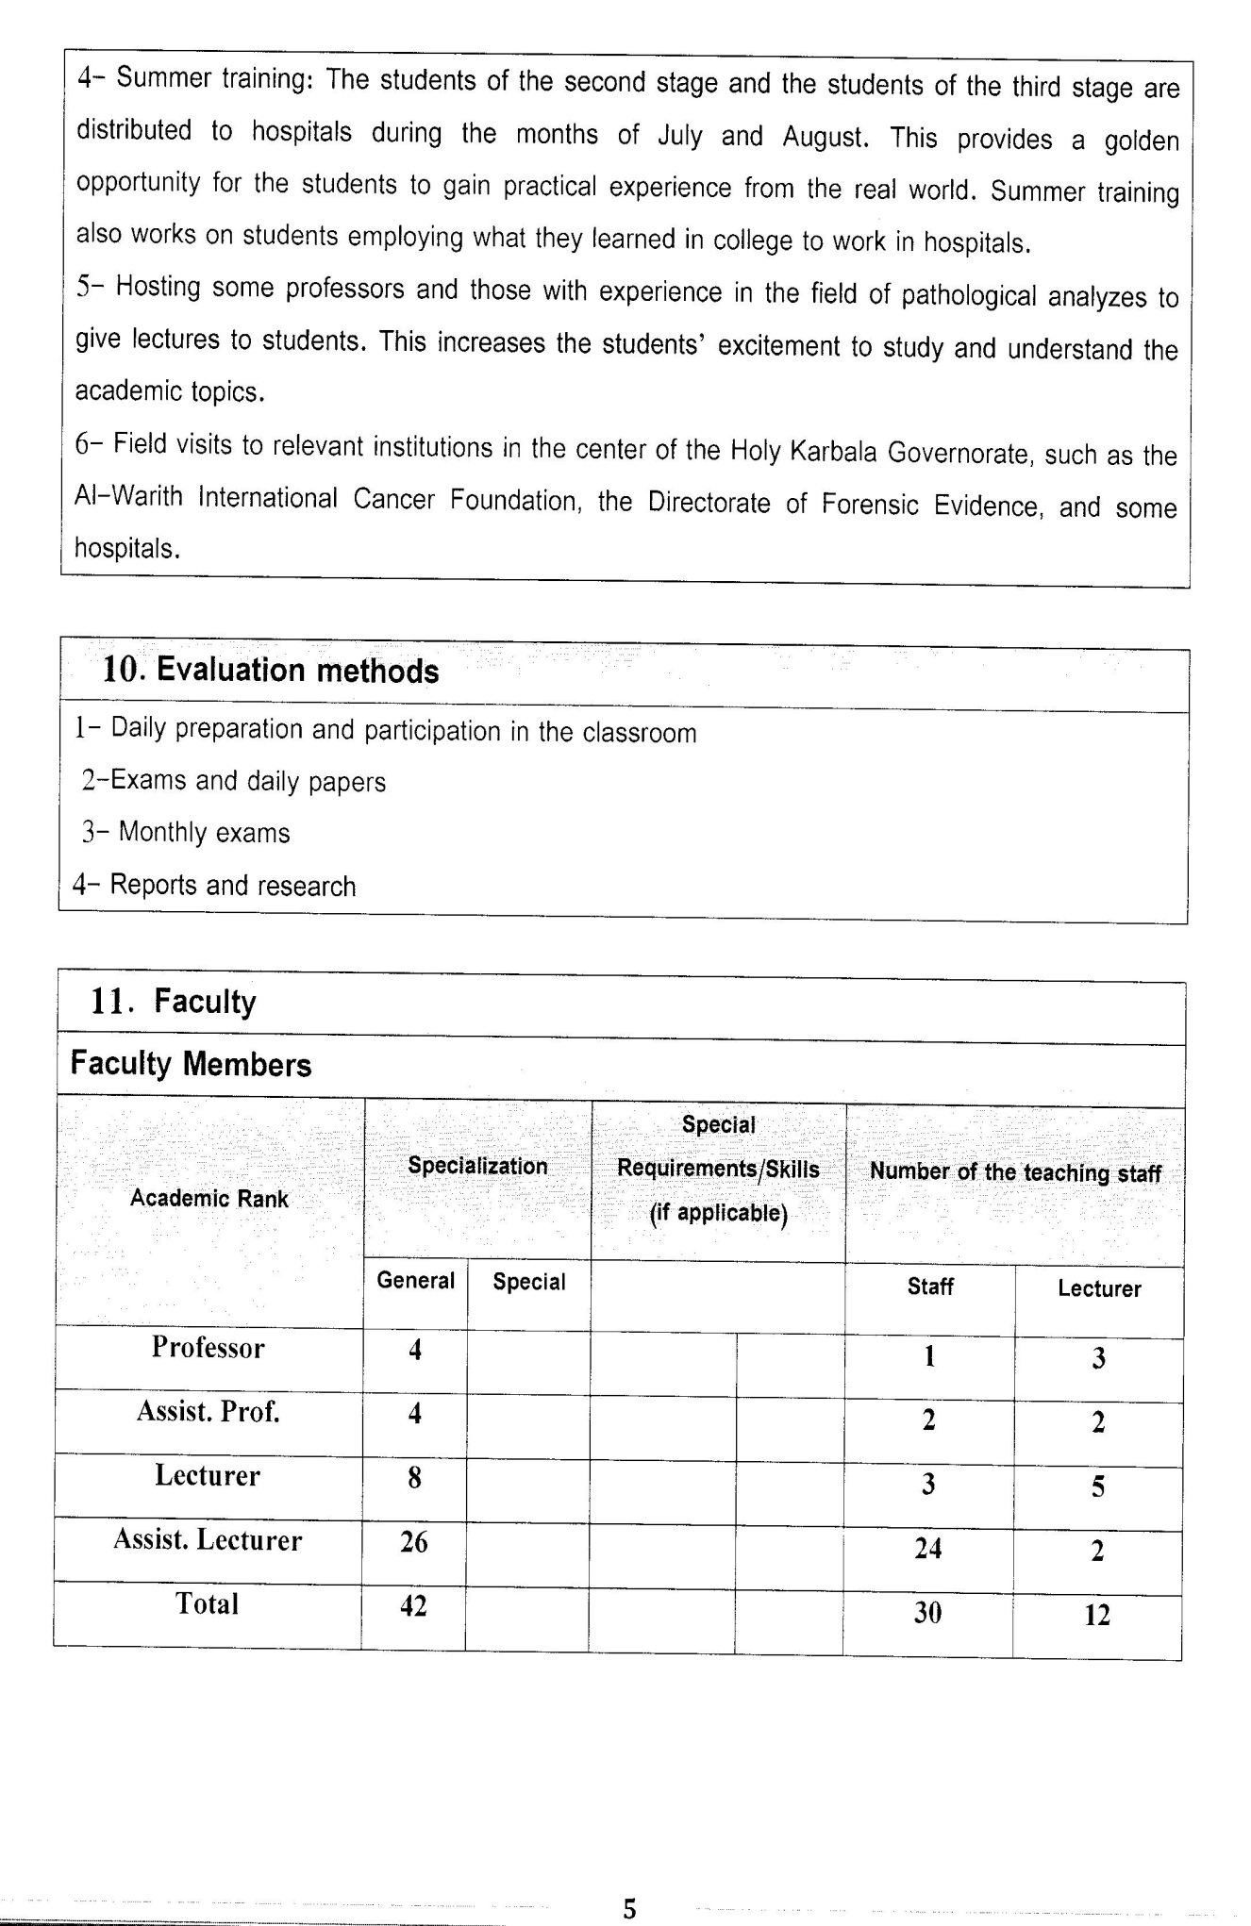

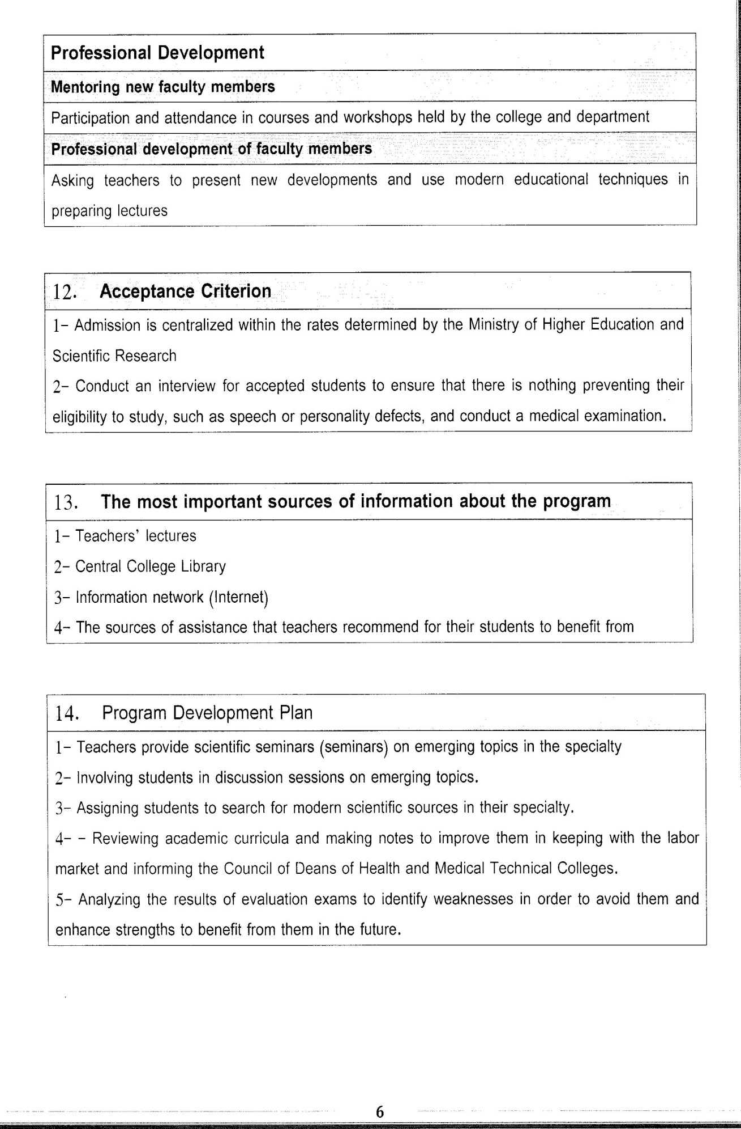

Course Description Form(2023-2024)

- Course Name:
Immunology
- Course Code:
- Semester / Year:
Fourth Year (Year)
- Description Preparation Date:
6 / 3 / 2024
- Available Attendance Forms:
- Number of Credit Hours (Total) / Number of Units (Total)
120 Hours
- Course administrator's name (mention all, if more than one name)
Name: Dr.Salah Hashim Shaheed
Email: salah.hashim@alsafwa.edu.iq
- Course Objectives
General objective: 1- The nature of the immune system, its cells and factors. 2- Medical conditions related to the functioning of the immune system. 3-General techniques used in the functioning of the immune system and diagnosis. Special goal: At the end of the academic year, the student can understand and realize: 1- Definition of immunology, its relationship with other sciences, and its importance to the student of pathological analyses. 2- Components of the immune system, which include cells and organs related to the formation of the immune system. 3- The concept of natural and acquired immunity, humoral factors, and cellular factors. 4- The relationship between the humoral components, cellular factors, and biological immune response. 5- Immunity and its types (beneficial and harmful): tumor immunity, allergic disease immunity, and immune disease immunity. Autoimmune diseases and immunodeficiency diseases. 6- Mechanisms of laboratory diagnosis and identification of some diseases that rely on immunological laboratory diagnosis.

- Teaching and Learning Strategies
Strategy |  | 1 -Provide students with the basics of  supporting materials related to the outputs of pre-skill education.  2 -Application of the topics studied  in theoretical lessons at a practical level.  3- Ask students to identify the types  of common immune diseases, techniques  and tests required for diagnosis.
- Course Structure
Week | Hours |  | Required Learning Outcomes | Unit or subject name |  | Learning method |  | Evaluation method
First Semester
1 | 2practical |  | Understand  the lecture | Introduction to the immune system and autoimmune diseases |  |  | Lecture  Laboratory |  | Attendance  Daily exam
2 | 2practical |  | Understand  the lecture | Features of immunological diagnostic techniques and methods for disease |  |  | Lecture  Laboratory |  | Attendance  Daily exam
3 | 2practical |  | Understand  the lecture | Agglutination reactions |  |  | Lecture  Laboratory |  | Attendance  Daily exam
4 | 2practical |  | Understand  the lecture | Dilution techniques |  |  | Lecture  Laboratory |  | Attendance  Daily exam
5 | 2practical |  | Understand  the lecture | ELISA Technique |  |  | Lecture  Laboratory |  | Attendance  Daily exam
6 | 2practical |  | Understand  the lecture | C-Reactive Protein Test |  |  | Lecture  Laboratory |  | Attendance  Daily exam
7 | 2practical |  | Understand  the lecture | Rheumatoid arthritis |  |  | Lecture  Laboratory |  | Attendance  Daily exam
8 | 2practical |  | Understand  the lecture | Rheumatoid Factor and ESR |  |  | Lecture  Laboratory |  | Attendance  Daily exam
9 | 2practical |  | Understand  the lecture | A cyclic citrullinated peptide |  |  | Lecture  Laboratory |  | Attendance  Daily exam
10 | 2practical |  | Understand  the lecture | SLE |  |  | Lecture  Laboratory |  | Attendance  Daily exam
11 | 2practical |  | Understand  the lecture | Antinuclear Antibody |  |  | Lecture  Laboratory |  | Attendance  Daily exam
12 | 2practical |  | Understand  the lecture | Ankylosing spondylitis |  |  | Lecture  Laboratory |  | Attendance  Daily exam
13 | 2practical |  | Understand  the lecture | Psoriatic arthritis |  |  | Lecture  Laboratory |  | Attendance  Daily exam
Second Semester
1 | 2practical |  | Understand  the lecture | Sjogren's syndrome |  | Lecture  Laboratory |  | Attendance  Daily exam
2 | 2practical |  | Understand  the lecture | Behcet's disease |  | Lecture  Laboratory |  | Attendance  Daily exam
3 | 2practical |  | Understand  the lecture | celiac disease |  | Lecture  Laboratory |  | Attendance  Daily exam
4 | 2practical |  | Understand  the lecture | pernicious anemia |  | Lecture  Laboratory |  | Attendance  Daily exam
5 | 2practical |  | Understand  the lecture | diabetes mellitus |  | Lecture  Laboratory |  | Attendance  Daily exam
6 | 2practical |  | Understand  the lecture | ulcerative colitis |  | Lecture  Laboratory |  | Attendance  Daily exam
7 | 2practical |  | Understand  the lecture | Crohn's disease |  | Lecture  Laboratory |  | Attendance  Daily exam
8 | 2practical |  | Understand  the lecture | MALT |  | Lecture  Laboratory |  | Attendance  Daily exam
9 | 2practical |  | Understand  the lecture | Autoimmune liver disease |  | Lecture  Laboratory |  | Attendance  Daily exam
10 | 2practical |  | Understand  the lecture | Autoimmune kidney disease |  | Lecture  Laboratory |  | Attendance  Daily exam
11 | 2practical |  | Understand  the lecture | Respiratory disease |  | Lecture  Laboratory |  | Attendance  Daily exam
12 | 2practical |  | Understand  the lecture | Asthma |  | Lecture  Laboratory |  | Attendance  Daily exam
13 | 2practical |  | Understand  the lecture | Hypersensitivity disease |  | Lecture  Laboratory |  | Attendance  Daily exam
- Course Evaluation
The following evaluation methods are adopted:
1. Theoretical and practical tests.
2. Reports.
3. Attendance and discussion.
The grades are distributed as follows:
1- Two monthly exams with a score of 20 points.
2-5 marks for activity and attendance.
3- 15 marks for the practical part, so the pursuit mark is 40.
4- The final exam score is distributed (35) points for the theoretical part and (25) points for the practical part, so the final score is 100.
- Learning and Teaching Resources
Required textbooks (curricular books, if any) |  |  |  |  | Not found
Main references (sources)
Recommended books and references (scientific journals, reports...)
Electronic References, Websites

