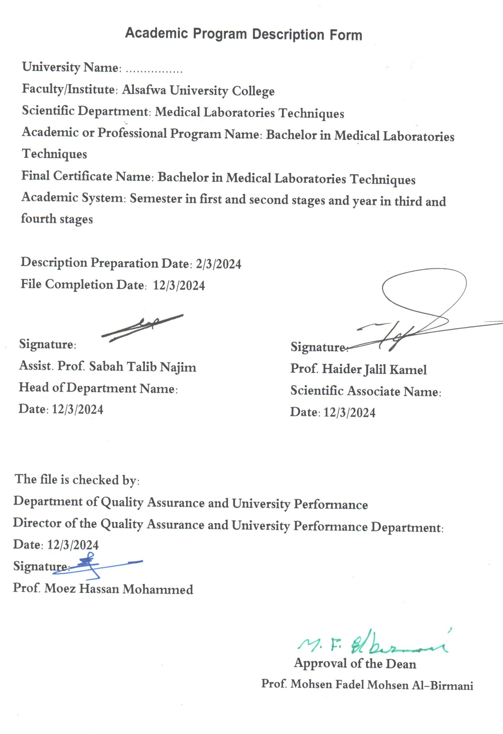

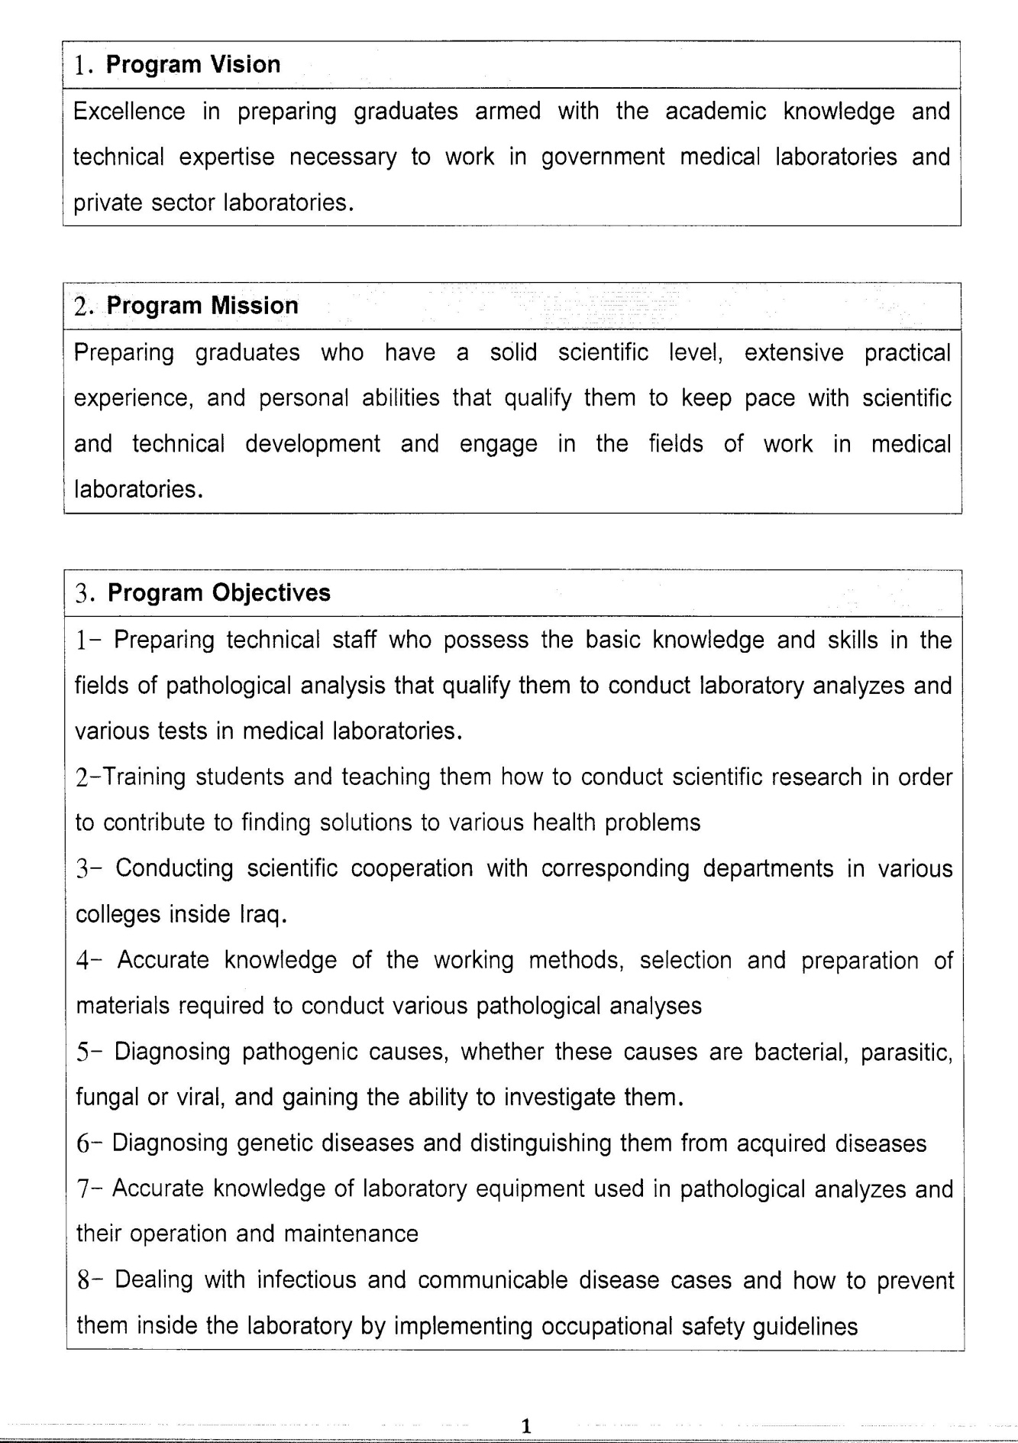

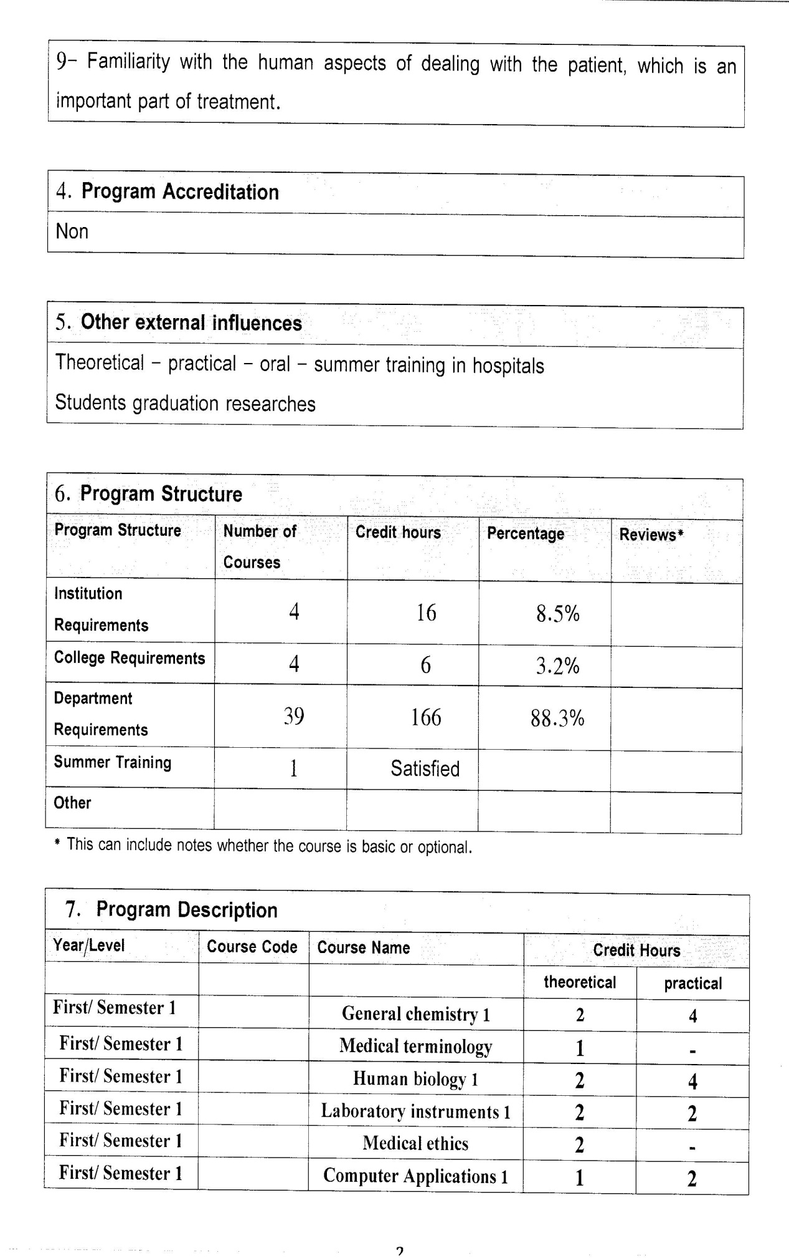

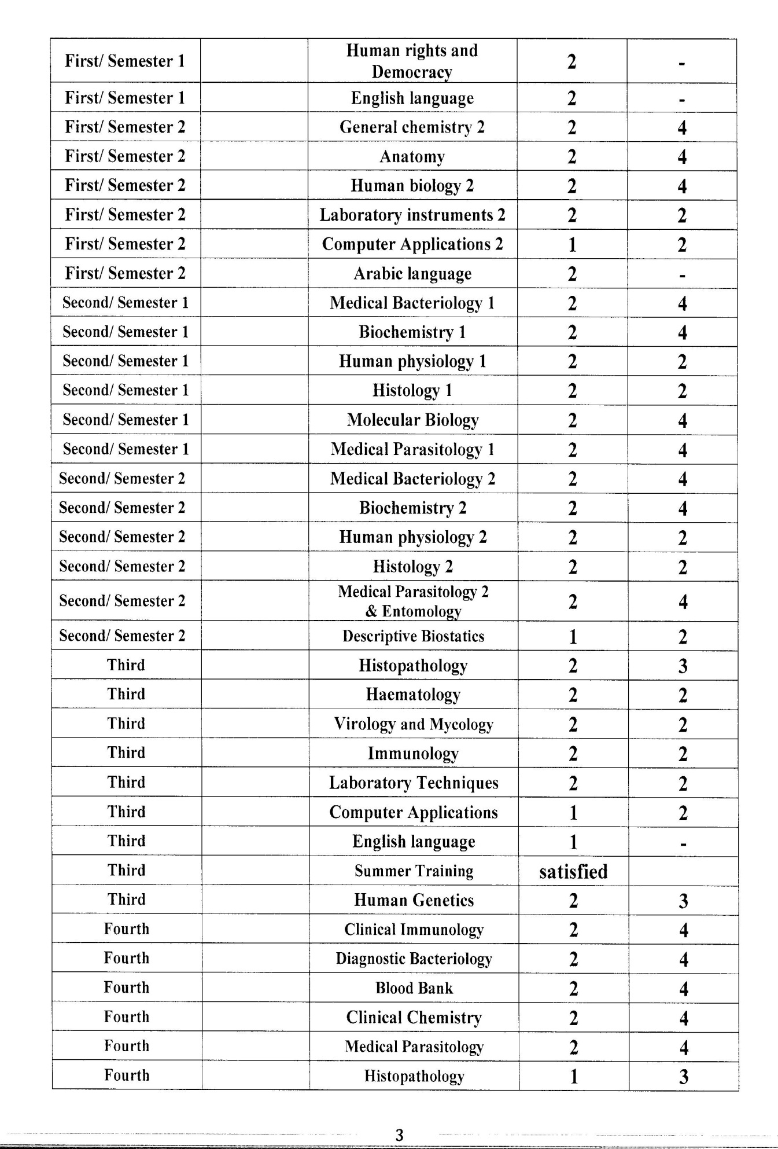

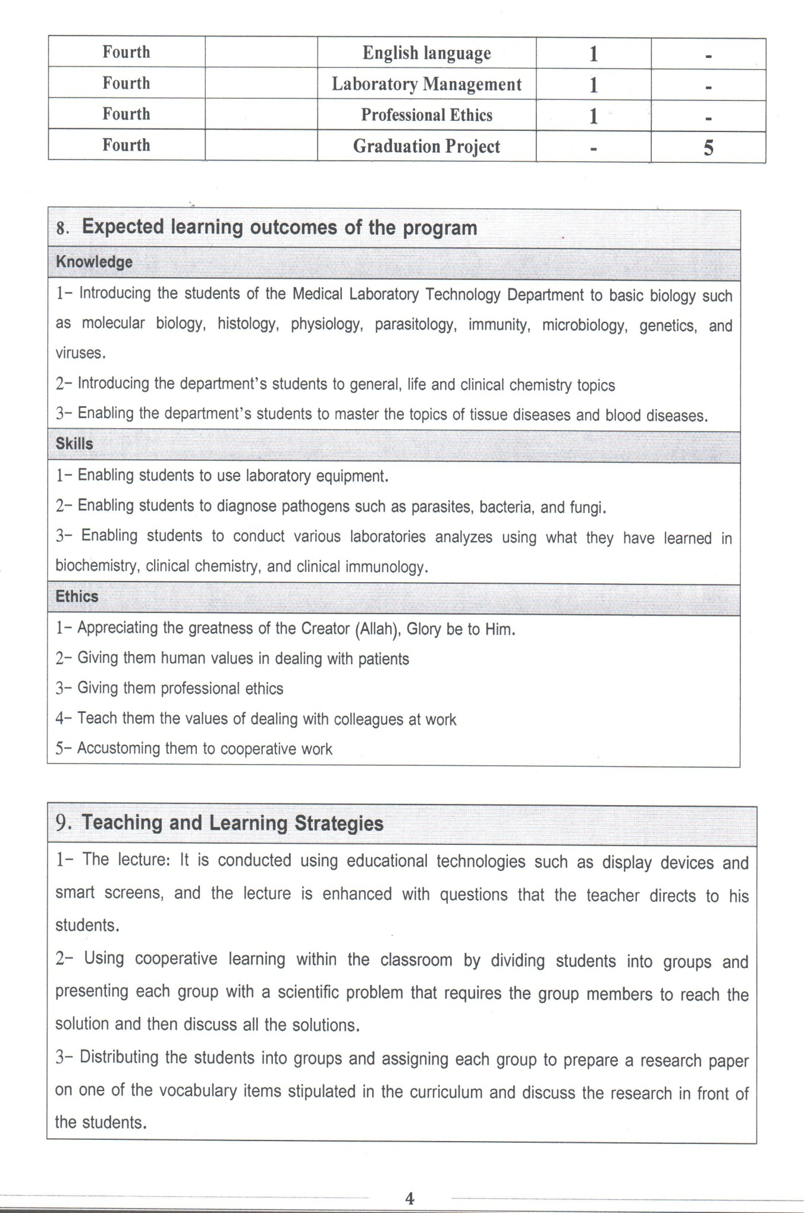

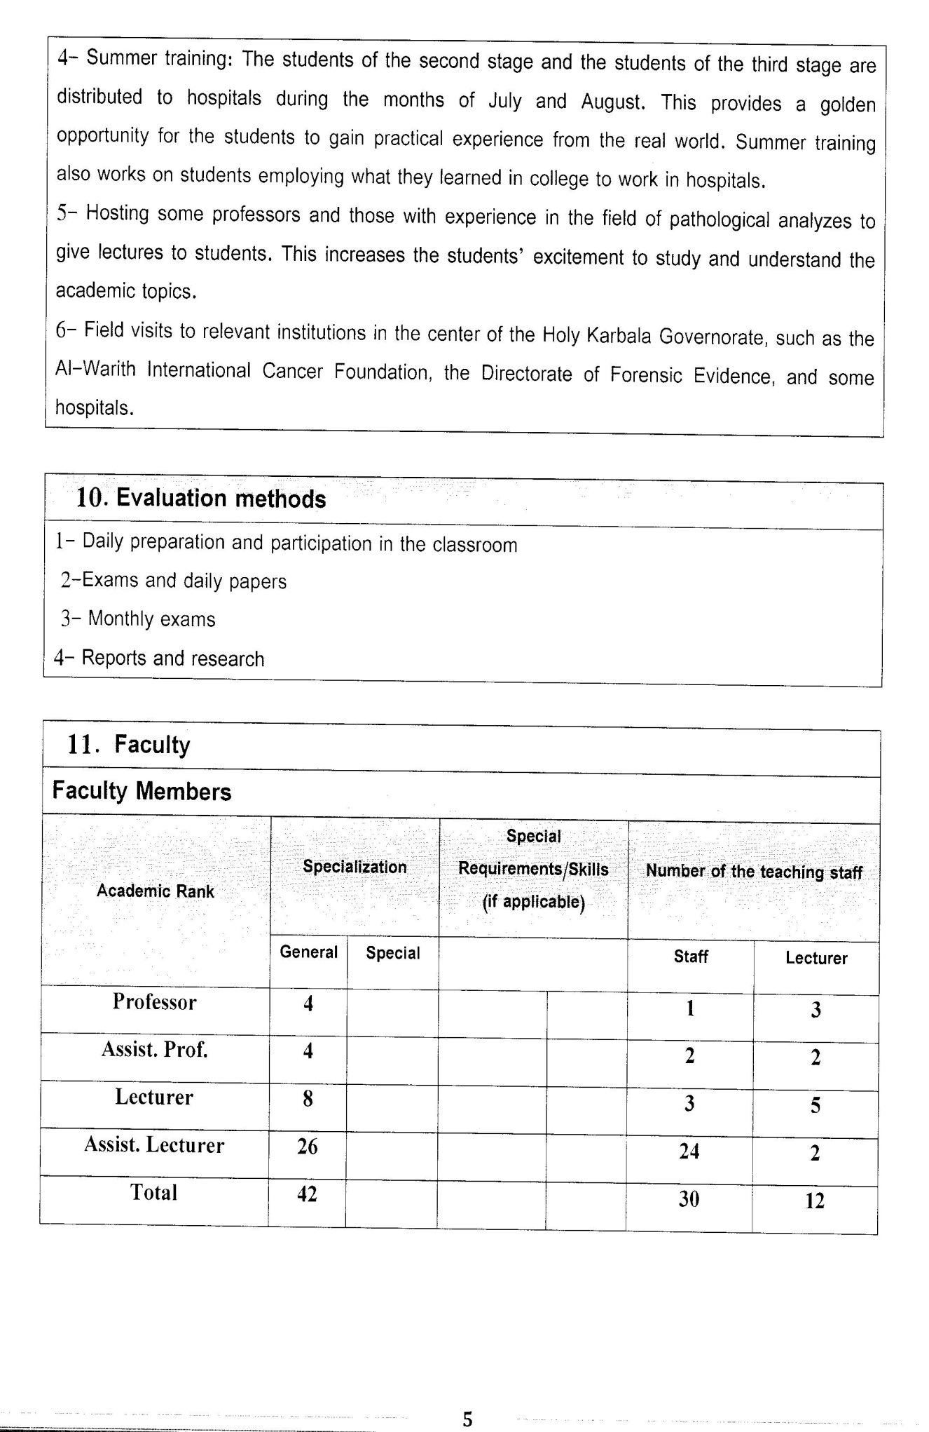

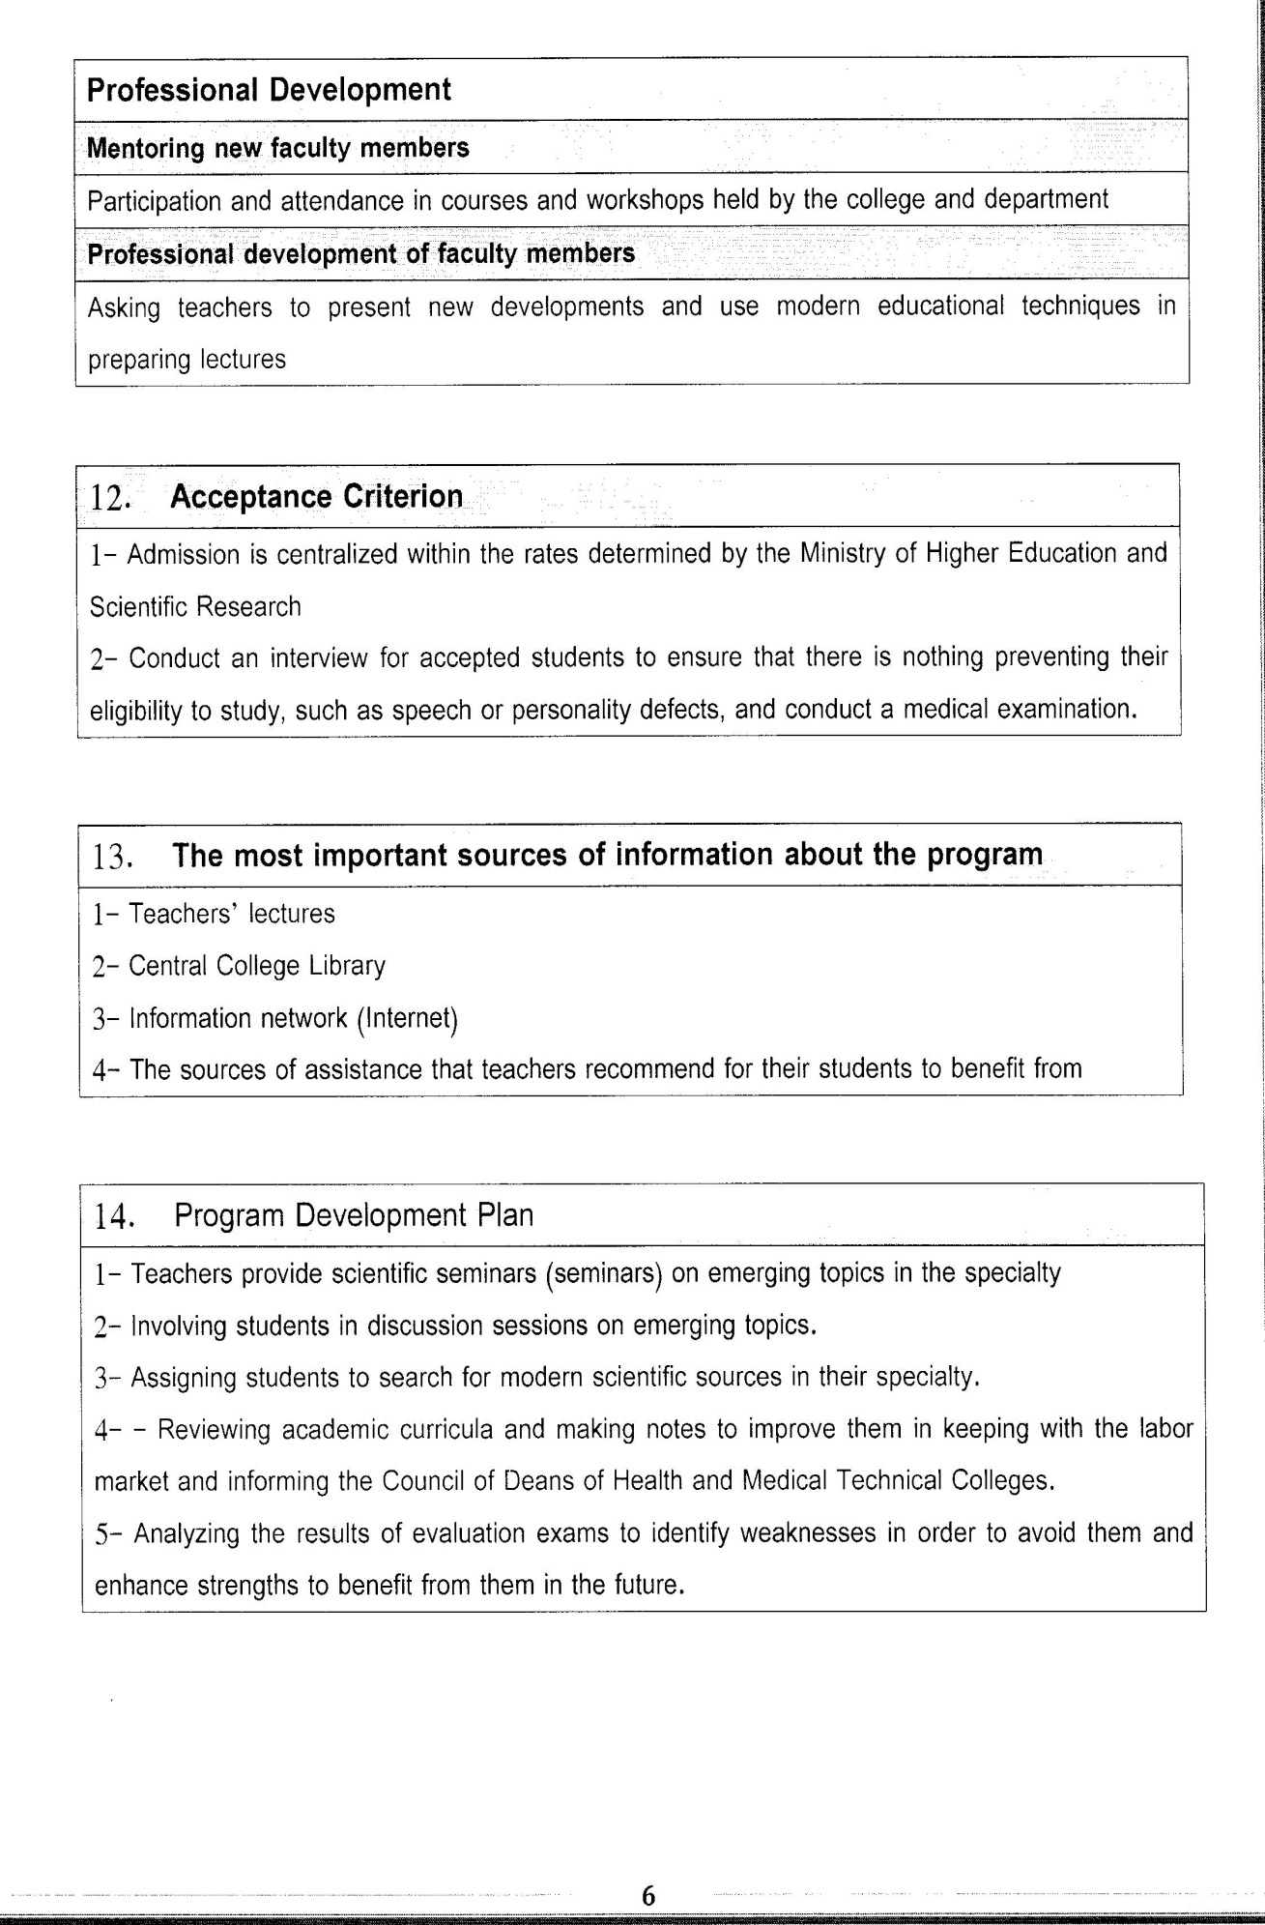

Course Description Form(2023 – 2024)
- Course Name:
Blood Bank
- Course Code:
- Semester / Year:
Fourth Year (Year)
- Description Preparation Date:
13 / 3 / 2024
- Available Attendance Forms:
- Number of Credit Hours (Total) / Number of Units (Total)
120 Hours
- Course administrator's name (mention all, if more than one name)
Name:Dr. Azal Alaa Abbass
Email: azal.alaa@alsafwa.edu.iq
- Course Objectives
Course Objectives
At the end of the academic year, the student should be able to:
1.Knowledge and understanding of the blood bank.
2. Knowing and understanding the mechanism of blood transfusion.
3. Know and understand the complications of blood transfusion.
4. Knowing and understanding blood types and the Rh factor
5. Knowing and understanding the tests that must be performed on donors.
6. Know and understand the types of blood transfusion.
7. Knowledge and understanding of diseases associated with platelets.
8. Knowledge and understanding of hemolytic blood disease in infants.
- Teaching and Learning Strategies
Strategy |  | 1. Providing students with the basics and supporting topics related to the pre-skills learning outcomes.  2. Applying the topics studied in theoretical lessons on the practical level.  3. Asking students to identify the types of mutations and types of inheritance patterns.
- Course Structure
Week | Hours |  | Required Learning Outcomes | Unit or subject name |  | Learning method | Evaluation method
First Semester
1 | 2practical+2 theoretical |  | Understand  the lecture | Blood Bank |  | Lecture  Laboratory | Attendance  Daily exam
2 | 2practical+2 theoretical |  | Understand  the lecture | Blood group and RH |  | Lecture  Laboratory | Attendance  Daily exam
3 | 2practical+2 theoretical |  | Understand  the lecture | Blood donation |  | Lecture  Laboratory | Attendance  Daily exam
4 | 2practical+2 theoretical |  | Understand  the lecture | Blood transfusion |  | Lecture  Laboratory | Attendance  Daily exam
5 | 2practical+2 theoretical |  | Understand  the lecture | Apheresis |  | Lecture  Laboratory | Attendance  Daily exam
6 | 2practical+2 theoretical |  | Understand  the lecture | Hemolytic disease of new born |  | Lecture  Laboratory | Attendance  Daily exam
7 | 2practical+2 theoretical |  | Understand  the lecture | Hemolytic anemia |  | Lecture  Laboratory | Attendance  Daily exam
8 | 2practical+2 theoretical |  | Understand  the lecture | Storage lesion |  | Lecture  Laboratory | Attendance  Daily exam
9 | 2practical+2 theoretical |  | Understand  the lecture | RBCs metabolism |  | Lecture  Laboratory | Attendance  Daily exam
10 | 2practical+2 theoretical |  | Understand  the lecture | RBCs component |  | Lecture  Laboratory | Attendance  Daily exam
11 | 2practical+2 theoretical |  | Understand  the lecture | Iron deficiency anemia |  | Lecture  Laboratory | Attendance  Daily exam
12 | 2practical+2 theoretical |  | Understand  the lecture | Coombs test |  | Lecture  Laboratory | Attendance  Daily exam
13 | 2practical+2 theoretical |  | Understand  the lecture | Platelets disorder |  | Lecture  Laboratory | Attendance  Daily exam
14 | 2practical+2 theoretical |  | Understand  the lecture | Storage lesion |  | Lecture  Laboratory | Attendance  Daily exam
15 | 2practical+2 theoretical |  | Understand  the lecture | Serological test |  | Lecture  Laboratory | Attendance  Daily exam
Second Semester
1 | 2practical+2 theoretical |  | Understand  the lecture | Hemostasis |  | Lecture  Laboratory | Attendance  Daily exam
2 | 2practical+2 theoretical |  | Understand  the lecture | Bleeding disorder |  | Lecture  Laboratory | Attendance  Daily exam
3 | 2practical+2 theoretical |  | Understand  the lecture | Anticoagulant |  | Lecture  Laboratory | Attendance  Daily exam
4 | 2practical+2 theoretical |  | Understand  the lecture | Inheritance of Rh system |  | Lecture  Laboratory | Attendance  Daily exam
5 | 2practical+2 theoretical |  | Understand  the lecture | the genetic basis of blood group |  | Lecture  Laboratory | Attendance  Daily exam
6 | 2practical+2 theoretical |  | Understand  the lecture | Phlebotomy |  | Lecture  Laboratory | Attendance  Daily exam
7 | 2practical+2 theoretical |  | Understand  the lecture | septic shock |  | Lecture  Laboratory | Attendance  Daily exam
8 | 2practical+2 theoretical |  | Understand  the lecture | Inflammatory Conditions. |  | Lecture  Laboratory | Attendance  Daily exam
9 | 2practical+2 theoretical |  | Understand  the lecture | Complications of blood transfusion |  | Lecture  Laboratory | Attendance  Daily exam
10 | 2practical+2 theoretical |  | Understand  the lecture | Blood component |  | Lecture  Laboratory | Attendance  Daily exam
11 | 2practical+2 theoretical |  | Understand  the lecture | Leukemia |  | Lecture  Laboratory | Attendance  Daily exam
12 | 2practical+2 theoretical |  | Understand  the lecture | Lymphoma |  | Lecture  Laboratory | Attendance  Daily exam
13 | 2practical+2 theoretical |  | Understand  the lecture | Autoimmune hemolytic anemia |  | Lecture  Laboratory | Attendance  Daily exam
- Course Evaluation
The following evaluation methods are adopted:
1. Theoretical and practical tests.
2. Reports.
3. Attendance and discussion.
The grades are distributed as follows:
1- Two monthly exams with a score of 20 points.
2-5 marks for activity and attendance.
3- 15 marks for the practical part, so the pursuit mark is 40.
4- The final exam score is distributed (35) points for the theoretical part and (25) points for the practical part, so the final score is 100.
- Learning and Teaching Resources
Required textbooks (curricular books, if any) |  |  |  |  | Not found
Main references (sources) |  |  |  |  | STANDARDS FOR BLOOD BANKS AND TRANSFUSION SERVICES, 33RD EDITION - PRINT
Recommended books and references (scientific journals, reports...)
Electronic References, Websites

