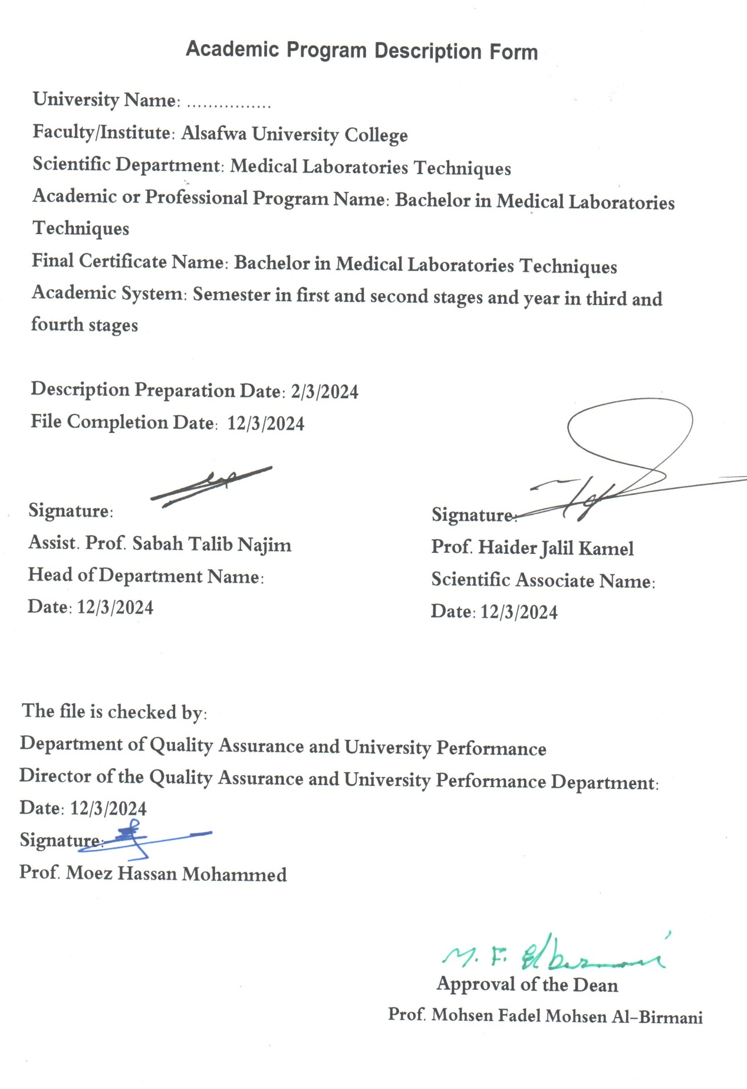

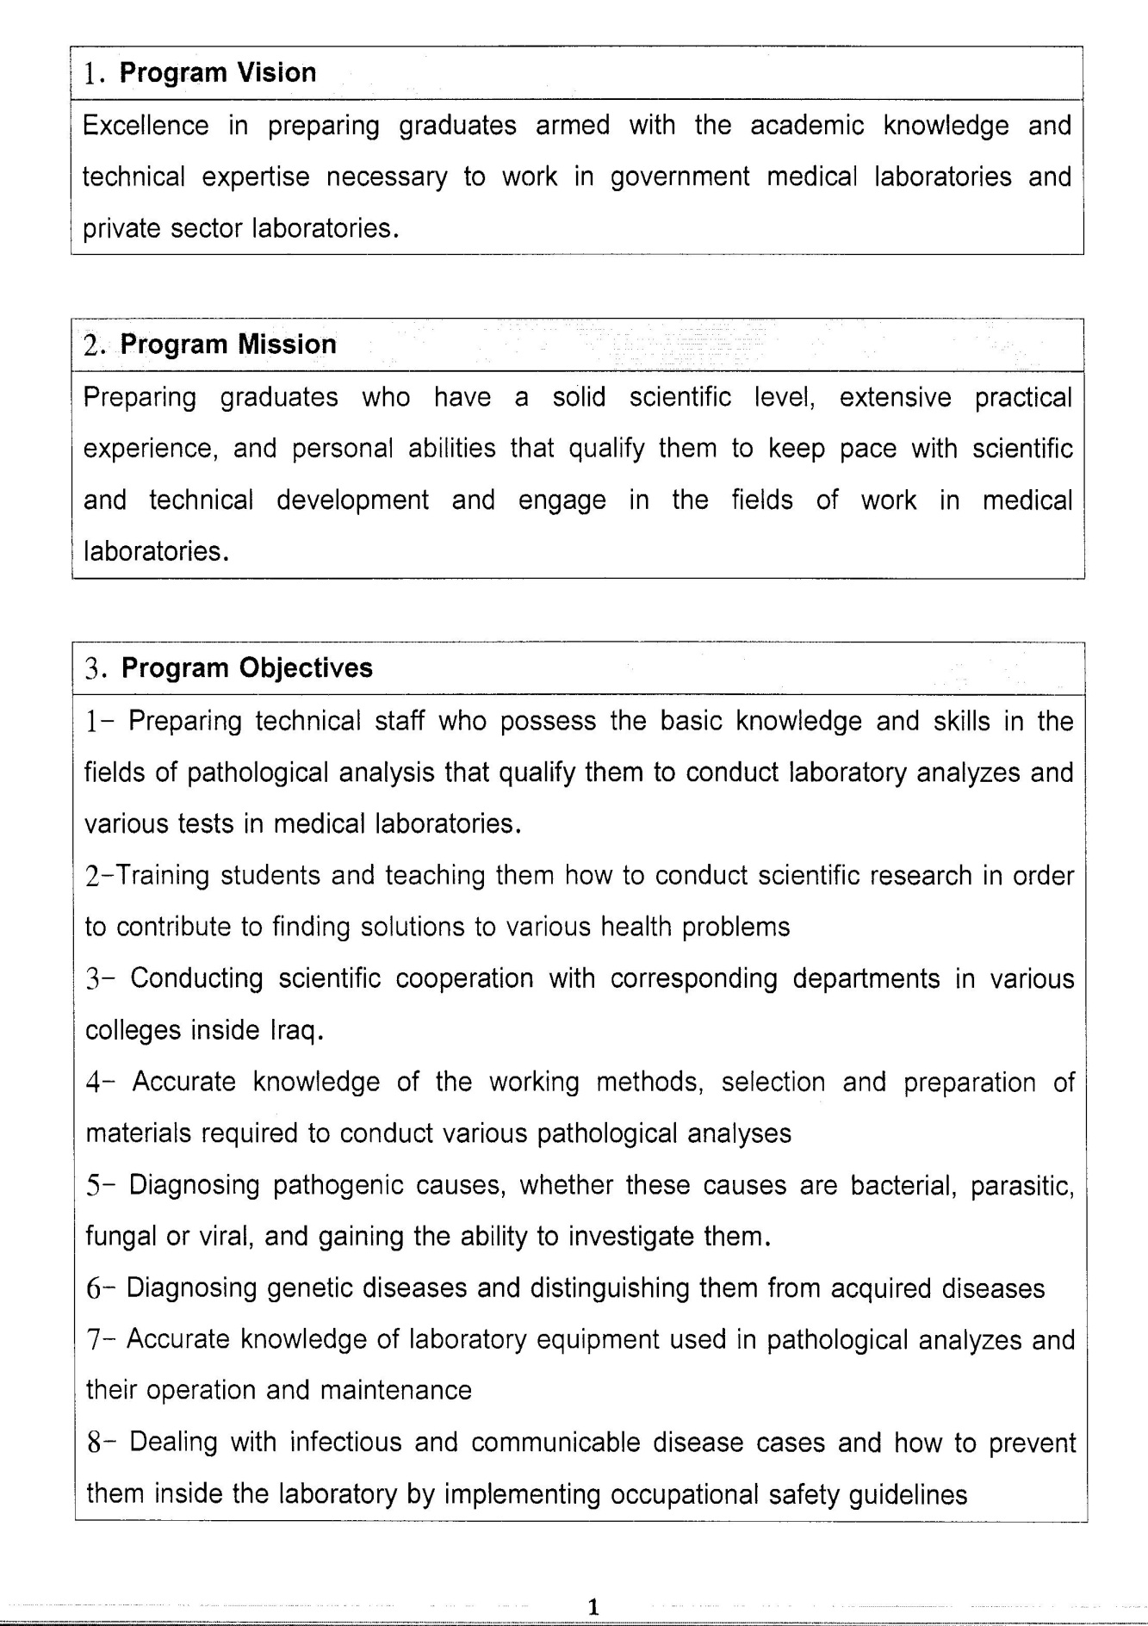

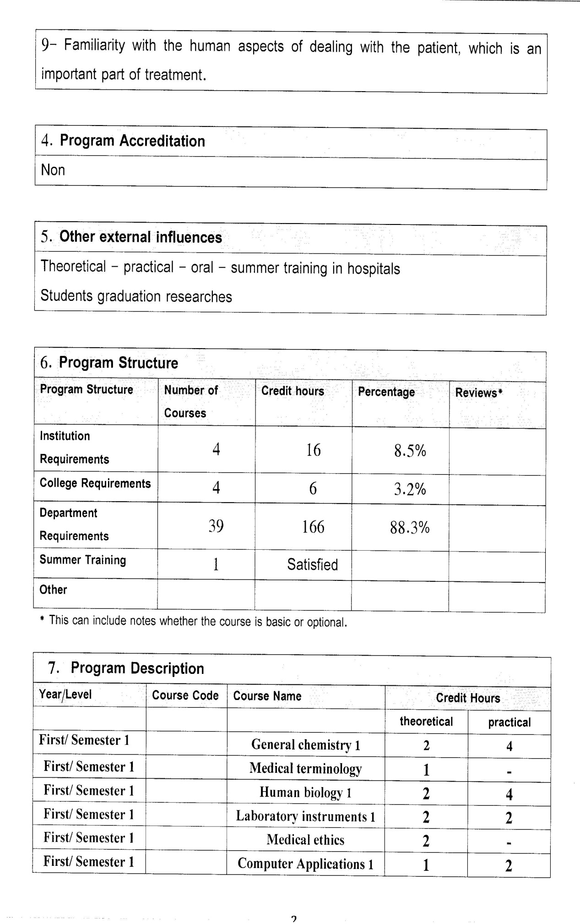

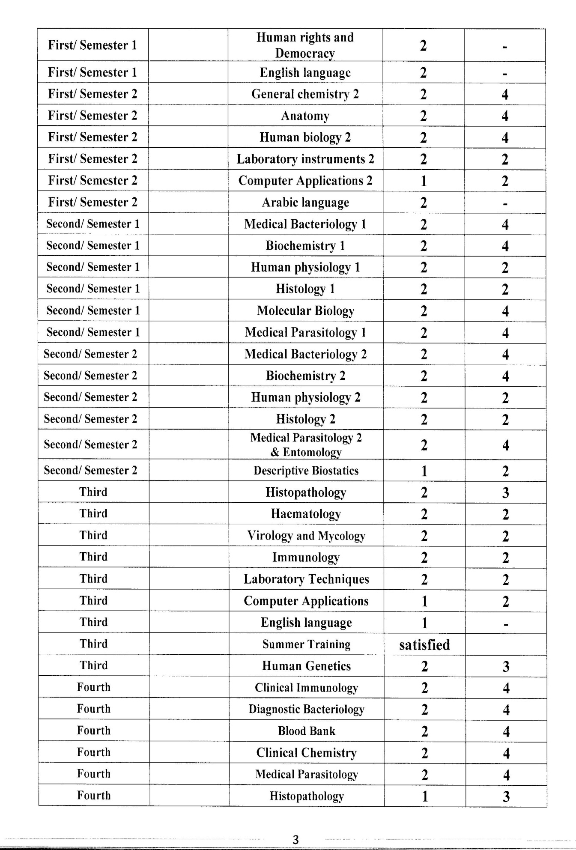

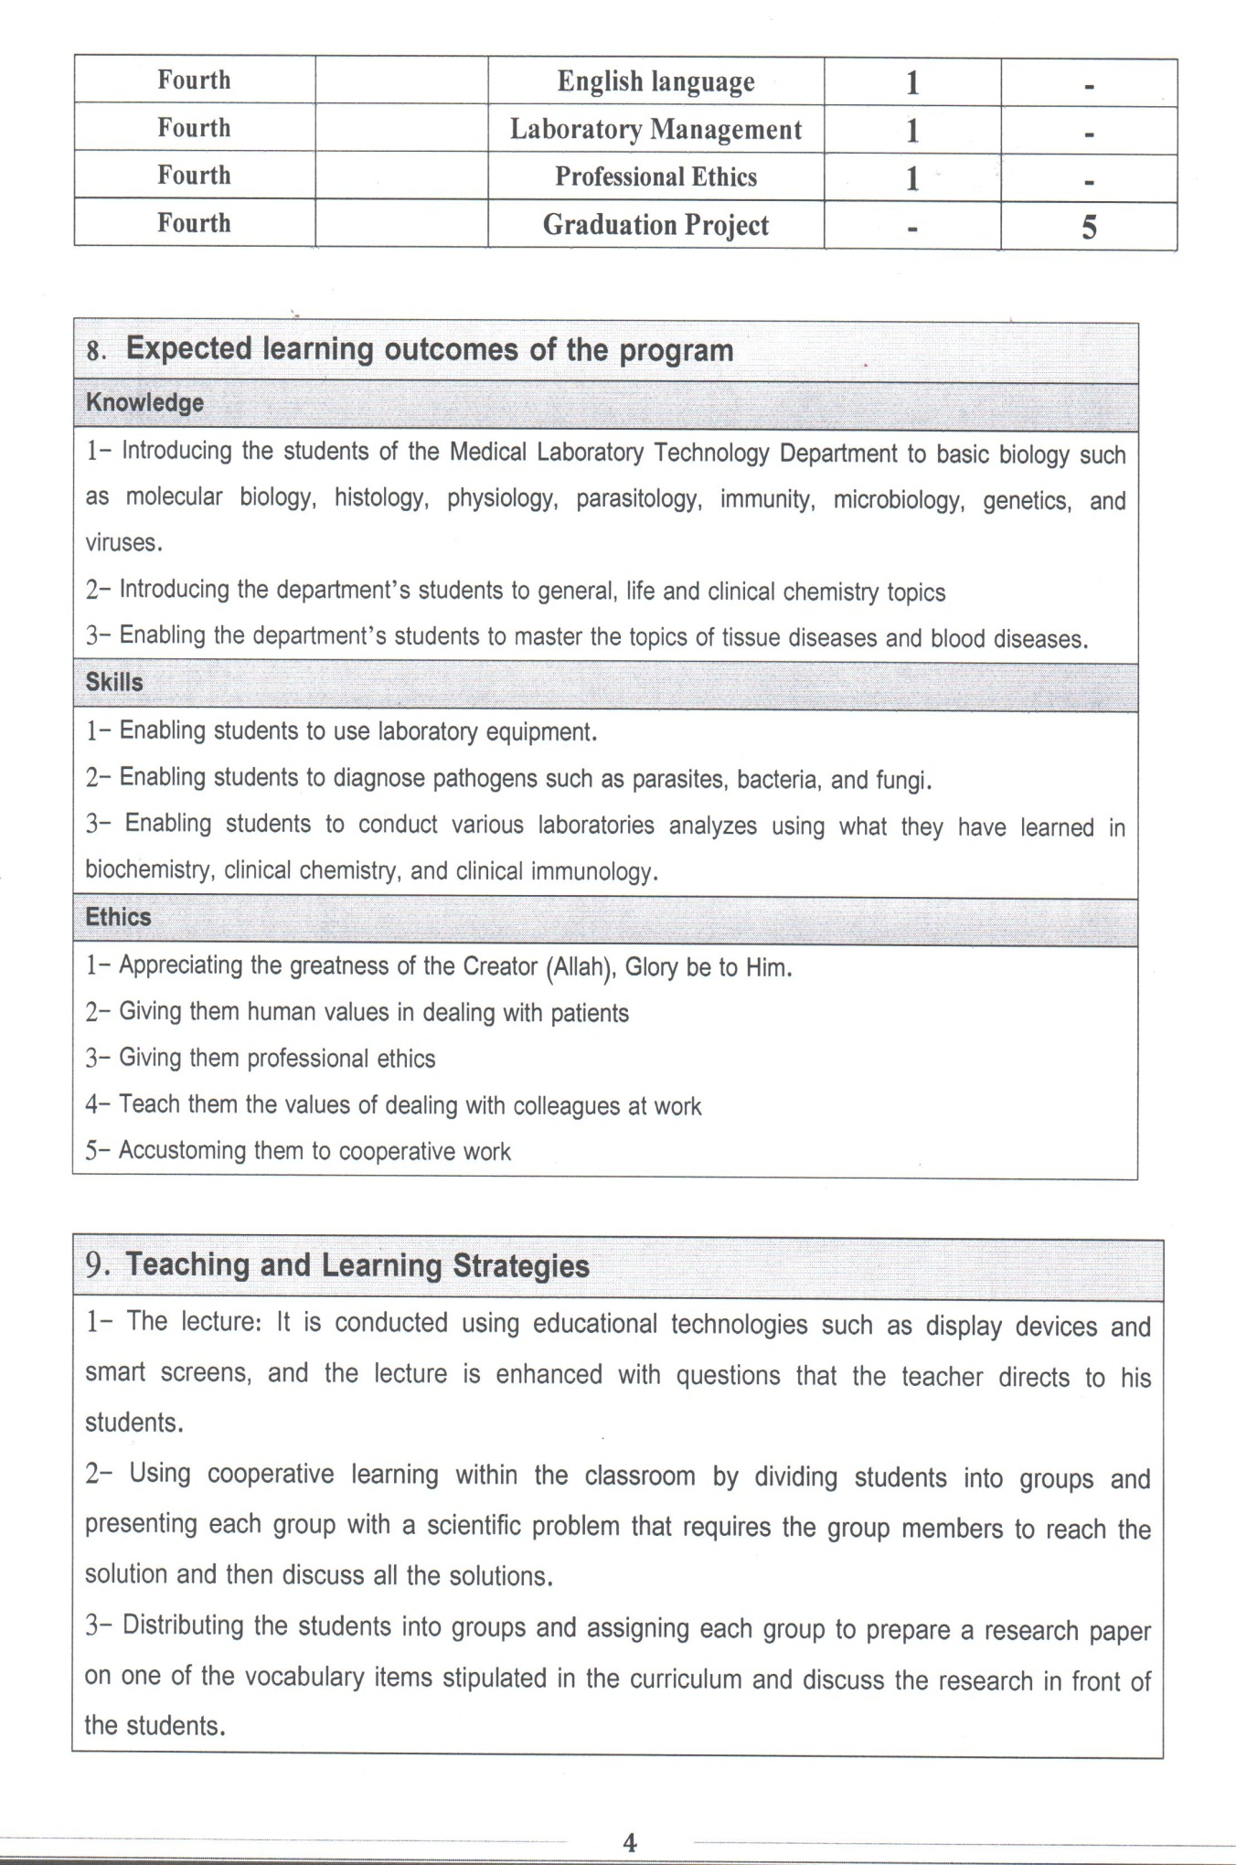

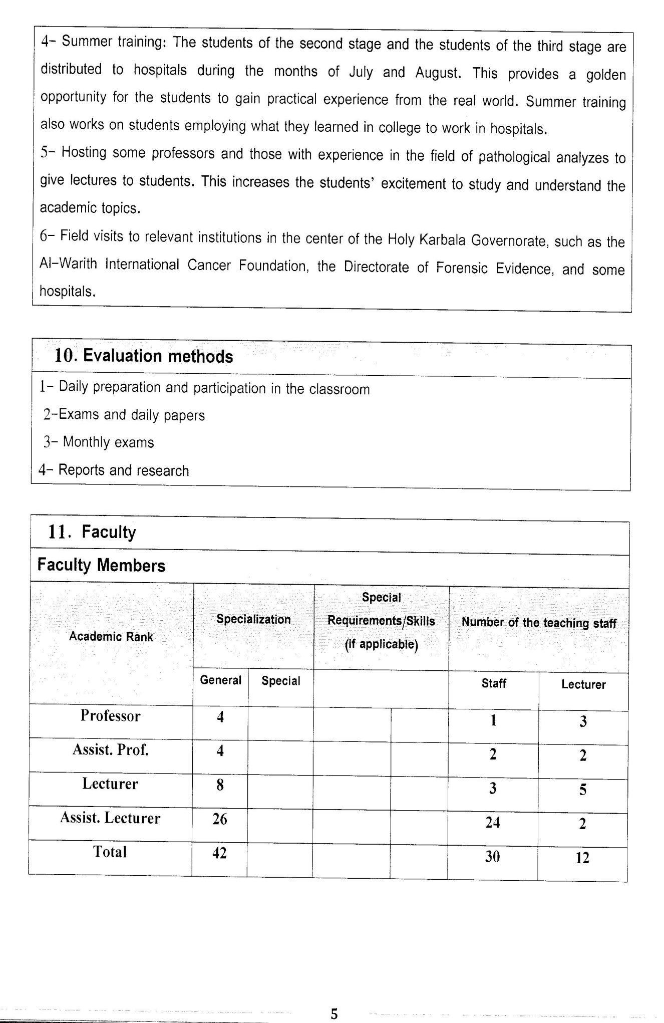

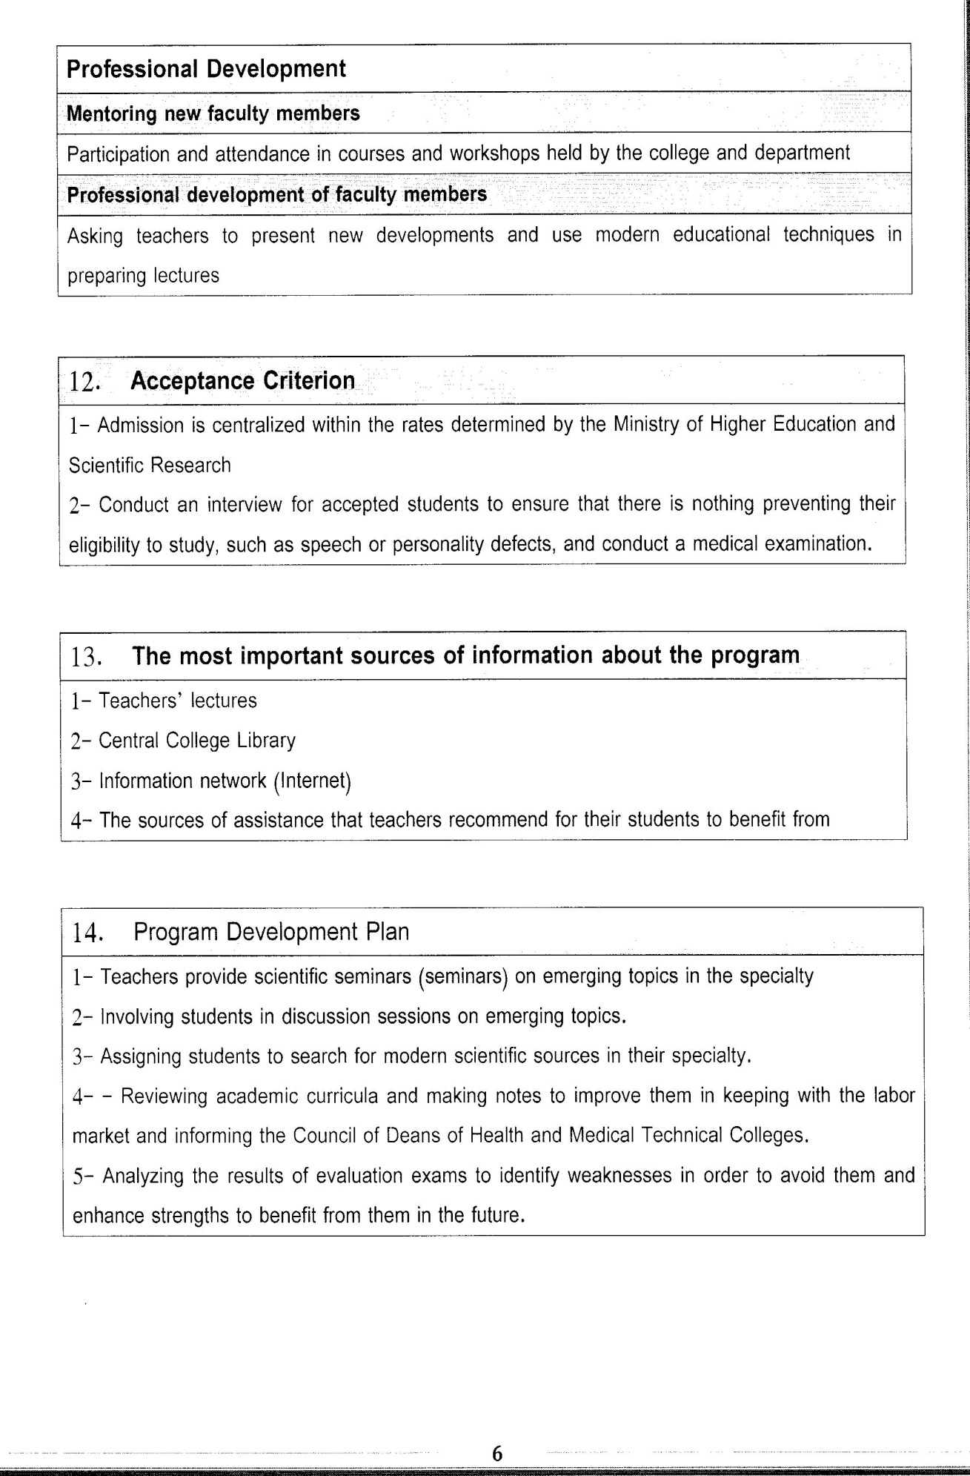

Course Description Form(2023-2024)
- Course Name:
Lab. Techniques
- Course Code:
- Semester / Year:
Third Year (Year)
- Description Preparation Date:
6 / 3 / 2024
- Available Attendance Forms:
- Number of Credit Hours (Total) / Number of Units (Total)
60 Hours
- Course administrator's name (mention all, if more than one name)
Name: Ashraf Ayyal Mutar
Email: dr.ashraf@alsafwa.edu.iq
- Course Objectives
Course Objectives
At the end of the academic year, the student should be able to:
1. Advanced tests in the field of various bodily fluids, such as urine, cerebrospinal fluid examination, and semen analyses.
2. Diagnostic immunological tests, such as the single immunodiffusion test.
3. Immunofluorescence assays and their applications in the field of microscopic and immunological diagnostics
4. Marking examinations with radioactive materials.
5. Various tests for immunological electrophoresis and its modifications.
6. Cellular immune tests such as phagocytosis, lymphocytic conversion, etc.
7. Techniques related to the preparation of immunochemical materials and methods of separation or preparation.
- Teaching and Learning Strategies
Strategy |  | 1. Providing students with the basics and supporting topics related to the pre-skills learning outcomes.  2. Applying the topics studied in theoretical lessons on the practical level.  3. Asking students to identify the types of mutations and types of inheritance patterns.
- Course Structure
Week | Hours |  | Required Learning Outcomes | Unit or subject name |  | Learning method | Evaluation method
First Semester
1 | 2practical |  | Understand  the lecture | Examination of urine |  | Lecture  Laboratory | Attendance  Daily exam
2 | 2practical |  | Understand  the lecture | Examination of stool |  | Lecture  Laboratory | Attendance  Daily exam
3 | 2practical |  | Understand  the lecture | Examination of sputum and swabs |  | Lecture  Laboratory | Attendance  Daily exam
4 | 2practical |  | Understand  the lecture | Examination of CSF & seminal fluid |  | Lecture  Laboratory | Attendance  Daily exam
5 | 2practical |  | Understand  the lecture | Viruses’ diagnosis |  | Lecture  Laboratory | Attendance  Daily exam
6 | 2practical |  | Understand  the lecture | PCR, hybridization, electrophoresis |  | Lecture  Laboratory | Attendance  Daily exam
7 | 2practical |  | Understand  the lecture | Cell and tissue culture |  | Lecture  Laboratory | Attendance  Daily exam
8 | 2practical |  | Understand  the lecture | Paper chromatography electrophoresis |  | Lecture  Laboratory | Attendance  Daily exam
9 | 2practical |  | Understand  the lecture | Examination of urine |  | Lecture  Laboratory | Attendance  Daily exam
10 | 2practical |  | Understand  the lecture | Examination of stool |  | Lecture  Laboratory | Attendance  Daily exam
11 | 2practical |  | Understand  the lecture | Examination of sputum and swabs |  | Lecture  Laboratory | Attendance  Daily exam
12 | 2practical |  | Understand  the lecture | Examination of CSF & seminal fluid |  | Lecture  Laboratory | Attendance  Daily exam
13 | 2practical |  | Understand  the lecture | Viruses’ diagnosis |  | Lecture  Laboratory | Attendance  Daily exam
14 | 2practical |  | Understand  the lecture | PCR, hybridization, electrophoresis |  | Lecture  Laboratory | Attendance  Daily exam
15 | 2practical |  | Understand  the lecture | Cell and tissue culture |  | Lecture  Laboratory | Attendance  Daily exam
Second Semester
1 | 2practical |  | Understand  the lecture | Liver function tests |  | Lecture  Laboratory | Attendance  Daily exam
2 | 2practical |  | Understand  the lecture | Renal profile tests |  | Lecture  Laboratory | Attendance  Daily exam
3 | 2practical |  | Understand  the lecture | Glucose &HBA1C tests |  | Lecture  Laboratory | Attendance  Daily exam
4 | 2practical |  | Understand  the lecture | Agglutination tests |  | Lecture  Laboratory | Attendance  Daily exam
5 | 2practical |  | Understand  the lecture | ELASA |  | Lecture  Laboratory | Attendance  Daily exam
6 | 2practical |  | Understand  the lecture | Inhibition test |  | Lecture  Laboratory | Attendance  Daily exam
7 | 2practical |  | Understand  the lecture | Common blood tests techniques |  | Lecture  Laboratory | Attendance  Daily exam
8 | 2practical |  | Understand  the lecture | Haemoglobinopathy tests |  | Lecture  Laboratory | Attendance  Daily exam
9 | 2practical |  | Understand  the lecture | Quality control of laboratory |  | Lecture  Laboratory | Attendance  Daily exam
- Course Evaluation
The following evaluation methods are adopted:
1. Theoretical and practical tests.
2. Reports.
3. Attendance and discussion.
The grades are distributed as follows:
1- Two monthly exams with a score of 20 points.
2-5 marks for activity and attendance.
3- 15 marks for the practical part, so the pursuit mark is 40.
4- The final exam score is distributed (35) points for the theoretical part and (25) points for the practical part, so the final score is 100.
- Learning and Teaching Resources
Required textbooks (curricular books, if any) |  |  |  |  | Not found
Main references (sources)
Recommended books and references (scientific journals, reports...)
Electronic References, Websites

