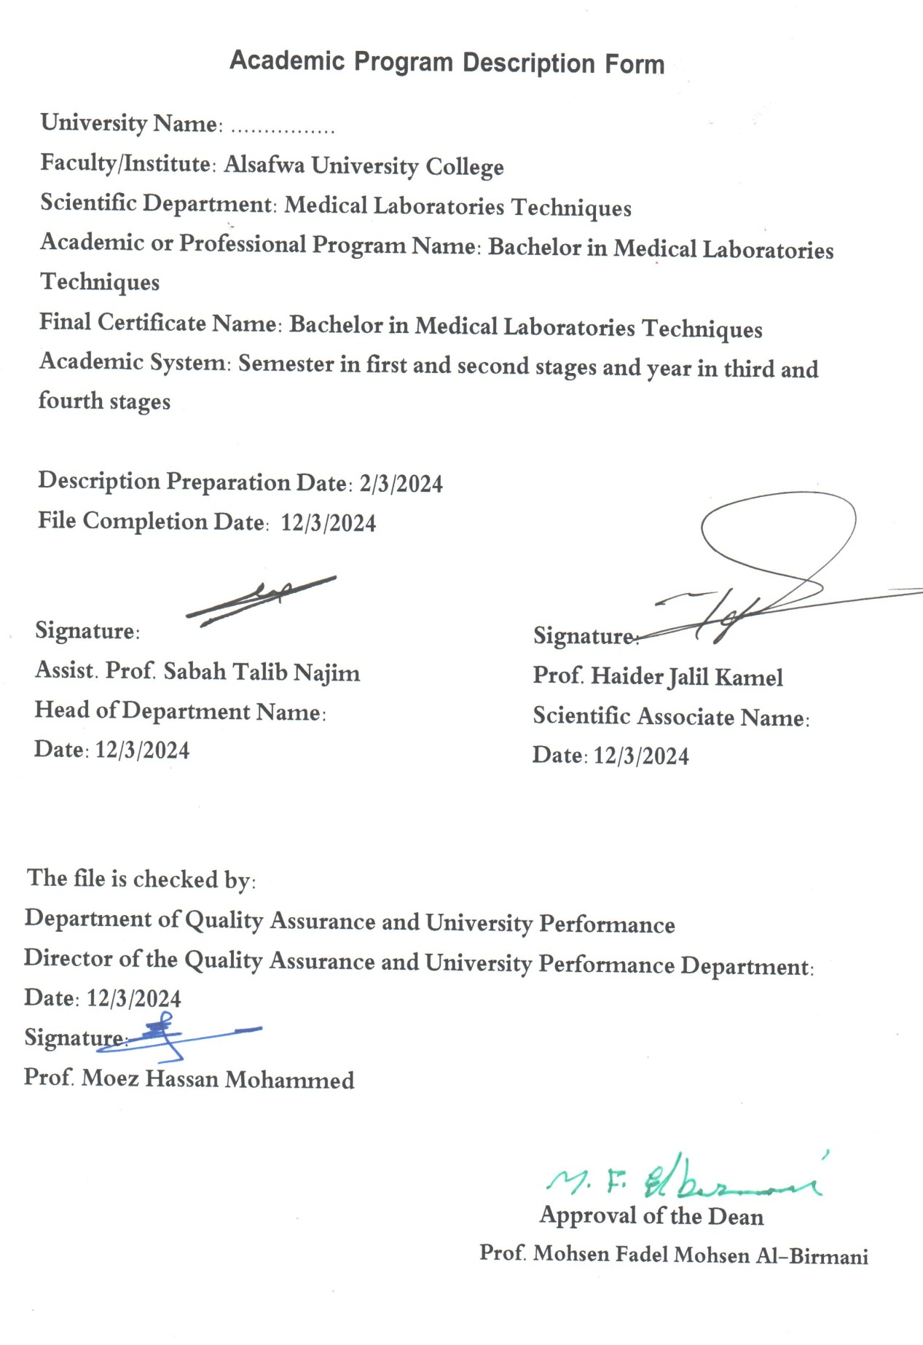

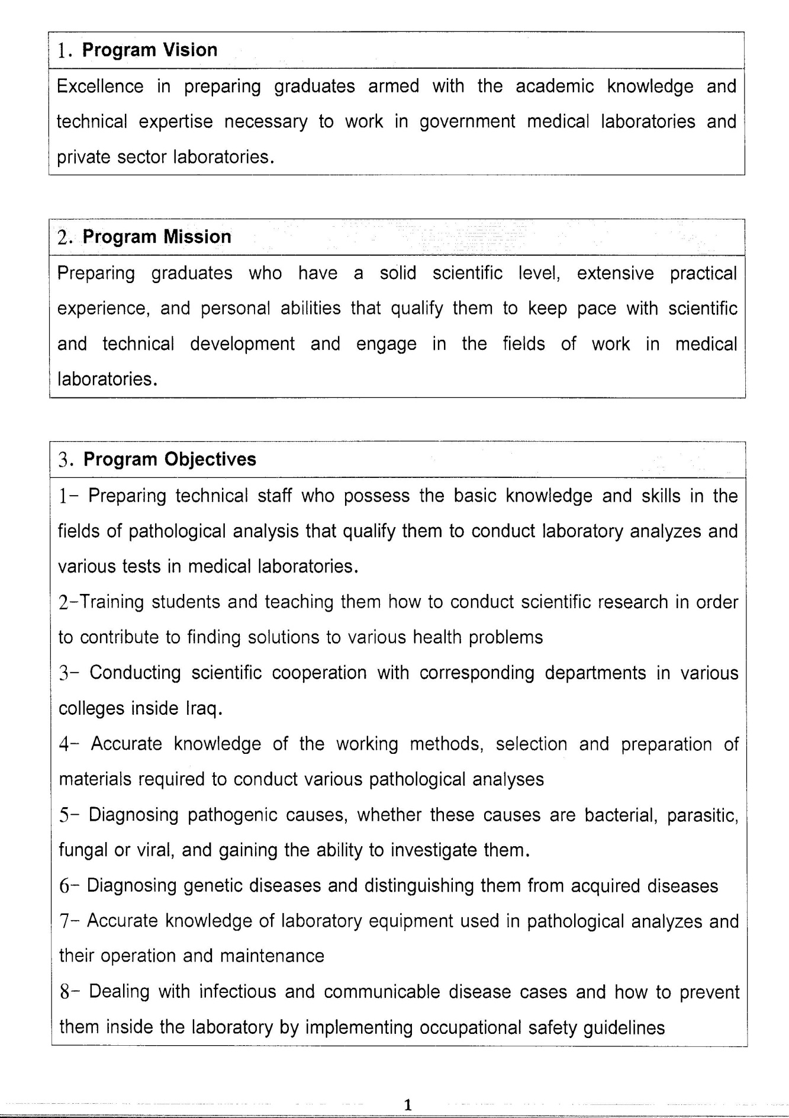

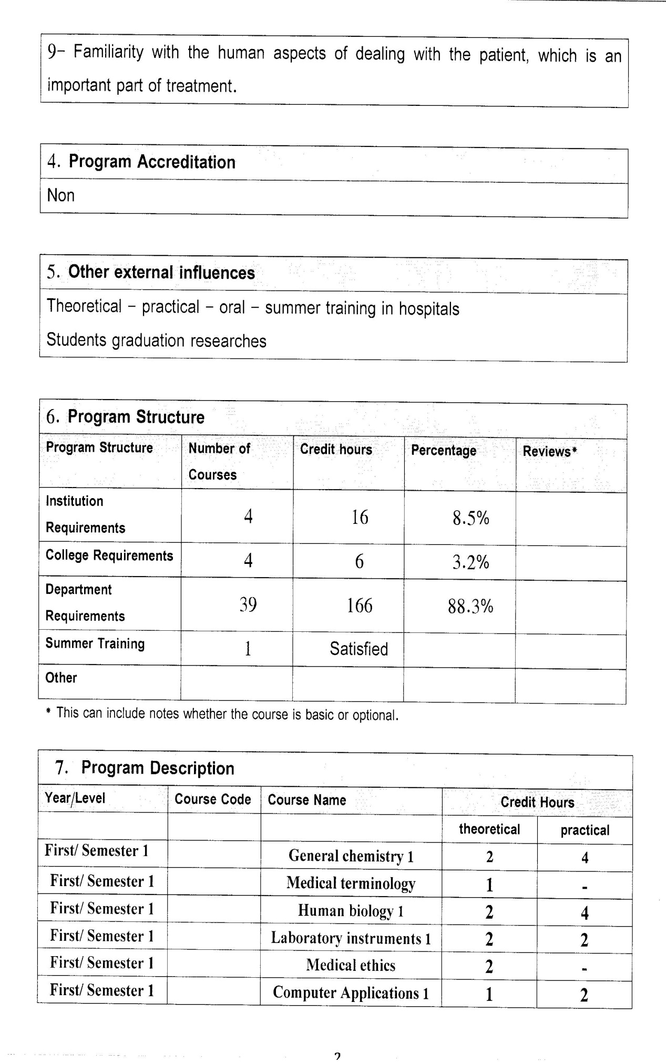

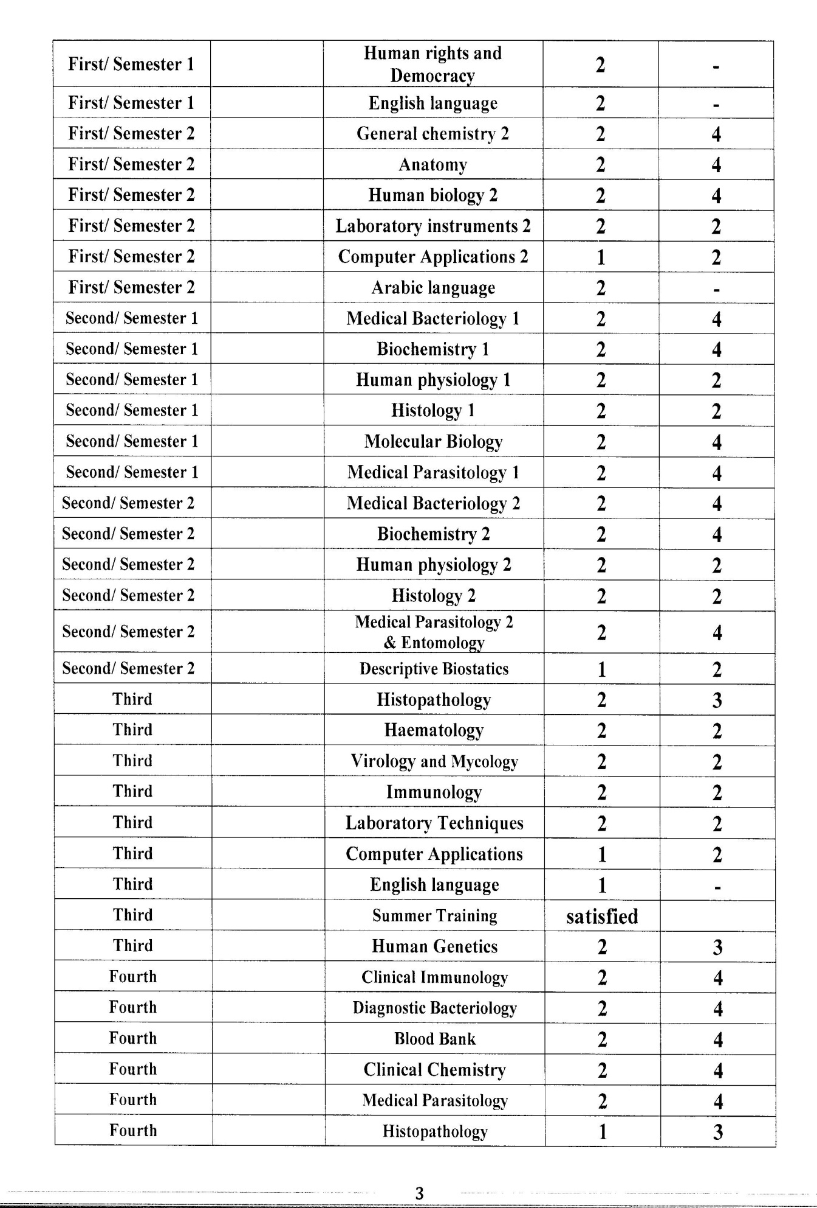

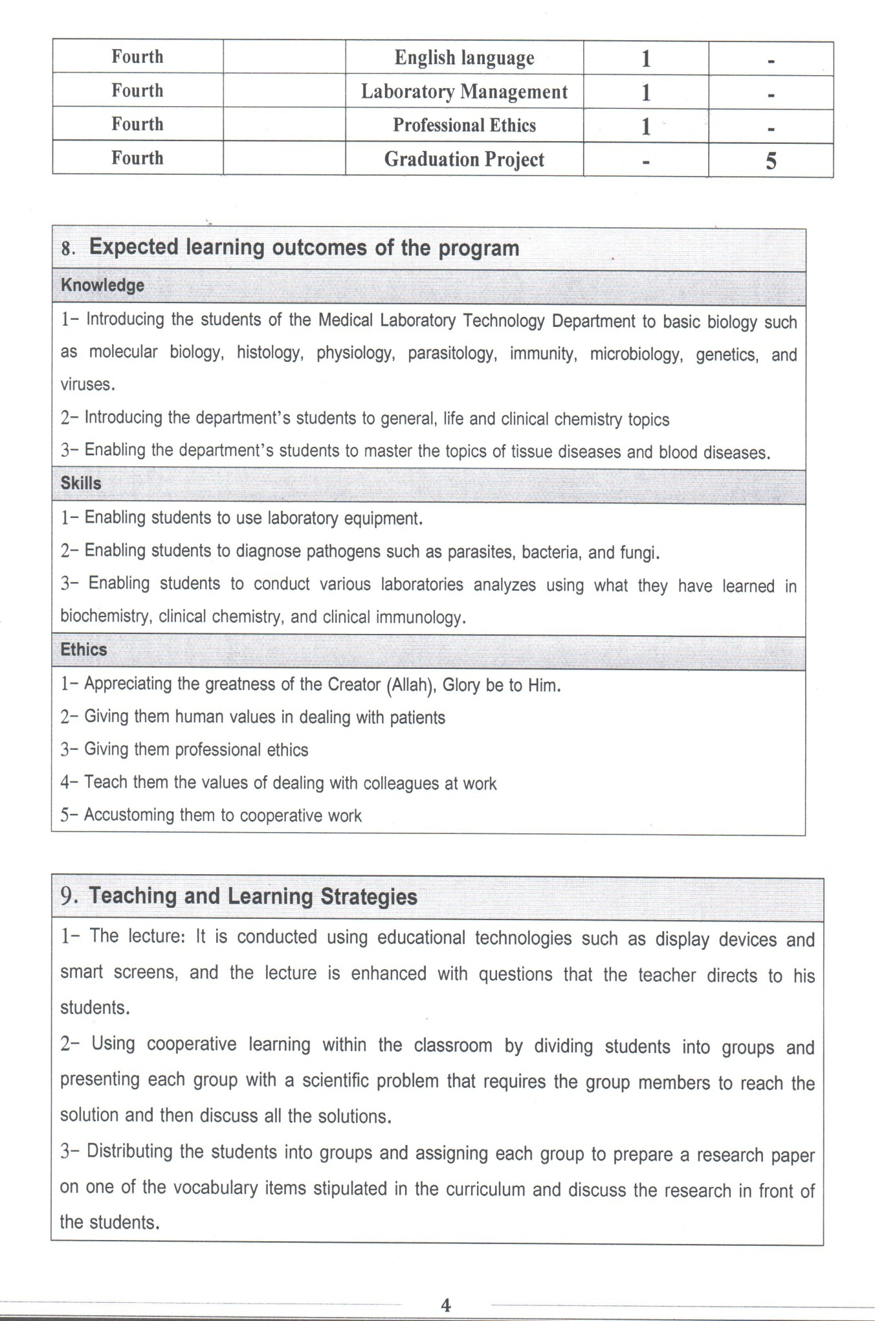

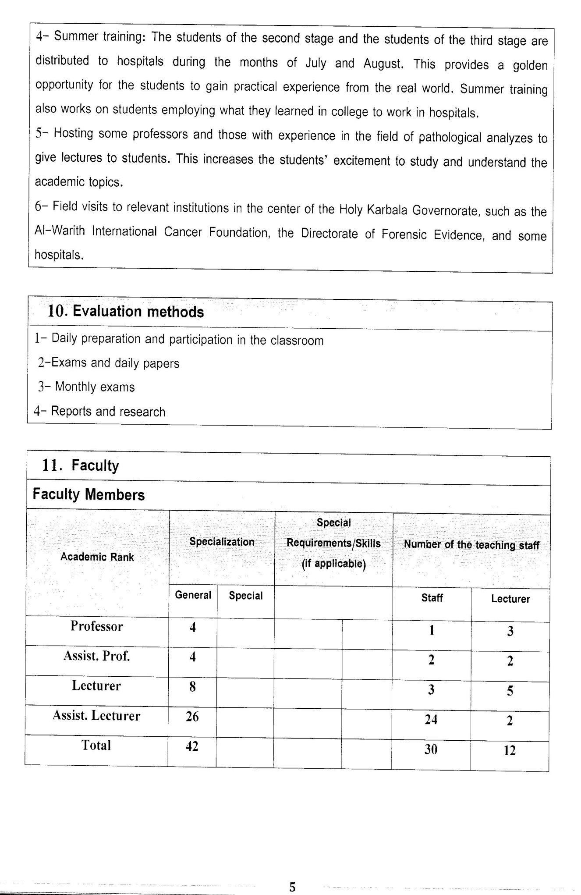

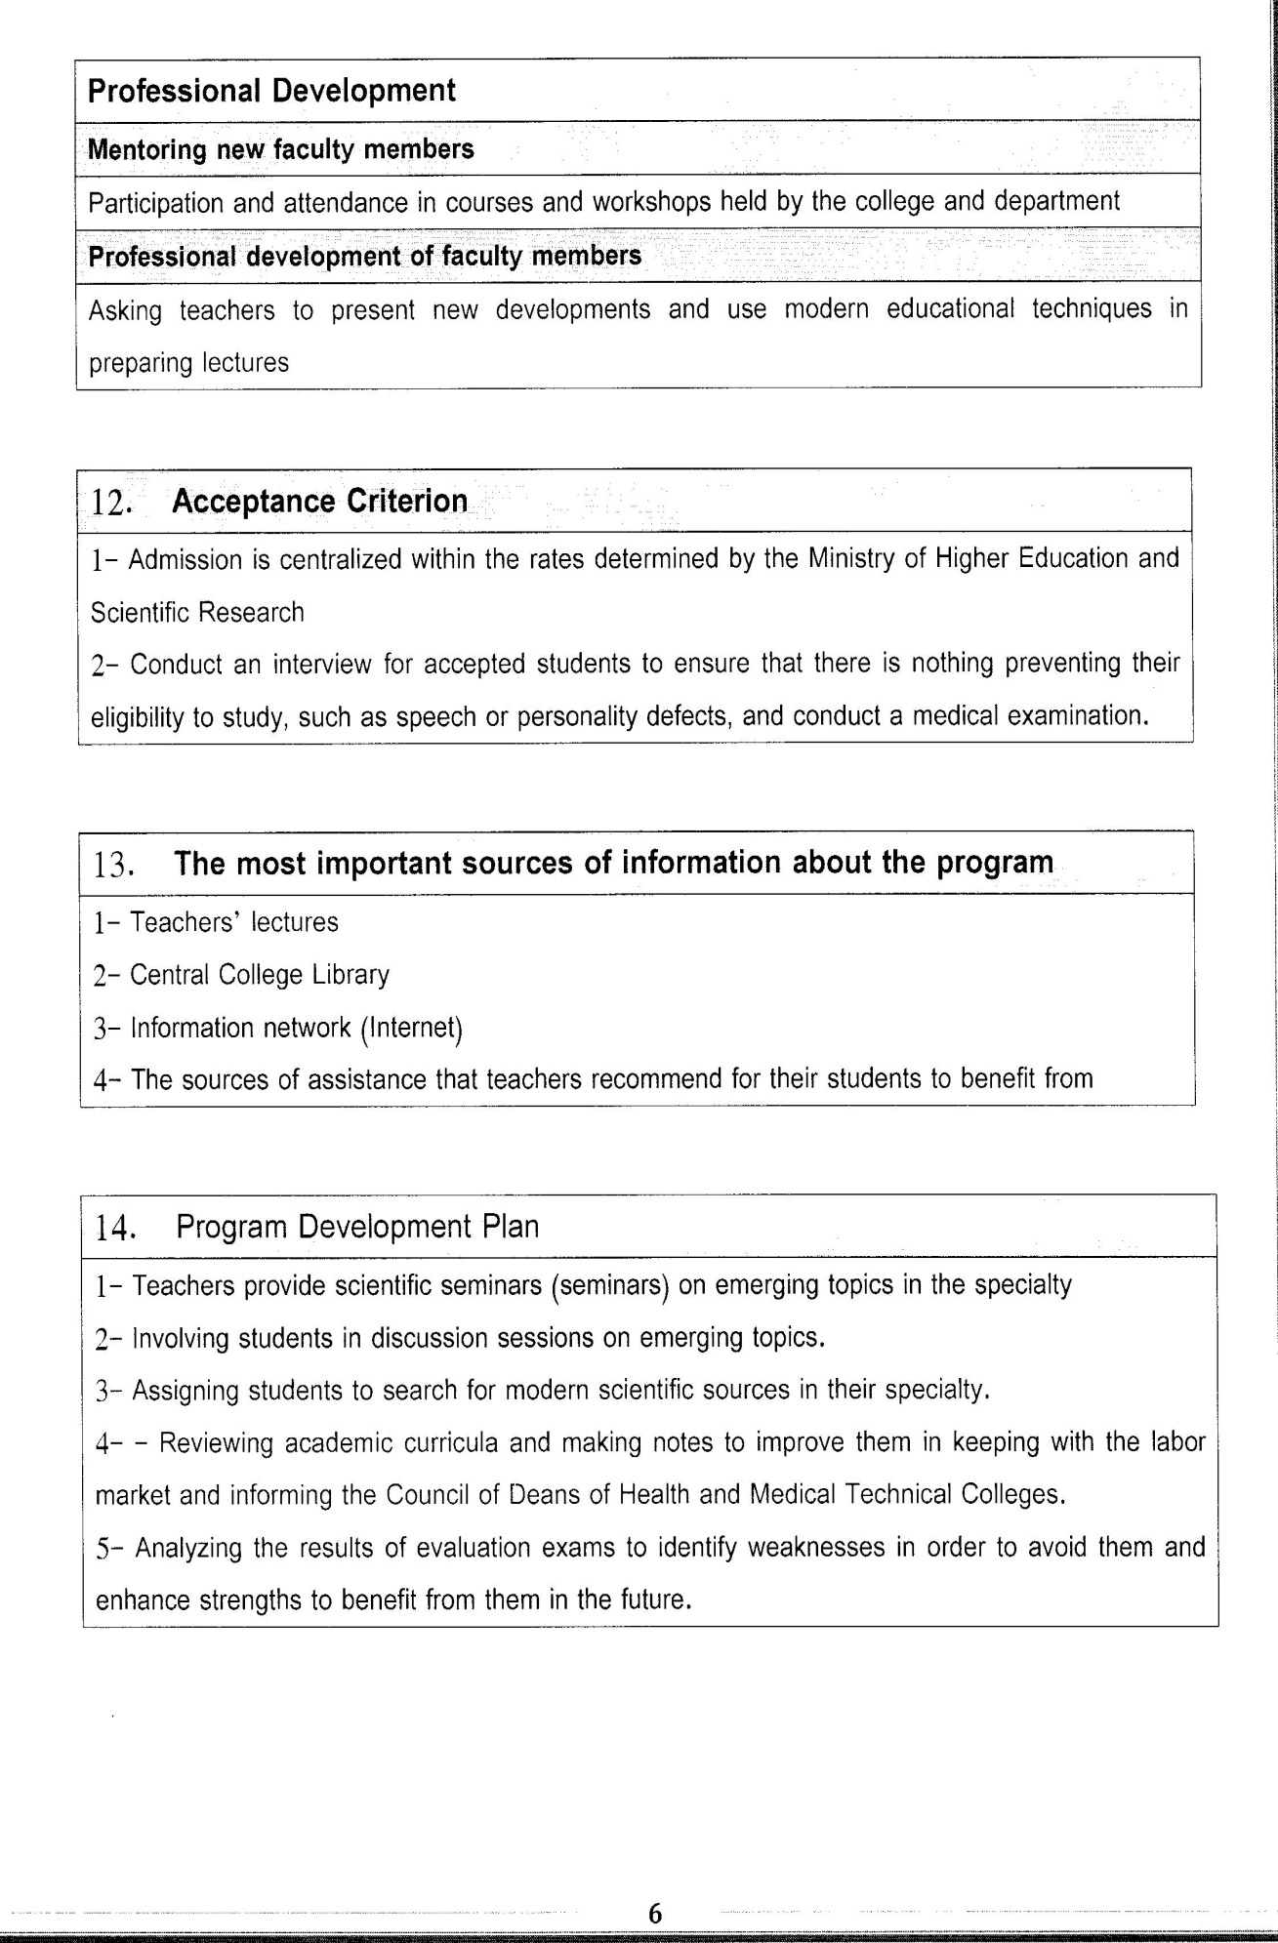

Course Description Form(2023-2024)
- Course Name:
Medical parasitology
- Course Code:
- Semester / Year:
Third Year (Year)
- Description Preparation Date:
6 / 3 / 2024
- Available Attendance Forms:
- Number of Credit Hours (Total) / Number of Units (Total)
120 Hours
- Course administrator's name (mention all, if more than one name)
Name: prof. Dr. Ali hussain makki almammuri
Email: alihussain@alsafwa.edu.iq
- Course Objectives
Course Objectives
At the end of the academic year, the student should be able to:
1. Knowledge and understanding of elementary animals.
2. Know and understand helminth parasites.
3. Knowledge and understanding of primary parasitological diagnosis.
4. Know and understand helminth diagnosis.
5. Knowledge and understanding of prevention.
6. Knowledge and understanding of health education.
7. Know and understand the life cycles of parasites.
8. Knowledge and understanding of medications that affect parasites.
9. Know and understand the danger of parasites to society..
- Teaching and Learning Strategies
Strategy |  | . Providing students with the basics and supporting topics related to the pre-skills learning outcomes.  2. Applying the topics studied in theoretical lessons on the practical level.  3. Asking students to identify the types of medical parasites.
- Course Structure
Week | Hours |  | Required Learning Outcomes | Unit or subject name |  | Learning method | Evaluation method
First Semester
1 | 2practical+2 theoretical |  | Understand  the lecture | Initial definitions of parasites |  | Lecture  Laboratory | Attendance  Daily exam
2 | 2practical+2 theoretical |  | Understand  the lecture | Classification of parasites |  | Lecture  Laboratory | Attendance  Daily exam
3 | 2practical+2 theoretical |  | Understand  the lecture | Epidemiological |  | Lecture  Laboratory | Attendance  Daily exam
4 | 2practical+2 theoretical |  | Understand  the lecture | Type of life cycle |  | Lecture  Laboratory | Attendance  Daily exam
5 | 2practical+2 theoretical |  | Understand  the lecture | G.lamblia |  | Lecture  Laboratory | Attendance  Daily exam
6 | 2practical+2 theoretical |  | Understand  the lecture | Trichomonas sp |  | Lecture  Laboratory | Attendance  Daily exam
7 | 2practical+2 theoretical |  | Understand  the lecture | E,nana |  | Lecture  Laboratory | Attendance  Daily exam
8 | 2practical+2 theoretical |  | Understand  the lecture | Leishmania sp |  | Lecture  Laboratory | Attendance  Daily exam
9 | 2practical+2 theoretical |  | Understand  the lecture | Toxoplasma sp |  | Lecture  Laboratory | Attendance  Daily exam
10 | 2practical+2 theoretical |  | Understand  the lecture | Plasmodium sp |  | Lecture  Laboratory | Attendance  Daily exam
11 | 2practical+2 theoretical |  | Understand  the lecture | Trypanosoma sp |  | Lecture  Laboratory | Attendance  Daily exam
12 | 2practical+2 theoretical |  | Understand  the lecture | Cryptosporidium sp |  | Lecture  Laboratory | Attendance  Daily exam
13 | 2practical+2 theoretical |  | Understand  the lecture | Balantidium sp |  | Lecture  Laboratory | Attendance  Daily exam
14 | 2practical+2 theoretical |  | Understand  the lecture | Iodomoeba bushilii |  | Lecture  Laboratory | Attendance  Daily exam
15 | 2practical+2 theoretical |  | Understand  the lecture | Entamoeba histolytica |  | Lecture  Laboratory | Attendance  Daily exam
Second Semester
1 | 2practical+2 theoretical |  | Understand  the lecture | Fasciola hepatica |  | Lecture  Laboratory | Attendance  Daily exam
2 | 2practical+2 theoretical |  | Understand  the lecture | F.gigantica |  | Lecture  Laboratory | Attendance  Daily exam
3 | 2practical+2 theoretical |  | Understand  the lecture | Clonoriches sp |  | Lecture  Laboratory | Attendance  Daily exam
4 | 2practical+2 theoretical |  | Understand  the lecture | Schistosoma sp |  | Lecture  Laboratory | Attendance  Daily exam
5 | 2practical+2 theoretical |  | Understand  the lecture | D.latum |  | Lecture  Laboratory | Attendance  Daily exam
6 | 2practical+2 theoretical |  | Understand  the lecture | Teania solium |  | Lecture  Laboratory | Attendance  Daily exam
7 | 2practical+2 theoretical |  | Understand  the lecture | T.saginata |  | Lecture  Laboratory | Attendance  Daily exam
8 | 2practical+2 theoretical |  | Understand  the lecture | Echinococcus granulosis |  | Lecture  Laboratory | Attendance  Daily exam
9 | 2practical+2 theoretical |  | Understand  the lecture | Heterophyes sp |  | Lecture  Laboratory | Attendance  Daily exam
10 | 2practical+2 theoretical |  | Understand  the lecture | Hymenolepis nana |  | Lecture  Laboratory | Attendance  Daily exam
11 | 2practical+2 theoretical |  | Understand  the lecture | D. caninium |  | Lecture  Laboratory | Attendance  Daily exam
12 | 2practical+2 theoretical |  | Understand  the lecture | Ascaris |  | Lecture  Laboratory | Attendance  Daily exam
13 | 2practical+2 theoretical |  | Understand  the lecture | Ancylostoma |  | Lecture  Laboratory | Attendance  Daily exam
14 | 2practical+2 theoretical |  | Understand  the lecture | Wuchereria bancuft |  | Lecture  Laboratory | Attendance  Daily exam
15 | 2practical+2 theoretical |  | Understand  the lecture | Enterobius vermicularis |  | Lecture  Laboratory | Attendance  Daily exam
- Course Evaluation
The following evaluation methods are adopted:
1. Theoretical and practical tests.
2. Reports.
3. Attendance and discussion.
The grades are distributed as follows:
1- Two monthly exams with a score of 20 points.
2-5 marks for activity and attendance.
3- 15 marks for the practical part, so the pursuit mark is 40.
4- The final exam score is distributed (35) points for the theoretical part and (25) points for the practical part, so the final score is 100.
- Learning and Teaching Resources
Required textbooks (curricular books, if any) |  |  |  |  | Not found
Main references (sources) |  |  |  |  | Medical Parasitology, Dawit Assafa, Ephrem Kibru, S. Nagesh,  Solomon Gebreselassie, Fetene Deribe, Jemal Ali  Jimma University  Debub University  University of Gondar  In collaboration with the Ethiopia Public Health Training Initiative, The Carter Center,  the Ethiopia Ministry of Health, and the Ethiopia Ministry of Education
Recommended books and references (scientific journals, reports...)
Electronic References, Websites

