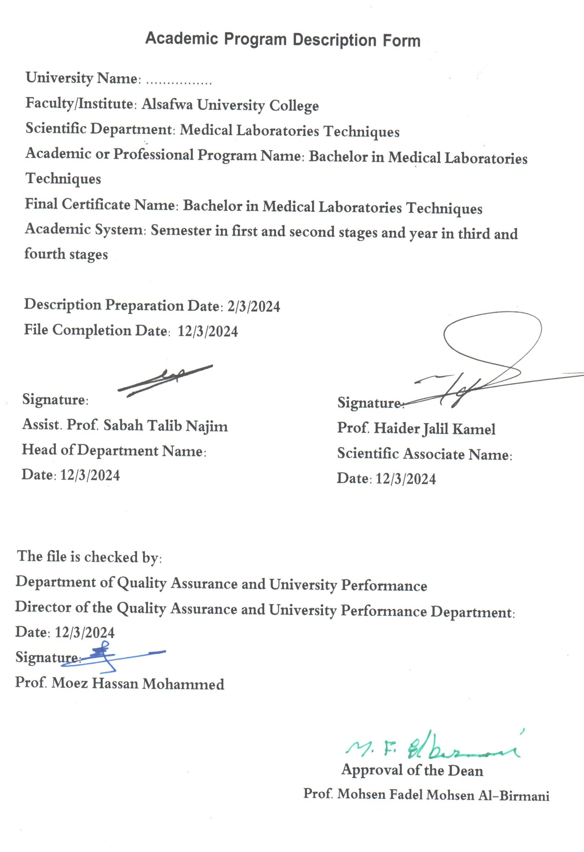

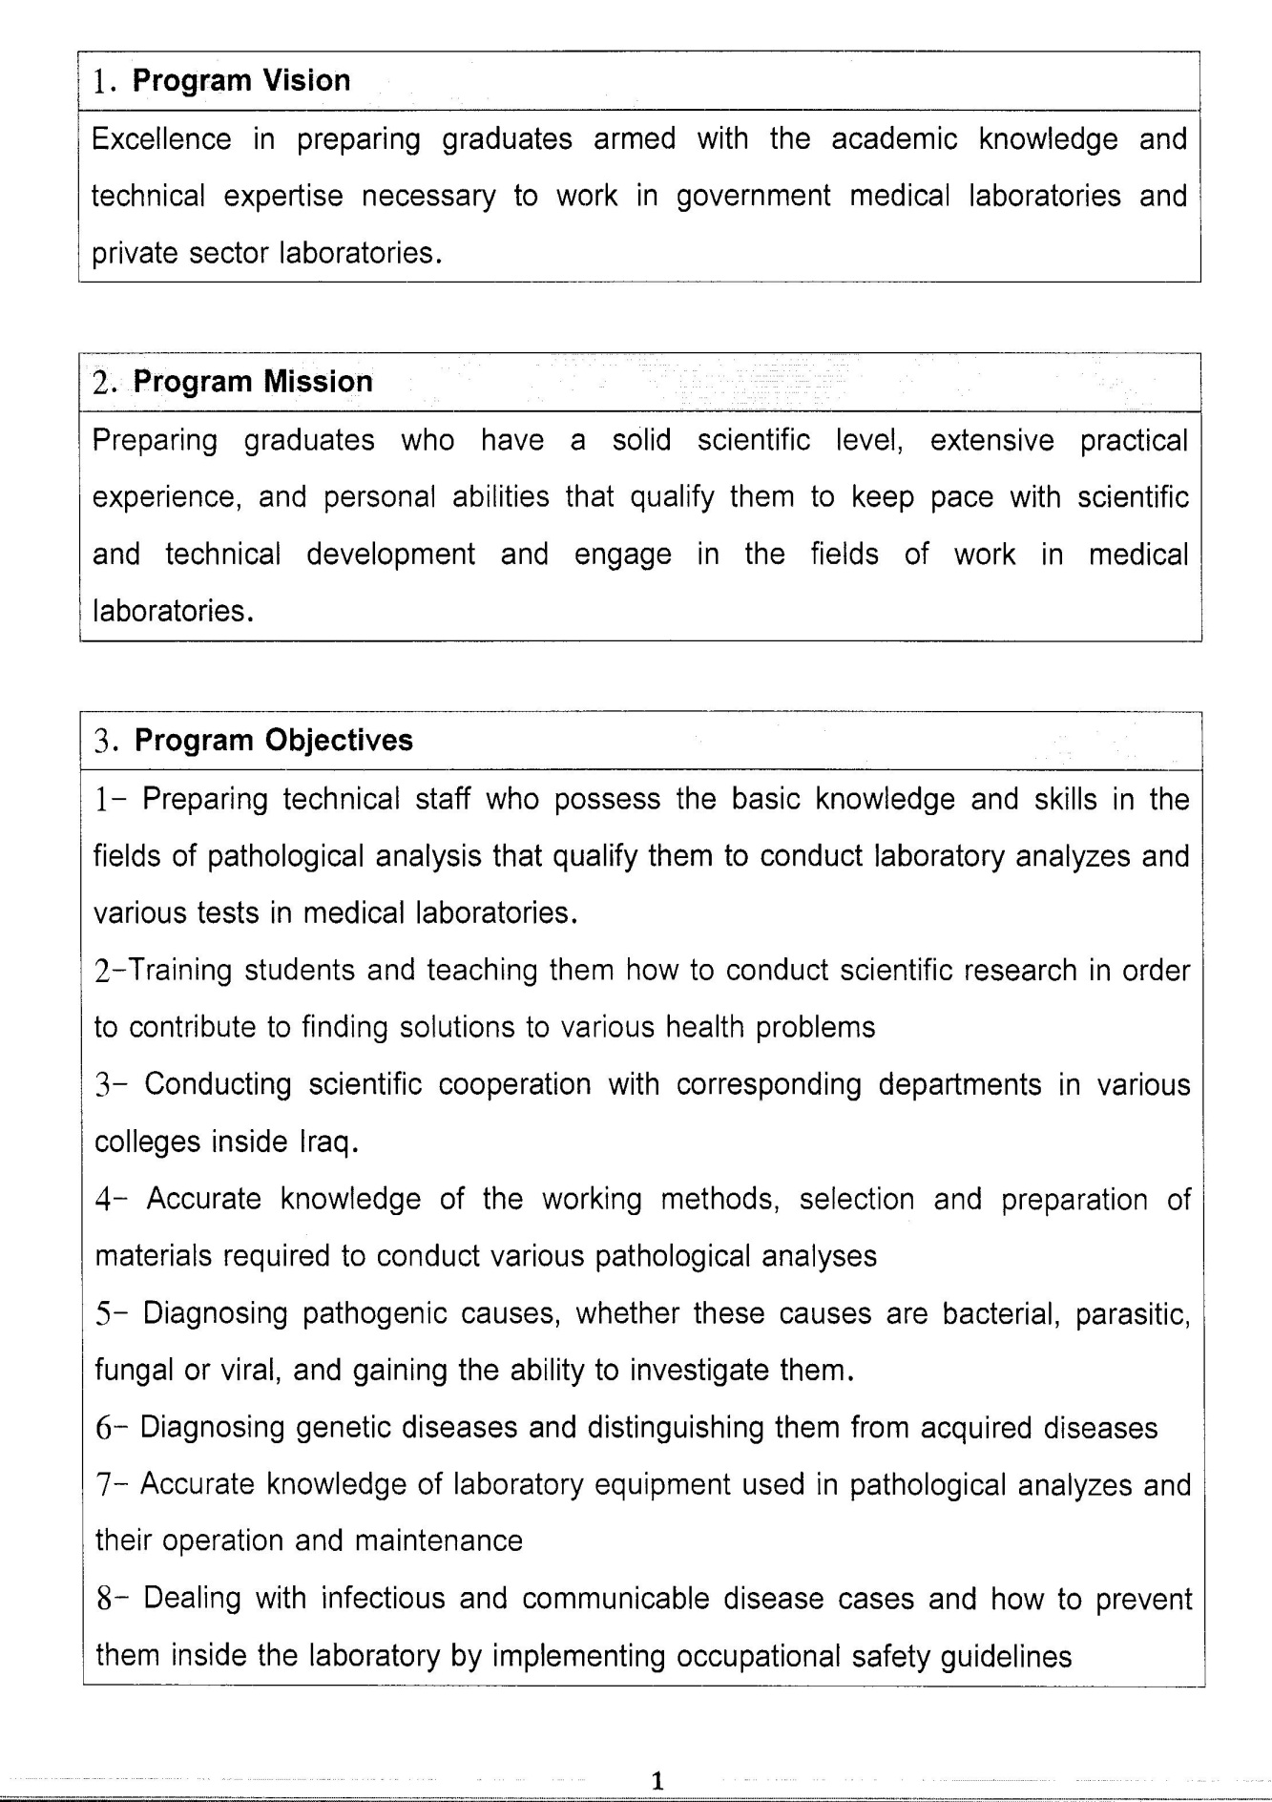

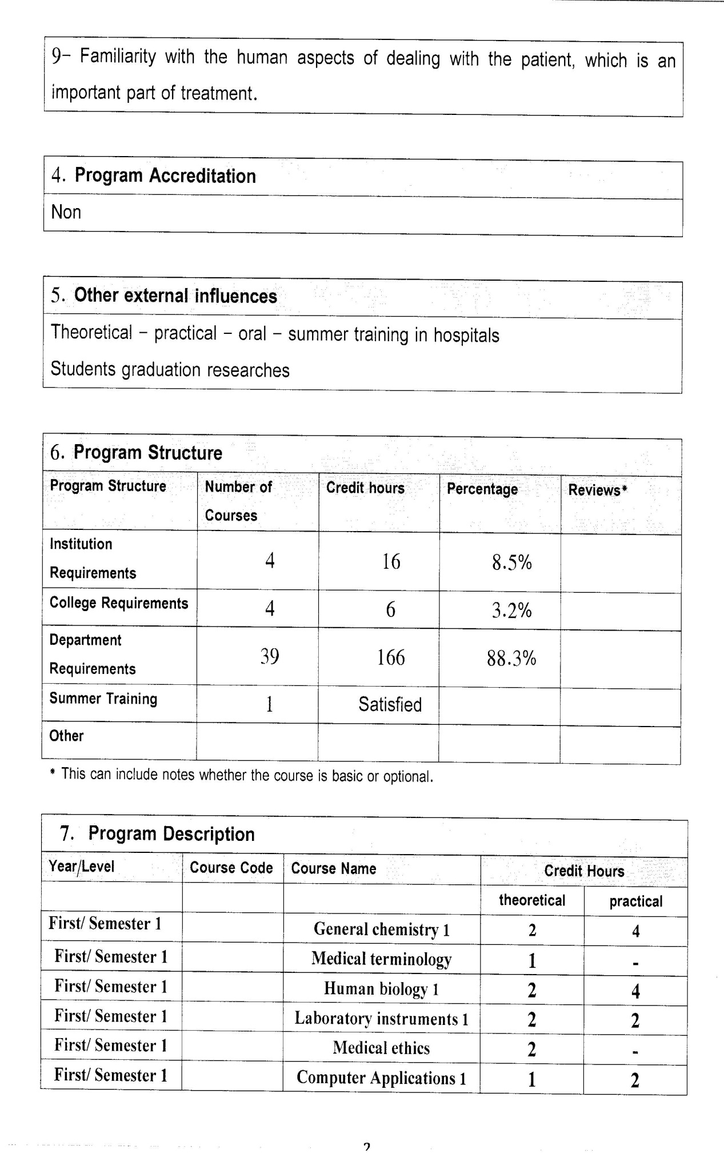

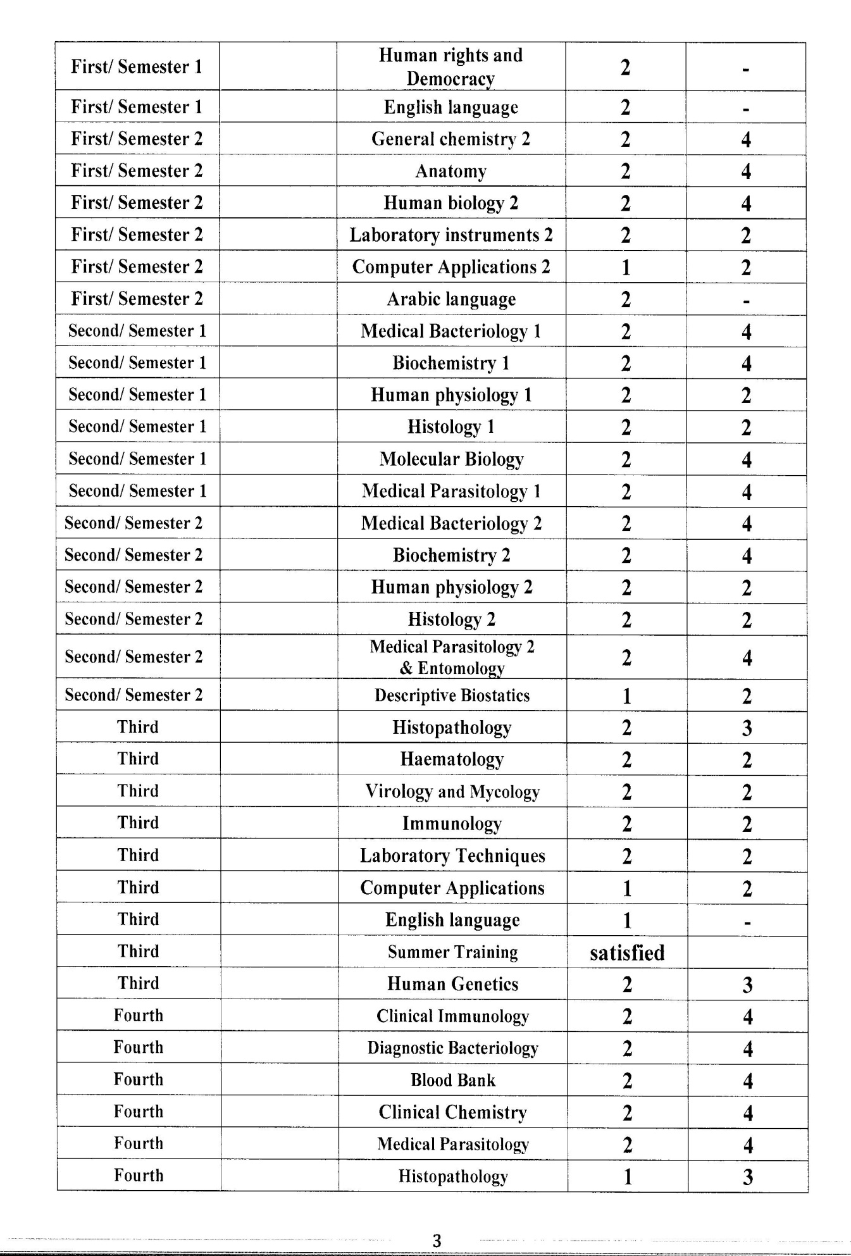

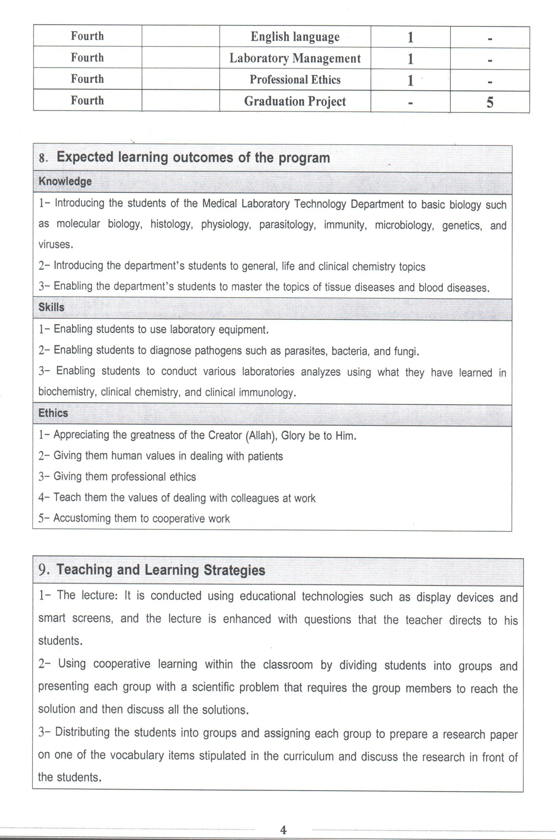

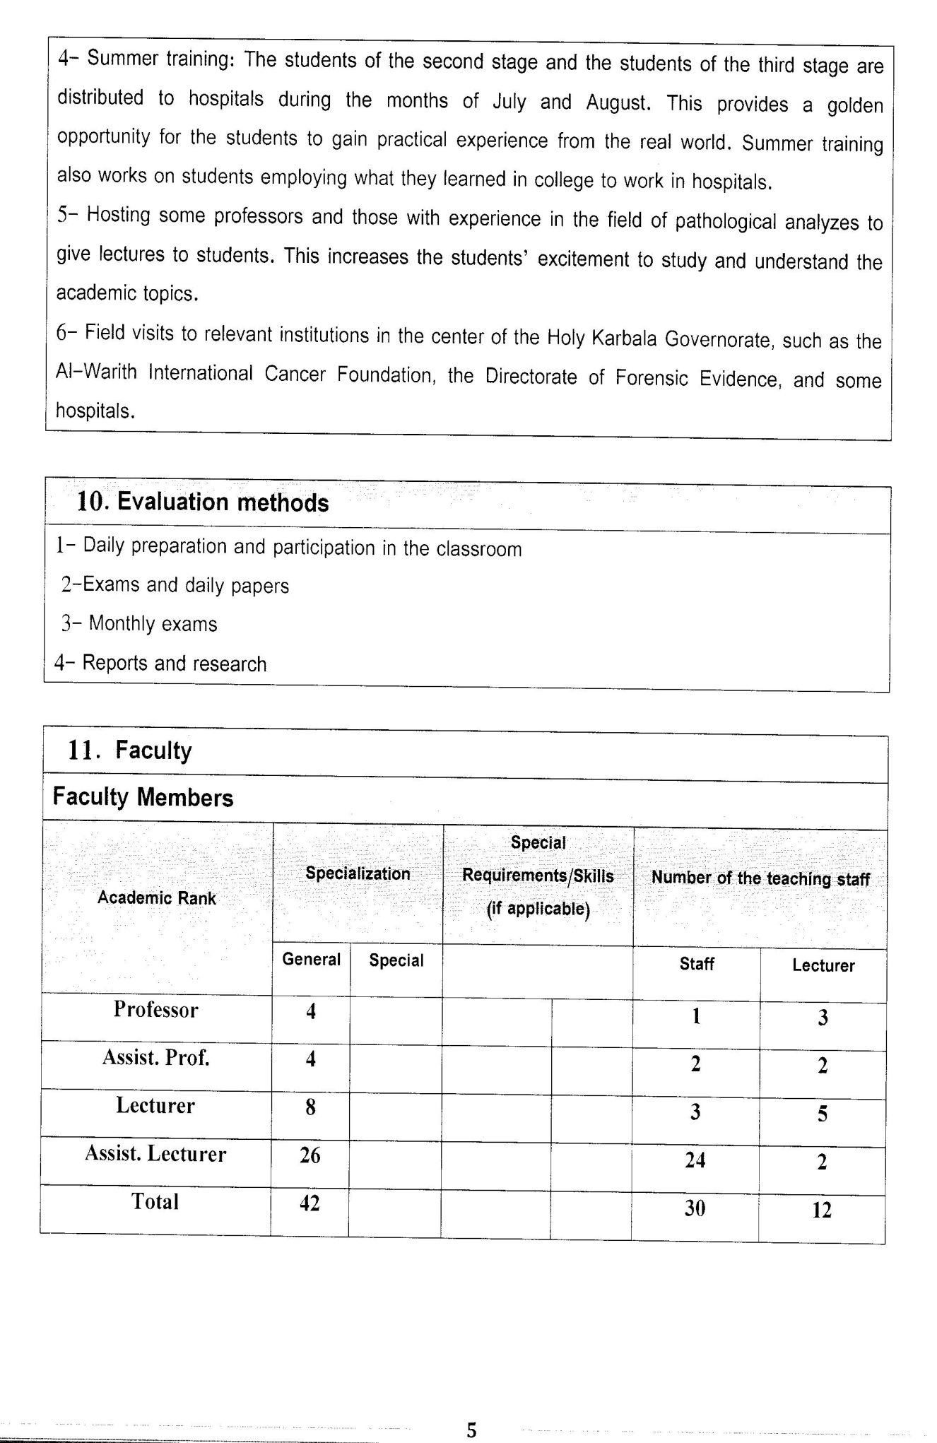



Course Description Form(2023 – 2024)
- Course Name:
Clinical Biochemistry
- Course Code:
- Semester / Year:
Third Year (Year)
- Description Preparation Date:
13 / 3 / 2024
- Available Attendance Forms:
- Number of Credit Hours (Total) / Number of Units (Total)
120 Hours
- Course administrator's name (mention all, if more than one name)
Name: Prof.Dr.Alaa Frak Hussain
Email: alaa.frak@uokerbala.edu.iq
- Course Objectives
Course Objectives
At the end of the academic year, the student should be able to:
1. Knowing and understanding the importance of water and its balance in the human body.
2. Knowing the importance of negative and positive ions in the human body.
3. Knowing acid-base balances in the body.
4. Knowing and identifying the cause of diabetes and its types.
5. Knowledge of the functions and diseases of kidney diseases, how to prevent them, and laboratory analyses.
6. Knowledge of liver functions, diseases, and laboratory analyses.
7. Knowledge of heart functions, their types, methods and laboratory analyses.
8. Identifying tumor markers for malignant and benign tumors and ways to distinguish between them.
9. Knowledge of enzymes and their functions, hormones and their functions.
- Teaching and Learning Strategies
Strategy |  | 1. Providing students with the basics and supporting topics related to the pre-skills learning outcomes.  2. Applying the topics studied in theoretical lessons on the practical level.  3. Asking students to identify the types of mutations and types of inheritance patterns.
- Course Structure
Week | Hours |  | Required Learning Outcomes | Unit or subject name |  | Learning method | Evaluation method
First Semester
1 | 2practical+2 theoretical |  | Understand  the lecture | Minerals metabolism |  | Lecture  Laboratory | Attendance  Daily exam
2 | 2practical+2 theoretical |  | Understand  the lecture | Electrolytes |  | Lecture  Laboratory | Attendance  Daily exam
3 | 2practical+2 theoretical |  | Understand  the lecture | Trace elements |  | Lecture  Laboratory | Attendance  Daily exam
4 | 2practical+2 theoretical |  | Understand  the lecture | Blood gases |  | Lecture  Laboratory | Attendance  Daily exam
5 | 2practical+2 theoretical |  | Understand  the lecture | Acid-Base balance |  | Lecture  Laboratory | Attendance  Daily exam
6 | 2practical+2 theoretical |  | Understand  the lecture | Blood Ph and blood buffer |  | Lecture  Laboratory | Attendance  Daily exam
7 | 2practical+2 theoretical |  | Understand  the lecture | Diabetes mellitus |  | Lecture  Laboratory | Attendance  Daily exam
8 | 2practical+2 theoretical |  | Understand  the lecture | Liver function |  | Lecture  Laboratory | Attendance  Daily exam
9 | 2practical+2 theoretical |  | Understand  the lecture | Bilirubin metabolism |  | Lecture  Laboratory | Attendance  Daily exam
10 | 2practical+2 theoretical |  | Understand  the lecture | jaundice |  | Lecture  Laboratory | Attendance  Daily exam
11 | 2practical+2 theoretical |  | Understand  the lecture | Alcoholic liver disease |  | Lecture  Laboratory | Attendance  Daily exam
12 | 2practical+2 theoretical |  | Understand  the lecture | Hepatitis |  | Lecture  Laboratory | Attendance  Daily exam
13 | 2practical+2 theoretical |  | Understand  the lecture | Kidney function |  | Lecture  Laboratory | Attendance  Daily exam
14 | 2practical+2 theoretical |  | Understand  the lecture | Renal function tests |  | Lecture  Laboratory | Attendance  Daily exam
15 | 2practical+2 theoretical |  | Understand  the lecture | Renal function tests |  | Lecture  Laboratory | Attendance  Daily exam
Second Semester
1 | 2practical+2 theoretical |  | Understand  the lecture | Lipid metabolism |  | Lecture  Laboratory | Attendance  Daily exam
2 | 2practical+2 theoretical |  | Understand  the lecture | Phospholips lipoprotein test |  | Lecture  Laboratory | Attendance  Daily exam
3 | 2practical+2 theoretical |  | Understand  the lecture | Heart function |  | Lecture  Laboratory | Attendance  Daily exam
4 | 2practical+2 theoretical |  | Understand  the lecture | Heart function tests |  | Lecture  Laboratory | Attendance  Daily exam
5 | 2practical+2 theoretical |  | Understand  the lecture | Pancreatic functions |  | Lecture  Laboratory | Attendance  Daily exam
6 | 2practical+2 theoretical |  | Understand  the lecture | Serum protein |  | Lecture  Laboratory | Attendance  Daily exam
7 | 2practical+2 theoretical |  | Understand  the lecture | Serum protein |  | Lecture  Laboratory | Attendance  Daily exam
8 | 2practical+2 theoretical |  | Understand  the lecture | Tumor marker |  | Lecture  Laboratory | Attendance  Daily exam
9 | 2practical+2 theoretical |  | Understand  the lecture | Tumor marker |  | Lecture  Laboratory | Attendance  Daily exam
10 | 2practical+2 theoretical |  | Understand  the lecture | Tumor marker |  | Lecture  Laboratory | Attendance  Daily exam
11 | 2practical+2 theoretical |  | Understand  the lecture | Enzymes |  | Lecture  Laboratory | Attendance  Daily exam
12 | 2practical+2 theoretical |  | Understand  the lecture | Isenzymes patterns |  | Lecture  Laboratory | Attendance  Daily exam
13 | 2practical+2 theoretical |  | Understand  the lecture | Isenzymes patterns |  | Lecture  Laboratory | Attendance  Daily exam
14 | 2practical+2 theoretical |  | Understand  the lecture | Hormones |  | Lecture  Laboratory | Attendance  Daily exam
15 | 2practical+2 theoretical |  | Understand  the lecture | Transport regulation |  | Lecture  Laboratory | Attendance  Daily exam
- Course Evaluation
The following evaluation methods are adopted:
1. Theoretical and practical tests.
2. Reports.
3. Attendance and discussion.
The grades are distributed as follows:
1- Two monthly exams with a score of 20 points.
2-5 marks for activity and attendance.
3- 15 marks for the practical part, so the pursuit mark is 40.
4- The final exam score is distributed (35) points for the theoretical part and (25) points for the practical part, so the final score is 100.
- Learning and Teaching Resources
Required textbooks (curricular books, if any) |  |  |  |  | Not found
Main references (sources) |  |  |  |  | Vogel and Motulsky’s: Human Genetics Problems and Approaches 4th Edition (2010)
Recommended books and references (scientific journals, reports...)
Electronic References, Websites

