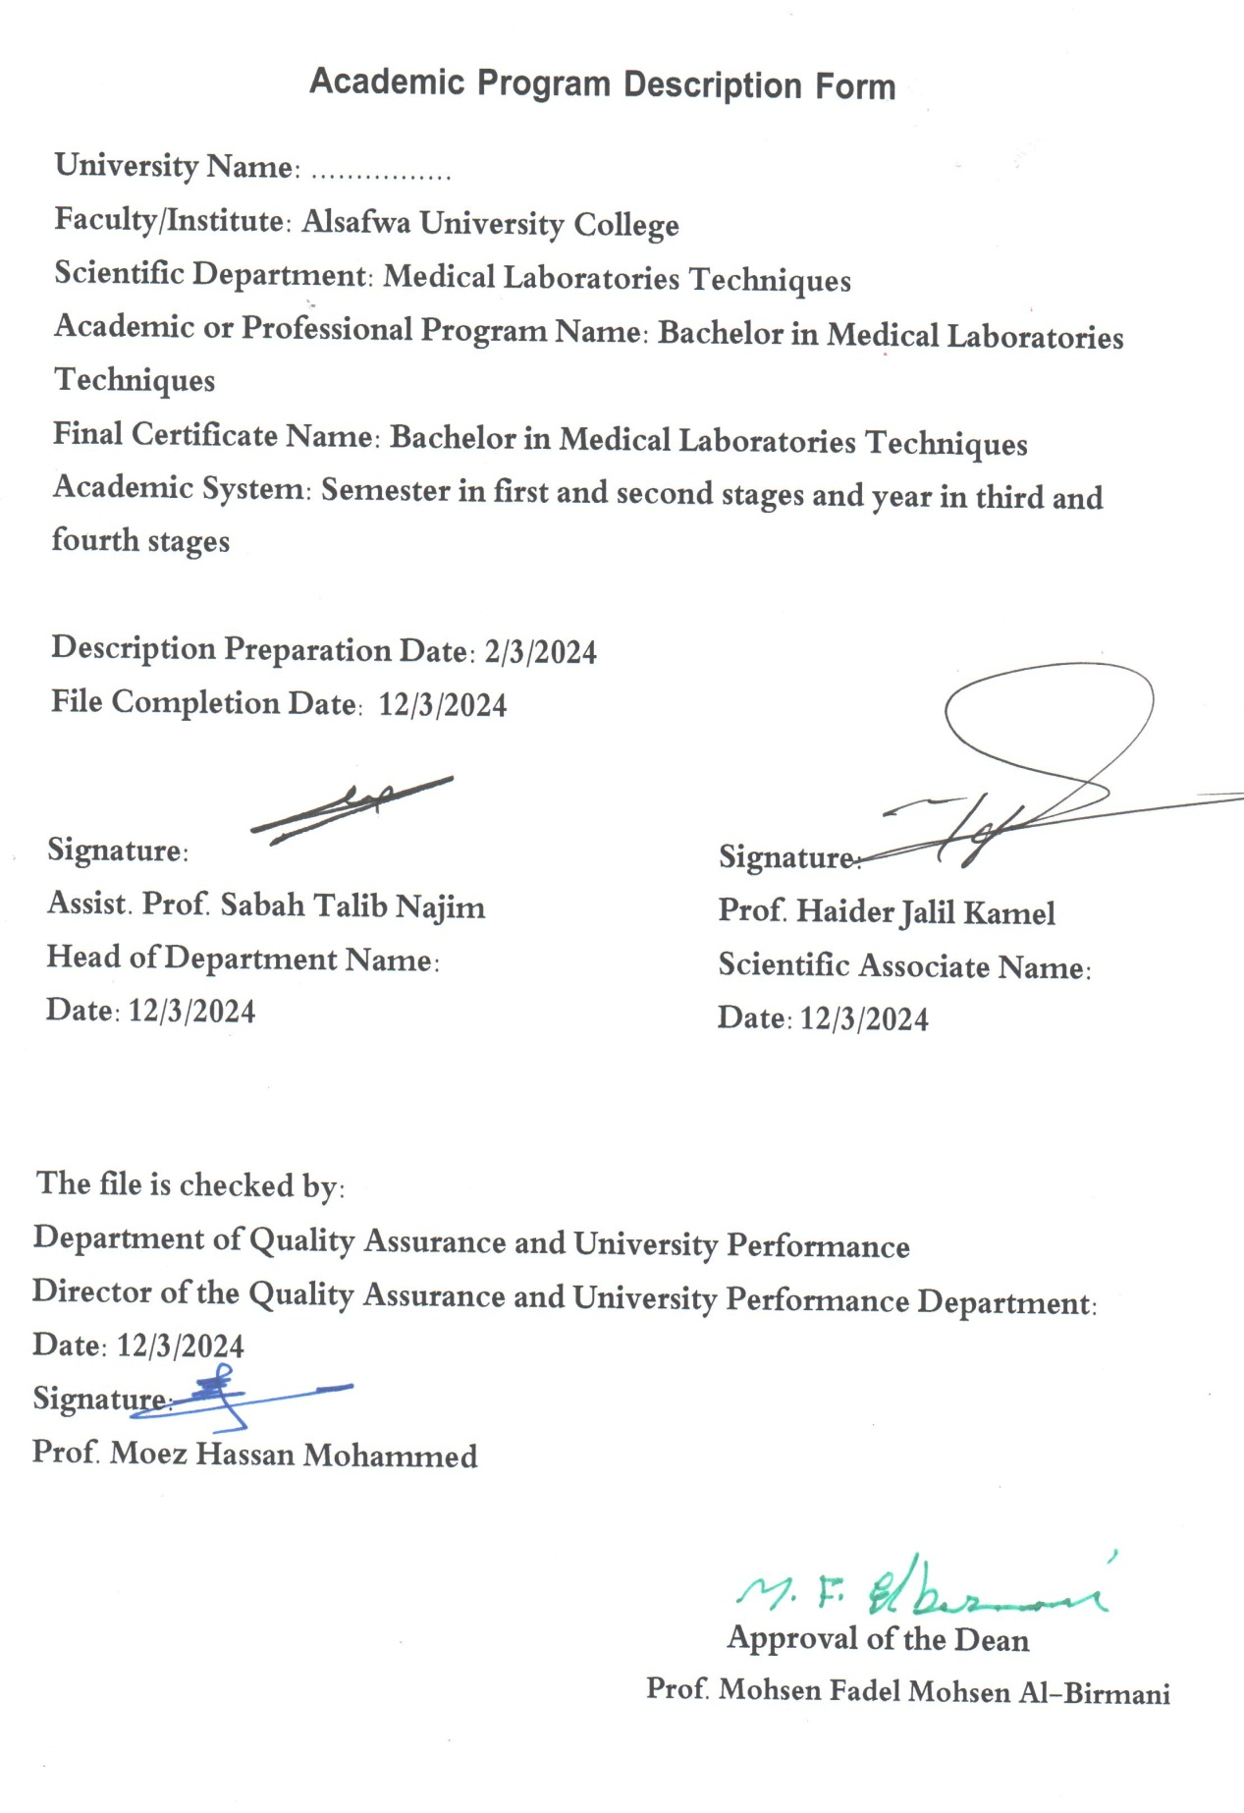

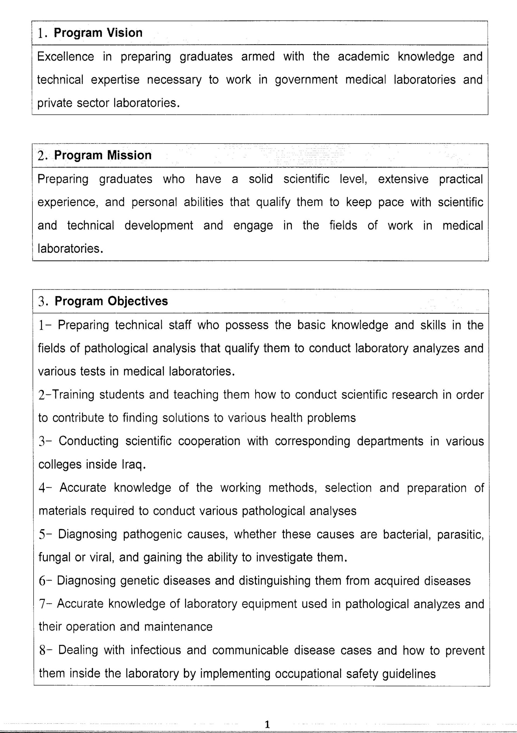

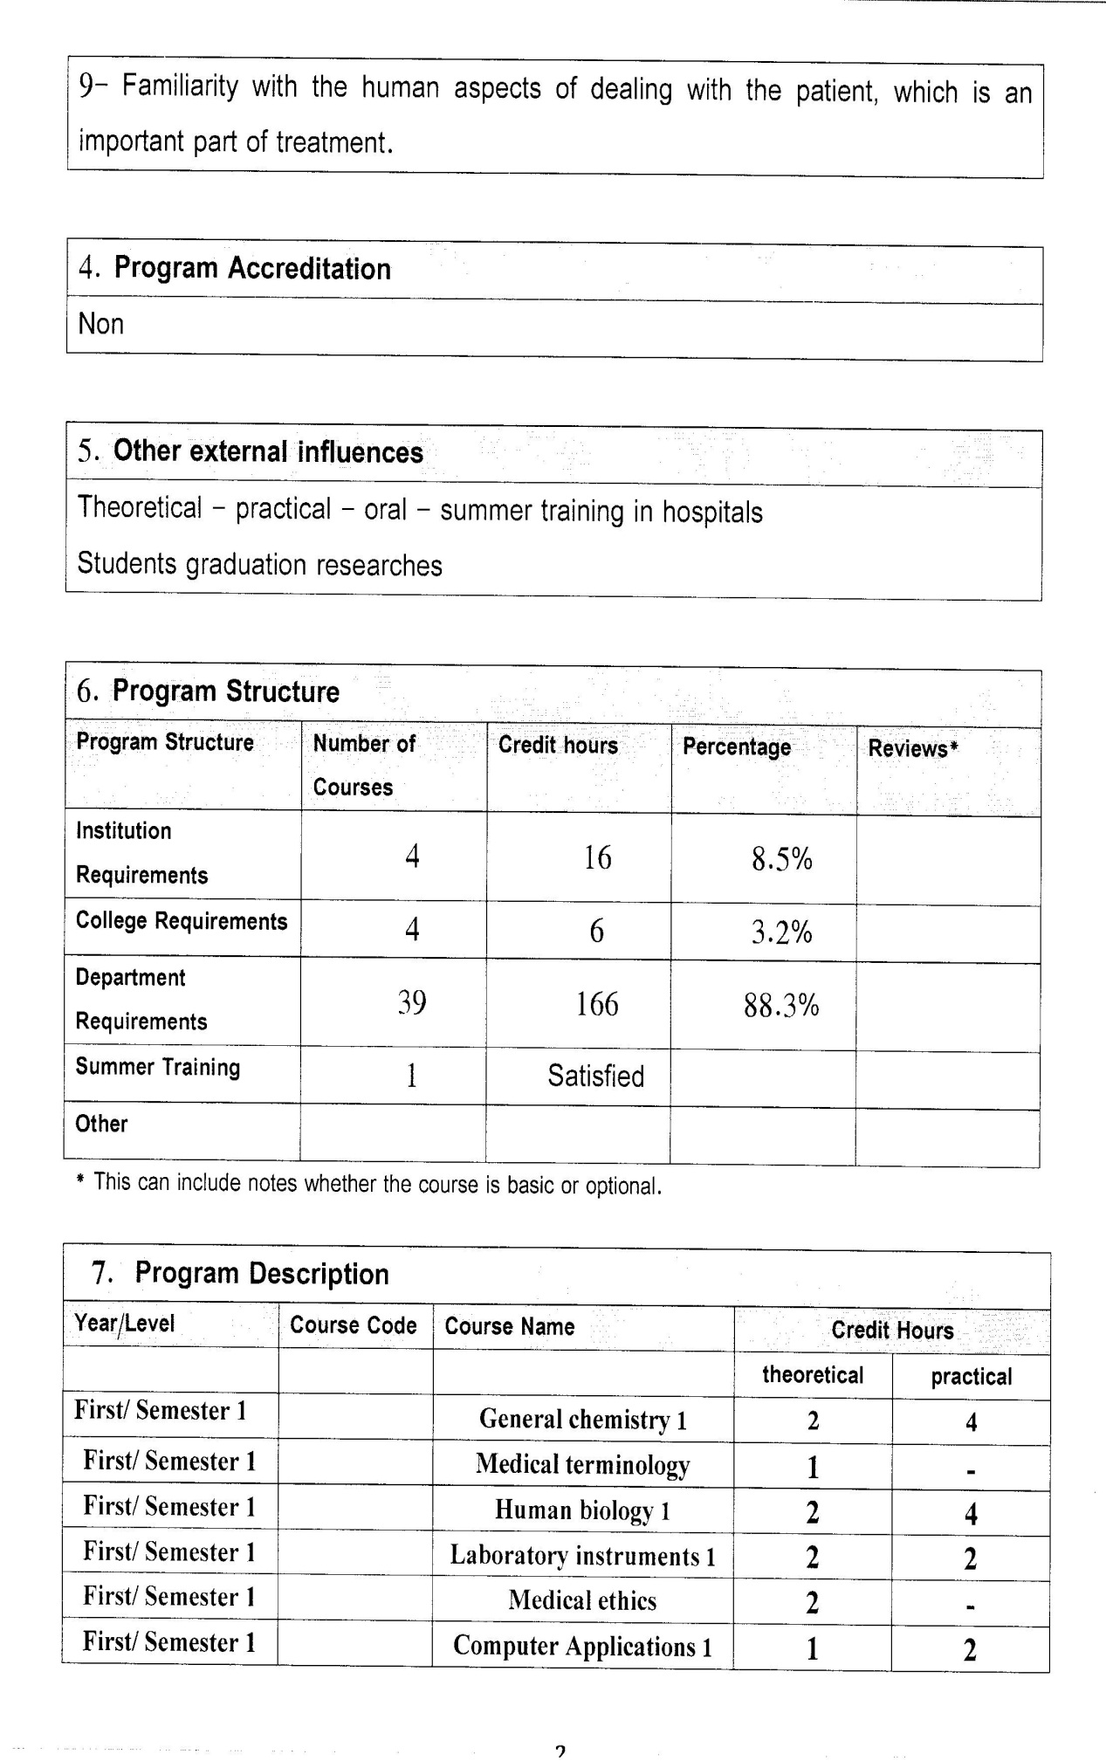

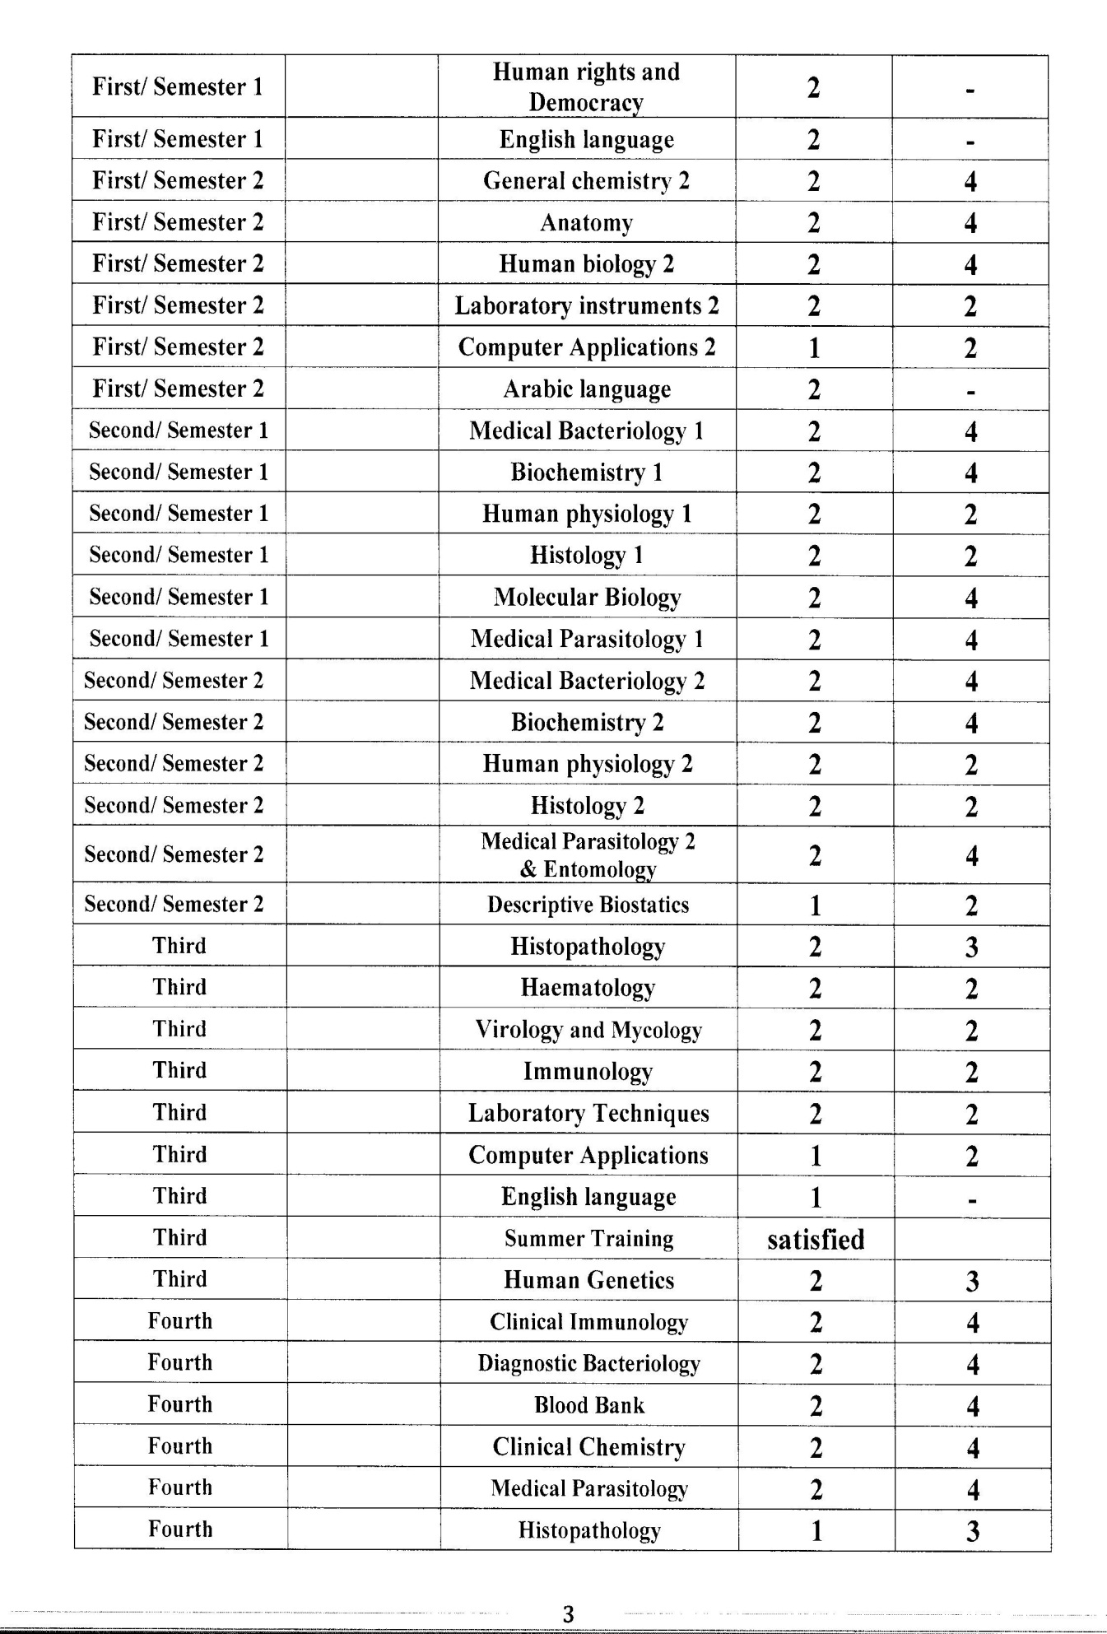

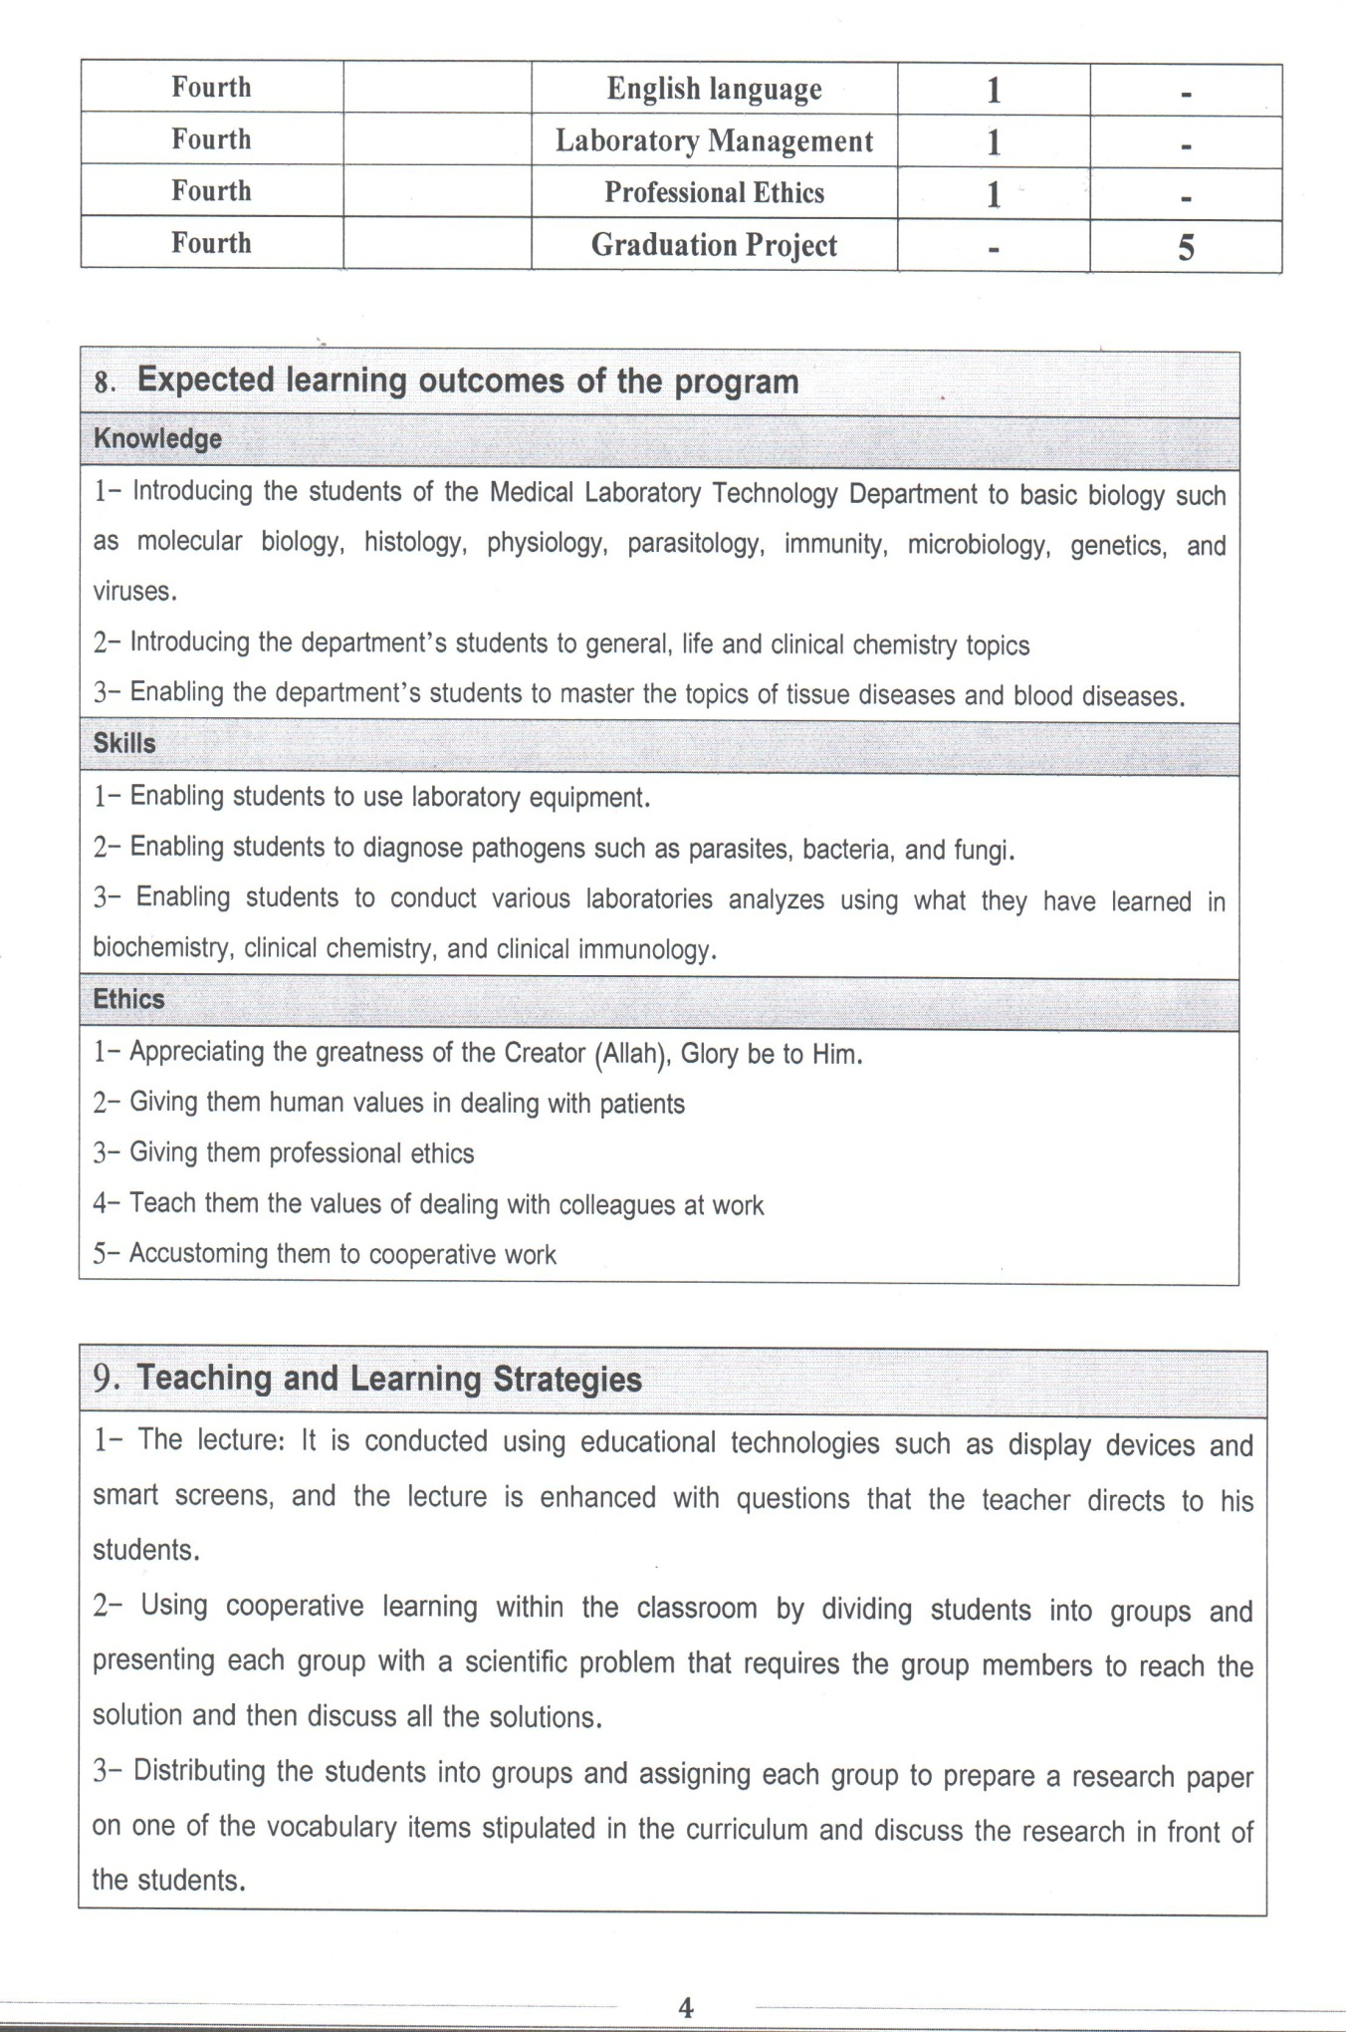

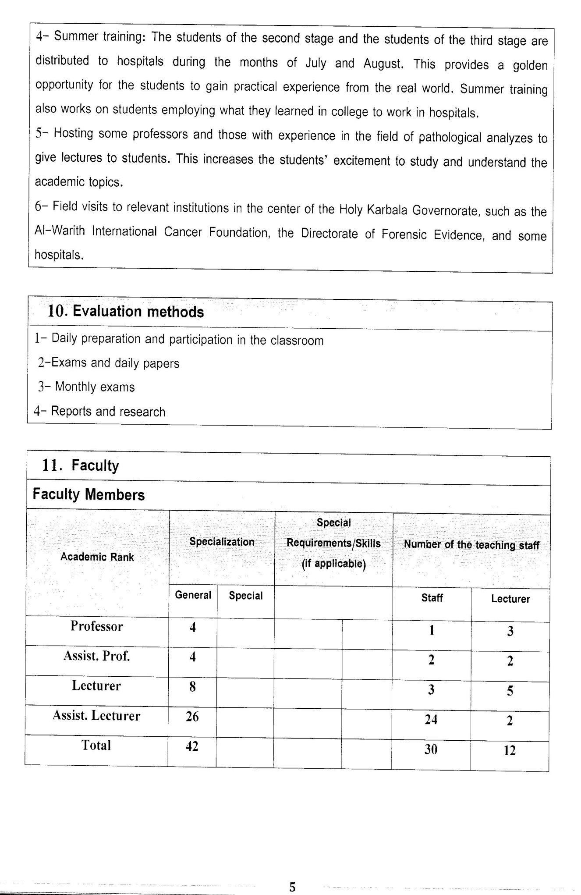

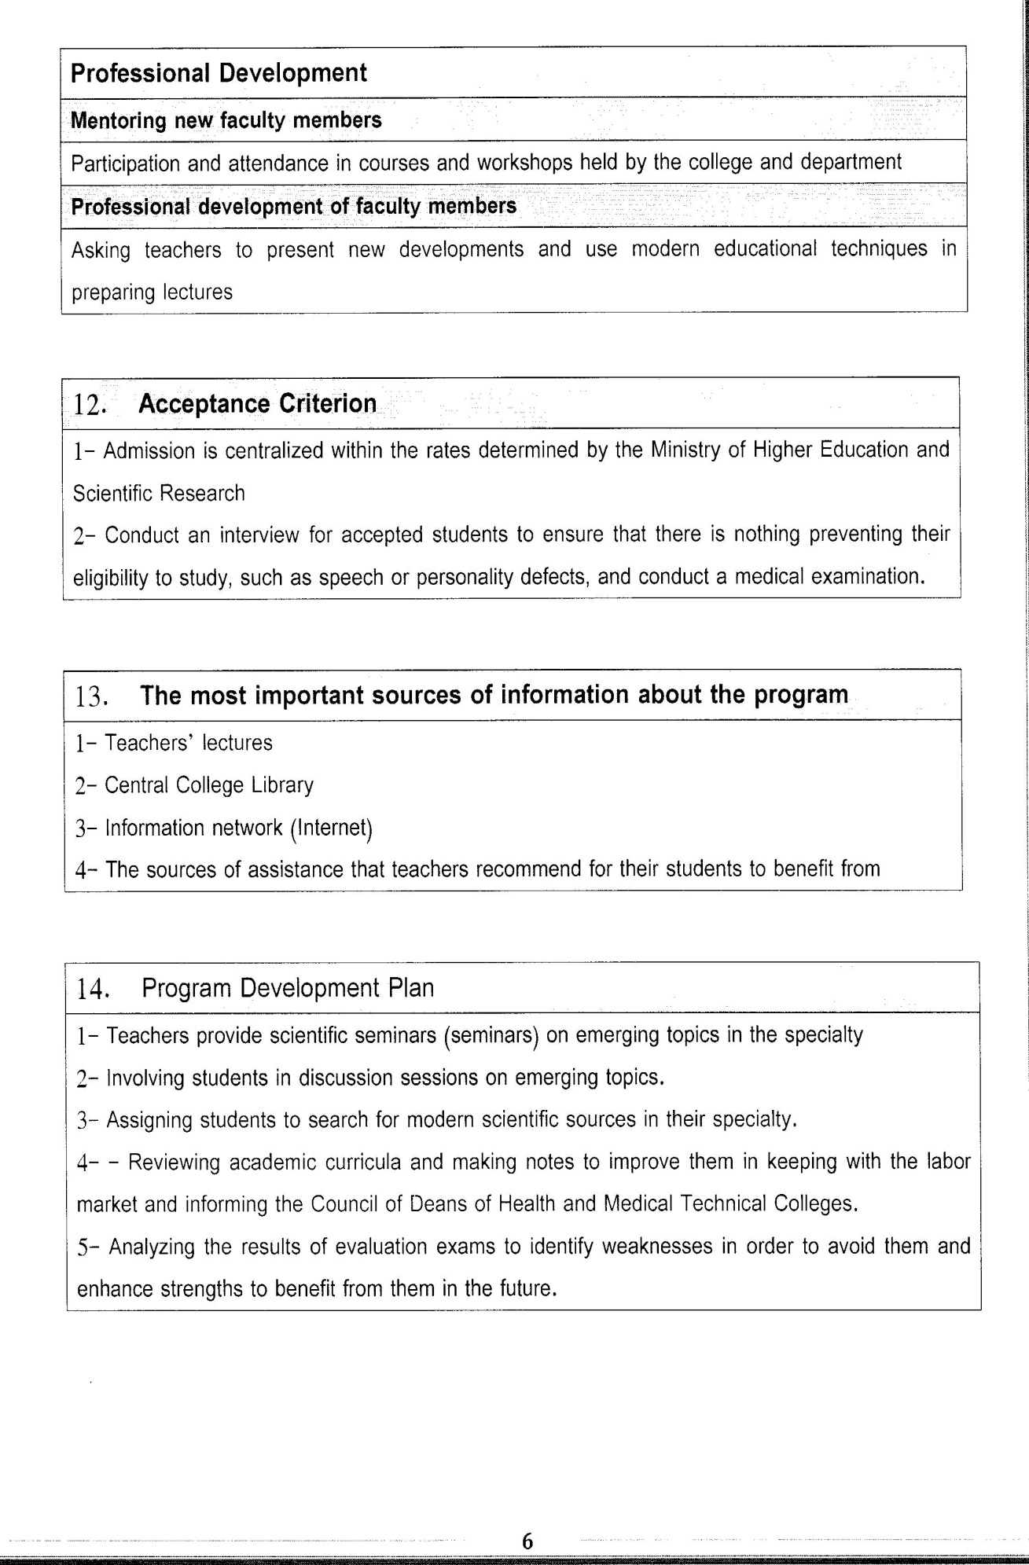

Course Description Form(2023- 2024)
- Course Name:
Advance Clinical biochemistry
- Course Code:
- Semester / Year:
Forth Year (Year)
- Description Preparation Date:
20 / 3 / 2024
- Available Attendance Forms:
- Number of Credit Hours (Total) / Number of Units (Total)
120 Hours
- Course administrator's name (mention all, if more than one name)
Name:Dr. Fatimah sahib abed
Email: dr.fatima.abd@alsafwa.edu.iq
- Course Objectives
Course Objectives
At the end of the academic year, the student should be able to:
1. Knowledge and understanding of safety.
2. Knowledge and understanding of case study in clinical diseases.
3. Knowledge and understanding of specimen collection.
4. Knowledge and understanding of total testing process.
5. Knowledge and understanding of preanalytical and analytical variables.
6. Knowledge and understanding of pediatric clinical chemistry.
7. Know and understand of advance technique in clinical chemistry.
- Teaching and Learning Strategies
Strategy |  | 1. Providing students with the basics and supporting topics related to the pre-skills learning outcomes.  2. Applying the topics studied in theoretical lessons on the practical level.  3. Asking students to identify the advance technique in clinical chemistry and case study in clinical diseases.
- Course Structure
Week | Hours |  | Required Learning Outcomes | Unit or subject name |  | Learning method | Evaluation method
First Semester
1 | 2practical+2 theoretical |  | Understand  the lecture | Safety of person and equipment |  | Lecture  Laboratory | Attendance  Daily exam
2 | 2practical+2 theoretical |  | Understand  the lecture | Chemical and biological safety |  | Lecture  Laboratory | Attendance  Daily exam
3 | 2practical+2 theoretical |  | Understand  the lecture | Requesting lab, selective and screening test |  | Lecture  Laboratory | Attendance  Daily exam
4 | 2practical+2 theoretical |  | Understand  the lecture | Specimen collection, transport and handling |  | Lecture  Laboratory | Attendance  Daily exam
5 | 2practical+2 theoretical |  | Understand  the lecture | Quality management |  | Lecture  Laboratory | Attendance  Daily exam
6 | 2practical+2 theoretical |  | Understand  the lecture | Total testing processes |  | Lecture  Laboratory | Attendance  Daily exam
7 | 2practical+2 theoretical |  | Understand  the lecture | Preanalytic variable |  | Lecture  Laboratory | Attendance  Daily exam
8 | 2practical+2 theoretical |  | Understand  the lecture | Analytical variable |  | Lecture  Laboratory | Attendance  Daily exam
9 | 2practical+2 theoretical |  | Understand  the lecture | External quality assessment |  | Lecture  Laboratory | Attendance  Daily exam
10 | 2practical+2 theoretical |  | Understand  the lecture | advance technique in clinical chemistry |  | Lecture  Laboratory | Attendance  Daily exam
11 | 2practical+2 theoretical |  | Understand  the lecture | advance technique in clinical chemistry |  | Lecture  Laboratory | Attendance  Daily exam
12 | 2practical+2 theoretical |  | Understand  the lecture | advance technique in clinical chemistry |  | Lecture  Laboratory | Attendance  Daily exam
13 | 2practical+2 theoretical |  | Understand  the lecture | advance technique in clinical chemistry |  | Lecture  Laboratory | Attendance  Daily exam
14 | 2practical+2 theoretical |  | Understand  the lecture | advance technique in clinical chemistry |  | Lecture  Laboratory | Attendance  Daily exam
15 | 2practical+2 theoretical |  | Understand  the lecture | advance technique in clinical chemistry |  | Lecture  Laboratory | Attendance  Daily exam
Second Semester
1 | 2practical+2 theoretical |  | Understand  the lecture | Pediatric in clinical chemistry |  | Lecture  Laboratory | Attendance  Daily exam
2 | 2practical+2 theoretical |  | Understand  the lecture | Pediatric in clinical chemistry |  | Lecture  Laboratory | Attendance  Daily exam
3 | 2practical+2 theoretical |  | Understand  the lecture | Pediatric in clinical chemistry |  | Lecture  Laboratory | Attendance  Daily exam
4 | 2practical+2 theoretical |  | Understand  the lecture | Pediatric in clinical chemistry |  | Lecture  Laboratory | Attendance  Daily exam
5 | 2practical+2 theoretical |  | Understand  the lecture | Functional test in clinical chemistry |  | Lecture  Laboratory | Attendance  Daily exam
6 | 2practical+2 theoretical |  | Understand  the lecture | Profile test in clinical chemistry |  | Lecture  Laboratory | Attendance  Daily exam
7 | 2practical+2 theoretical |  | Understand  the lecture | Problem in biochemistry calculation |  | Lecture  Laboratory | Attendance  Daily exam
8 | 2practical+2 theoretical |  | Understand  the lecture | Case study in clinical chemistry |  | Lecture  Laboratory | Attendance  Daily exam
9 | 2practical+2 theoretical |  | Understand  the lecture | Case study in clinical chemistry |  | Lecture  Laboratory | Attendance  Daily exam
10 | 2practical+2 theoretical |  | Understand  the lecture | Case study in clinical chemistry |  | Lecture  Laboratory | Attendance  Daily exam
11 | 2practical+2 theoretical |  | Understand  the lecture | Case study in clinical chemistry |  | Lecture  Laboratory | Attendance  Daily exam
12 | 2practical+2 theoretical |  | Understand  the lecture | Case study in clinical chemistry |  | Lecture  Laboratory | Attendance  Daily exam
13 | 2practical+2 theoretical |  | Understand  the lecture | Case study in clinical chemistry |  | Lecture  Laboratory | Attendance  Daily exam
14 | 2practical+2 theoretical |  | Understand  the lecture | Case study in clinical chemistry |  | Lecture  Laboratory | Attendance  Daily exam
15 | 2practical+2 theoretical |  | Understand  the lecture | Case study in clinical chemistry |  | Lecture  Laboratory | Attendance  Daily exam
- Course Evaluation
The following evaluation methods are adopted:
1. Theoretical and practical tests.
2. Reports.
3. Attendance and discussion.
The grades are distributed as follows:
1- Two monthly exams with a score of 20 points.
2-5 marks for activity and attendance.
3- 15 marks for the practical part, so the pursuit mark is 40.
4- The final exam score is distributed (35) points for the theoretical part and (25) points for the practical part, so the final score is 100.
- Learning and Teaching Resources
Required textbooks (curricular books, if any) |  |  |  |  | Not found
Main references (sources) |  |  |  |  | Clinical biochemistry and metabolic medicine
Recommended books and references (scientific journals, reports...)
Electronic References, Websites

