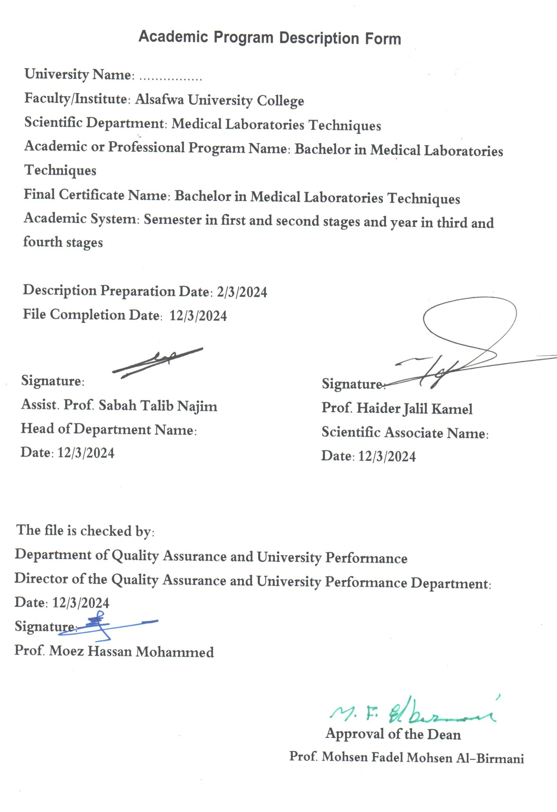

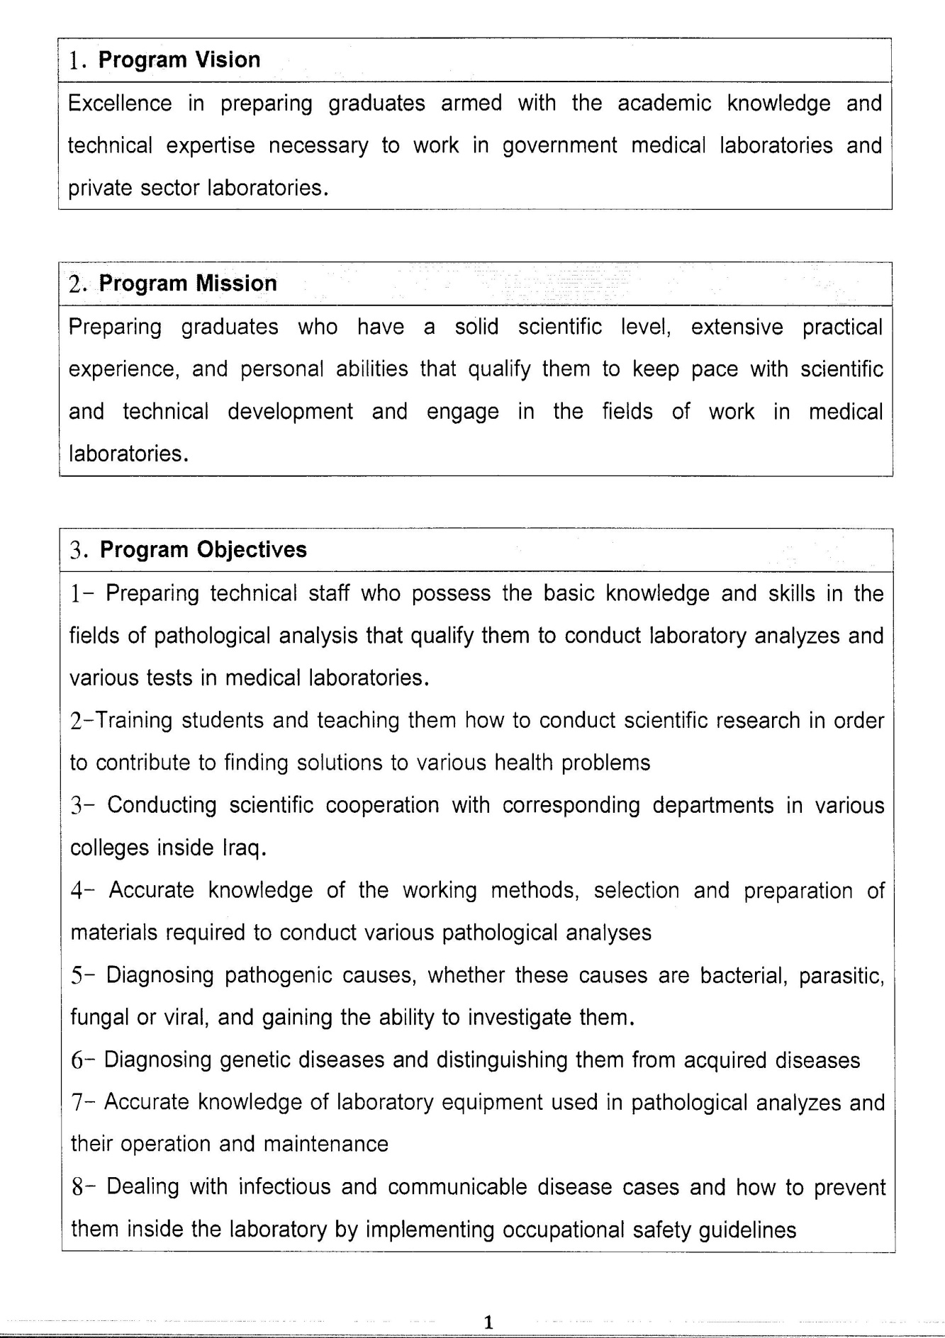

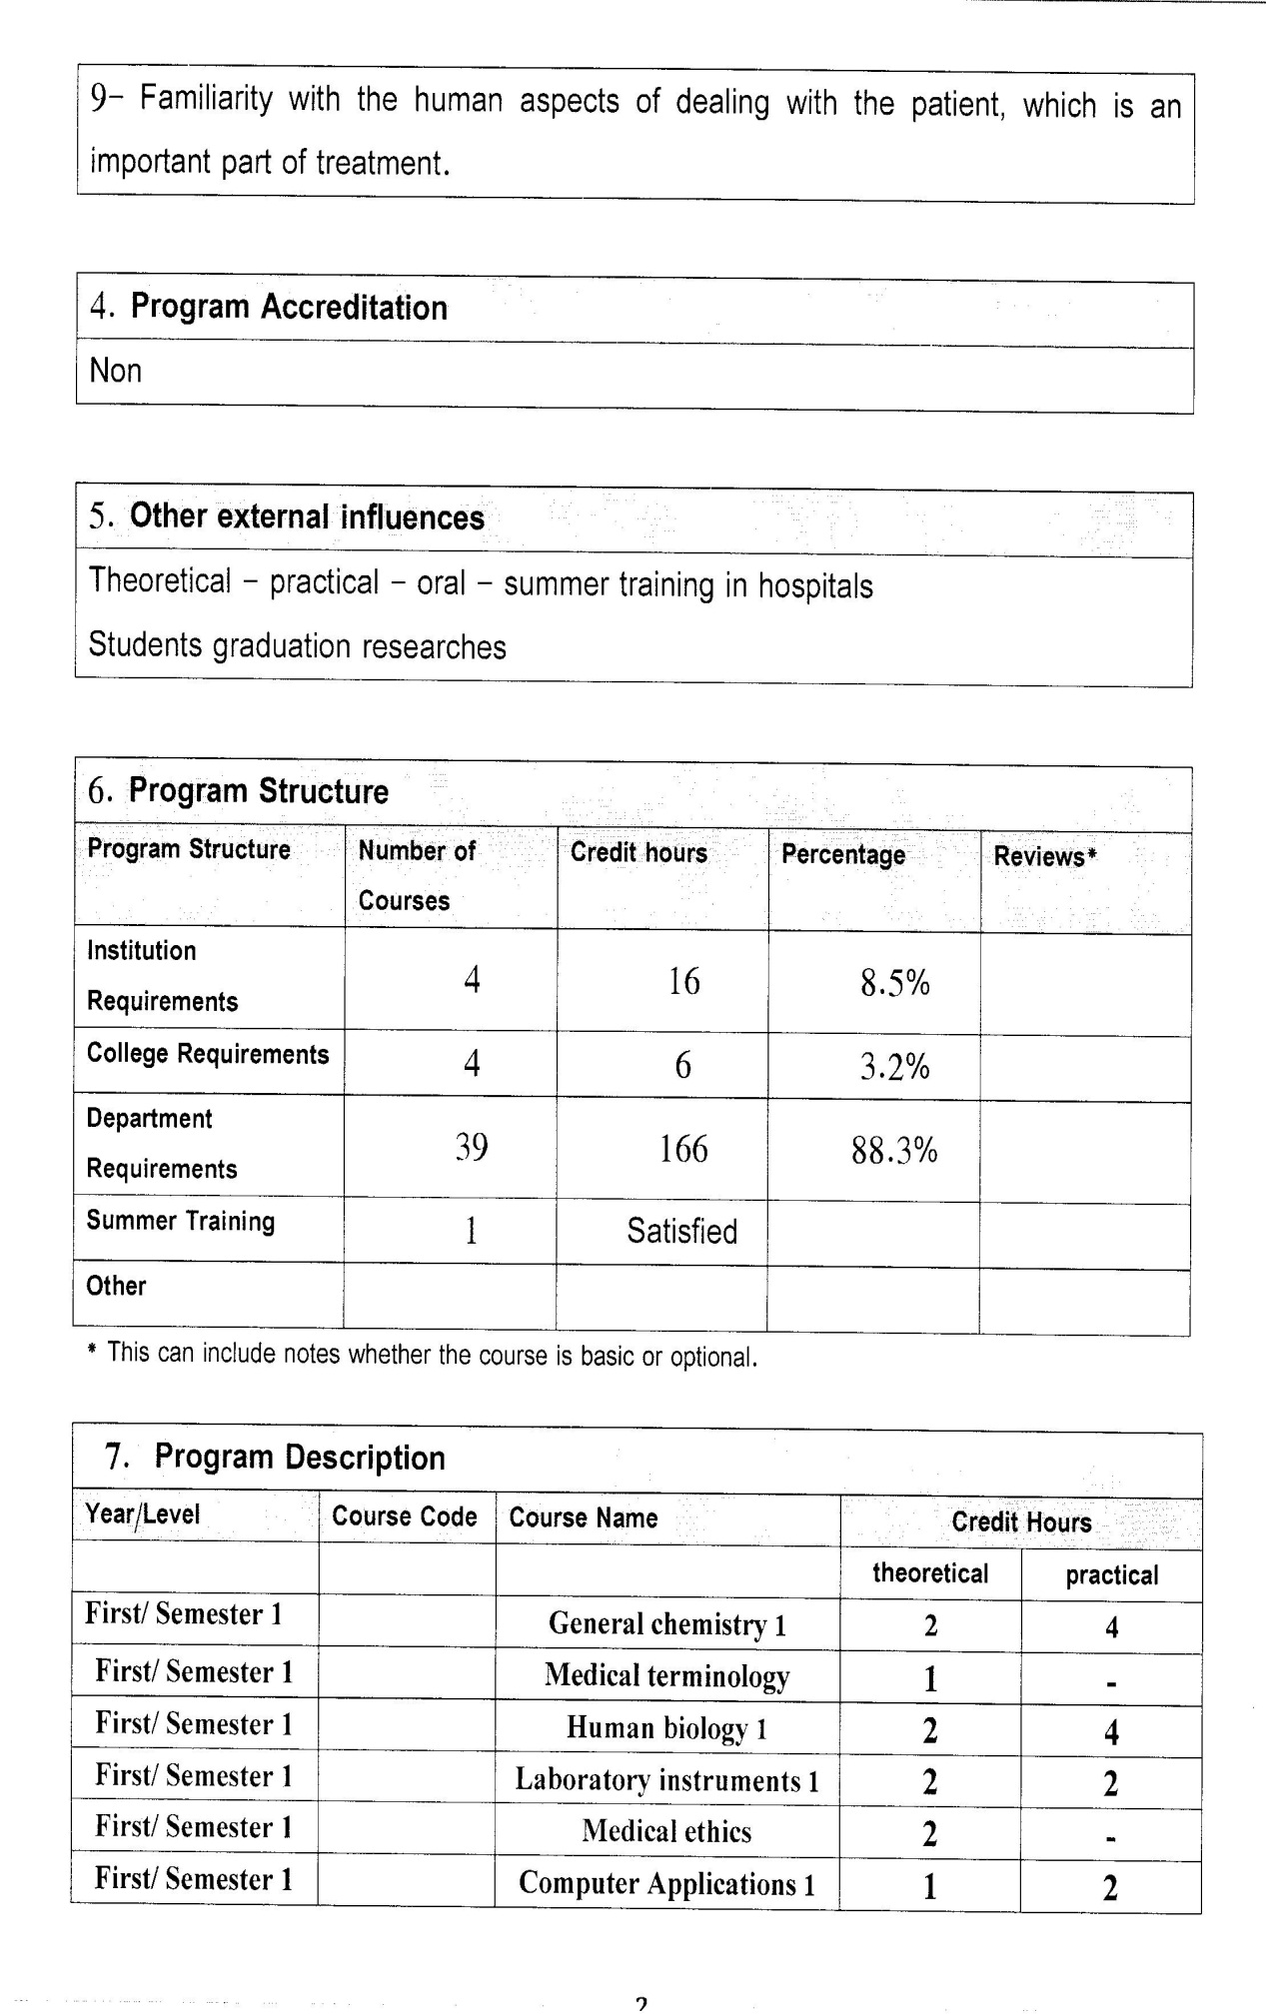

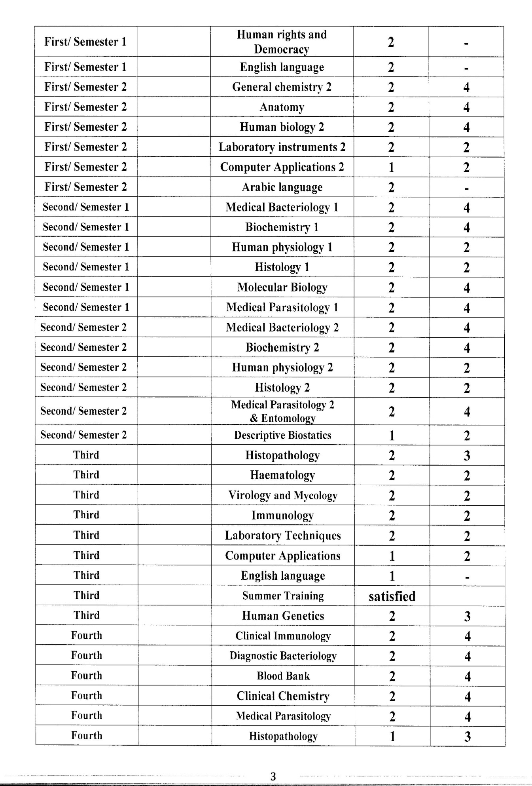

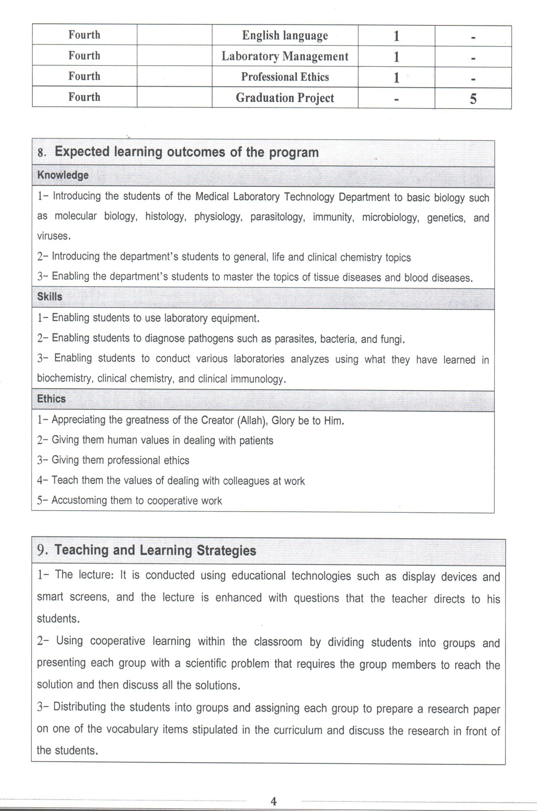

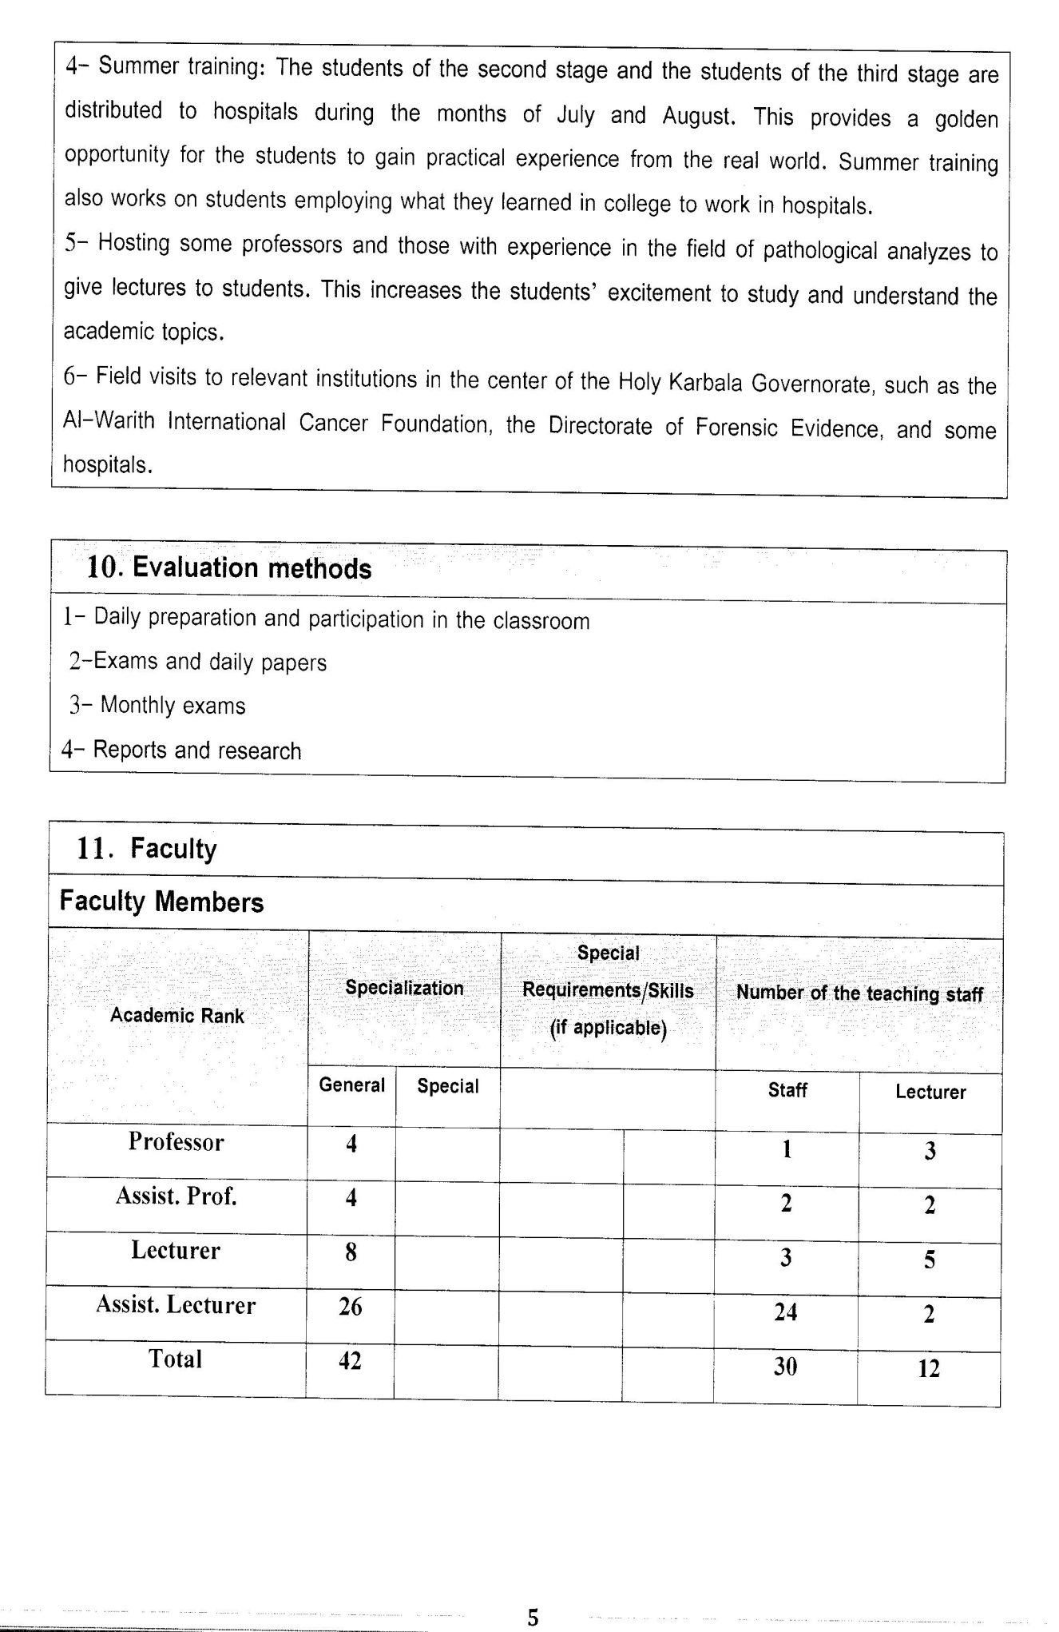

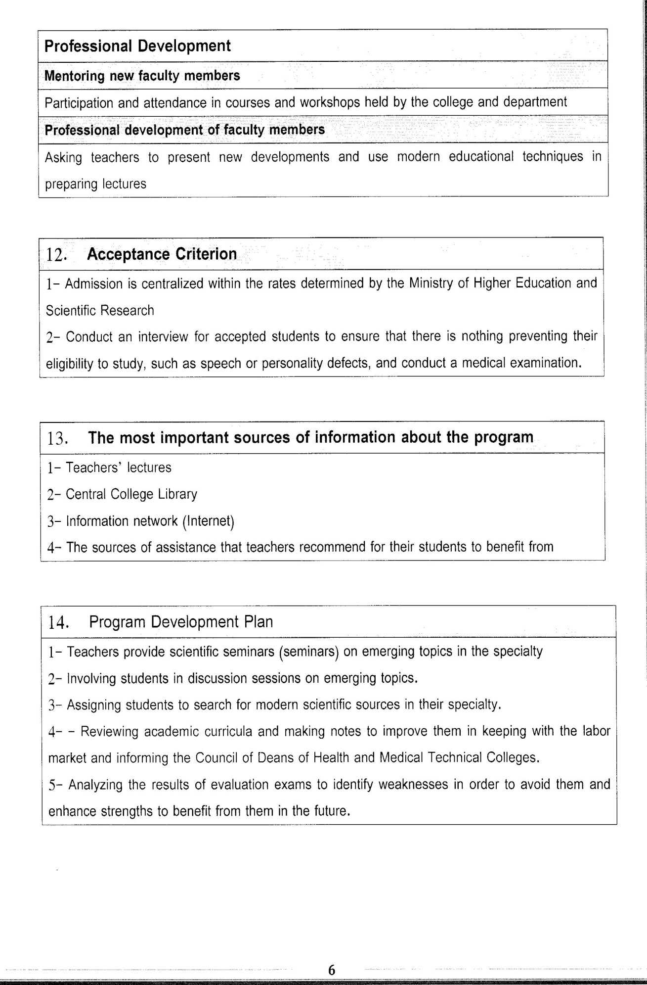

Course Description Form
- Course Name:
General Chemistry
- Course Code:
- Semester / Year:
(Semester)
- Description Preparation Date:
6 / 3 / 2024
- Available Attendance Forms:
- Number of Credit Hours (Total) / Number of Units (Total)
120 Hours
- Course administrator's name (mention all, if more than one name)
Name: Dr. Sabah Talib Najim
Email: dr.sabah.t.najim@Alsafwa.edu.iq
- Course Objectives
Course Objectives
At the end of the academic year, the student should be able to:
1. Knowledge and understanding of hydrolytic and organic chemistry.
2. Know the importance of analytical and organic chemistry.
3. Knowledge of importance in medicine, pharmacy, industry and drug preparation.
4. Knowledge of preparing solutions and concentrations.
5. Knowledge of the use of laboratory equipment.
6. Know how to get the best results.
7. Know the components of gasoline.
8. Know the importance of petroleum in industry.
9. About sugar in nature.

- Teaching and Learning Strategies
Strategy |  | 1. Providing students with the basics and supporting topics related to the pre-skills learning outcomes.  2. Applying the topics studied in theoretical lessons on the practical level.  of inheritance patterns.
- Course Structure
Week | Hours |  | Required Learning Outcomes | Unit or subject name |  | Learning method | Evaluation method
First Semester
1 | 2practical+2 theoretical |  | Understand  the lecture | The importance of analytical chemistry |  | Lecture  Laboratory | Attendance  Daily exam
2 | 2practical+2 theoretical |  | Understand  the lecture | Definitions and terms |  | Lecture  Laboratory | Attendance  Daily exam
3 | 2practical+2 theoretical |  | Understand  the lecture | Electrolytes |  | Lecture  Laboratory | Attendance  Daily exam
4 | 2practical+2 theoretical |  | Understand  the lecture | Different concentrations |  | Lecture  Laboratory | Attendance  Daily exam
5 | 2practical+2 theoretical |  | Understand  the lecture | Issues and solutions |  | Lecture  Laboratory | Attendance  Daily exam
6 | 2practical+2 theoretical |  | Understand  the lecture | Evidence and its benefits |  | Lecture  Laboratory | Attendance  Daily exam
7 | 2practical+2 theoretical |  | Understand  the lecture | Measurement of PH of solutions |  | Lecture  Laboratory | Attendance  Daily exam
8 | 2practical+2 theoretical |  | Understand  the lecture | Strong bases |  | Lecture  Laboratory | Attendance  Daily exam
9 | 2practical+2 theoretical |  | Understand  the lecture | Weak bases |  | Lecture  Laboratory | Attendance  Daily exam
10 | 2practical+2 theoretical |  | Understand  the lecture | PH of salt solutions |  | Lecture  Laboratory | Attendance  Daily exam
11 | 2practical+2 theoretical |  | Understand  the lecture | Gravimetric chemistry |  | Lecture  Laboratory | Attendance  Daily exam
12 | 2practical+2 theoretical |  | Understand  the lecture | calculates the percentage of impurities in the drug |  | Lecture  Laboratory | Attendance  Daily exam
13 | 2practical+2 theoretical |  | Understand  the lecture | Alkanes Introduction |  | Lecture  Laboratory | Attendance  Daily exam
14 | 2practical+2 theoretical |  | Understand  the lecture | Properties of alkanes, their law, and existence |  | Lecture  Laboratory | Attendance  Daily exam
15 | 2practical+2 theoretical |  | Understand  the lecture | Preparation of alkanes |  | Lecture  Laboratory | Attendance  Daily exam
- Course Evaluation
The following evaluation methods are adopted:
1. Theoretical and practical tests.
2. Reports.
3. Attendance and discussion.
The grades are distributed as follows:
1- Two monthly exams with a score of 20 points.
2-5 marks for activity and attendance.
3- 15 marks for the practical part, so the pursuit mark is 40.
4- The final exam score is distributed (35) points for the theoretical part and (25) points for the practical part, so the final score is 100.
- Learning and Teaching Resources
Required textbooks (curricular books, if any) |  |  |  |  | Not found
Main references (sources) |  |  |  |  | 1. Organic Chemistry by Morrison  and Boyd  2. Quantitative Analytical Chemistry  Vol II By H.A. Flaschka / A.J.Barnard,Jr
Recommended books and references (scientific journals, reports...)
Electronic References, Websites

