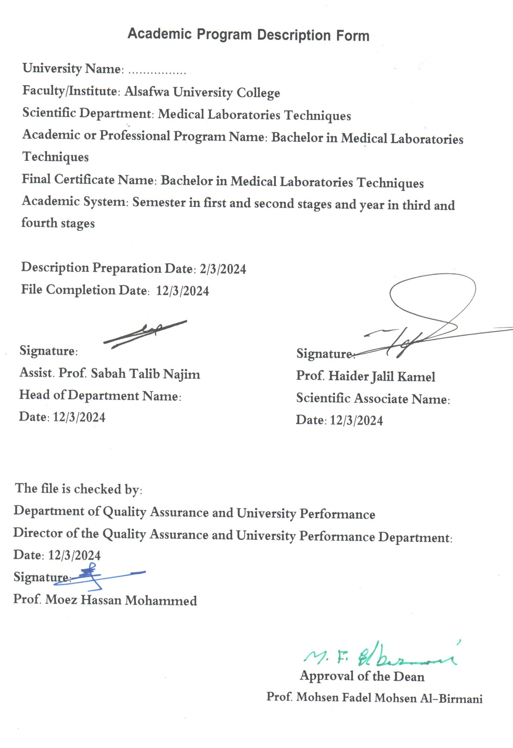

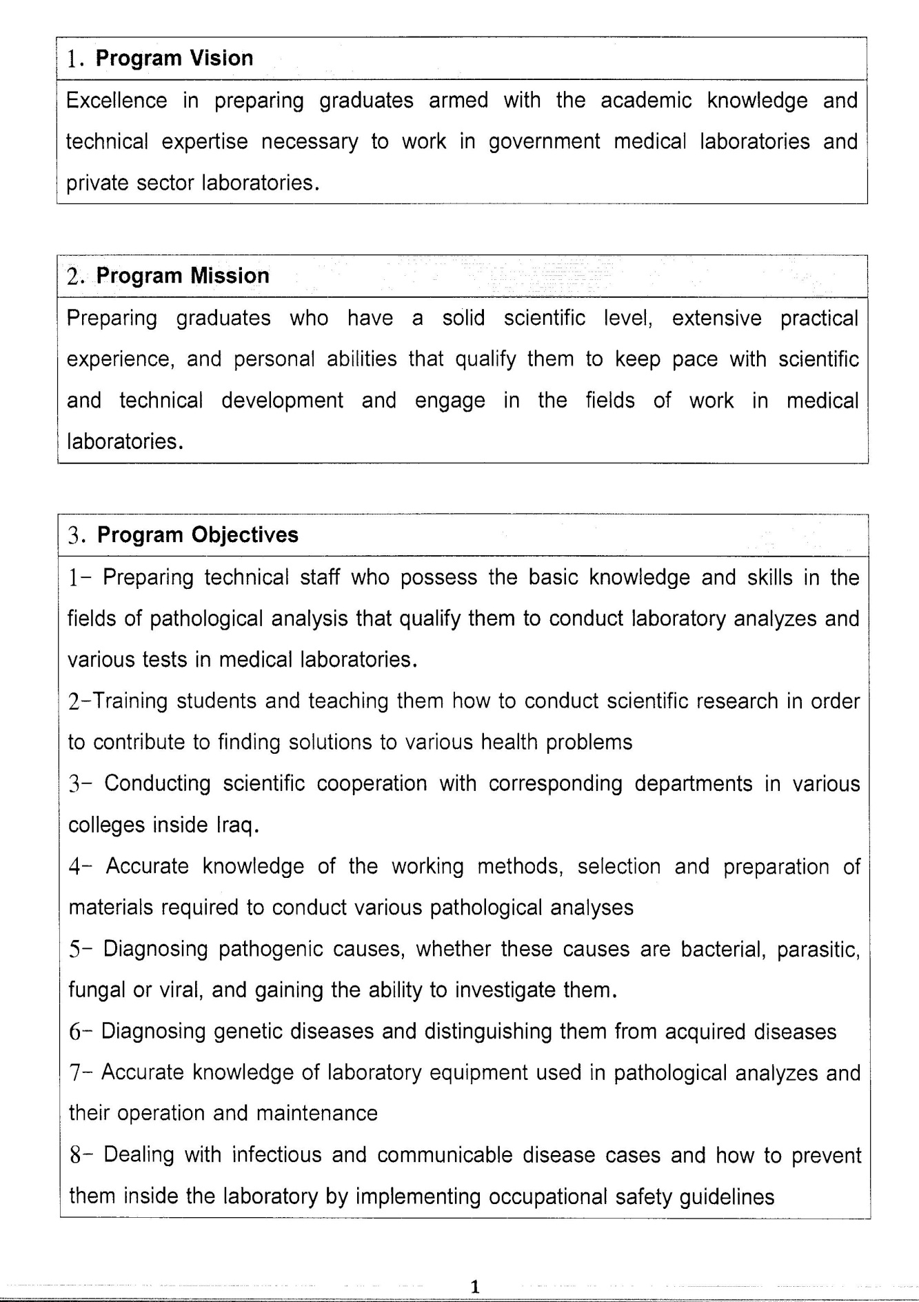

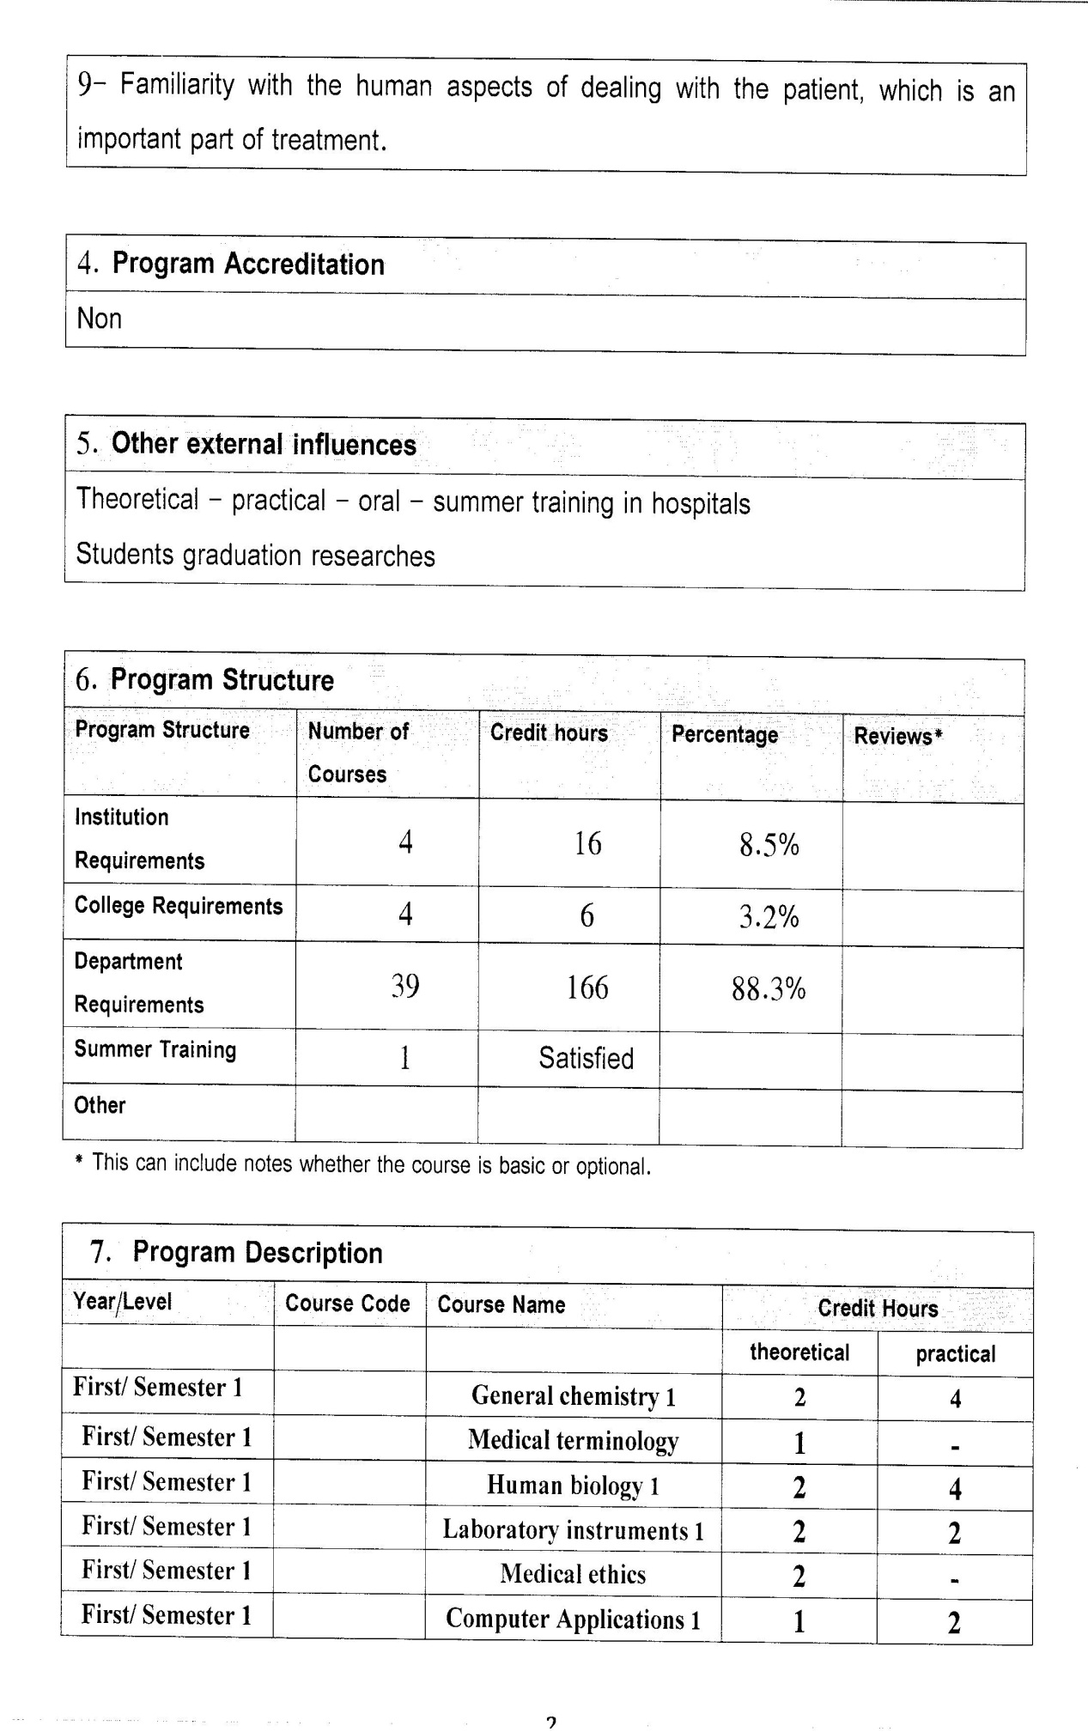

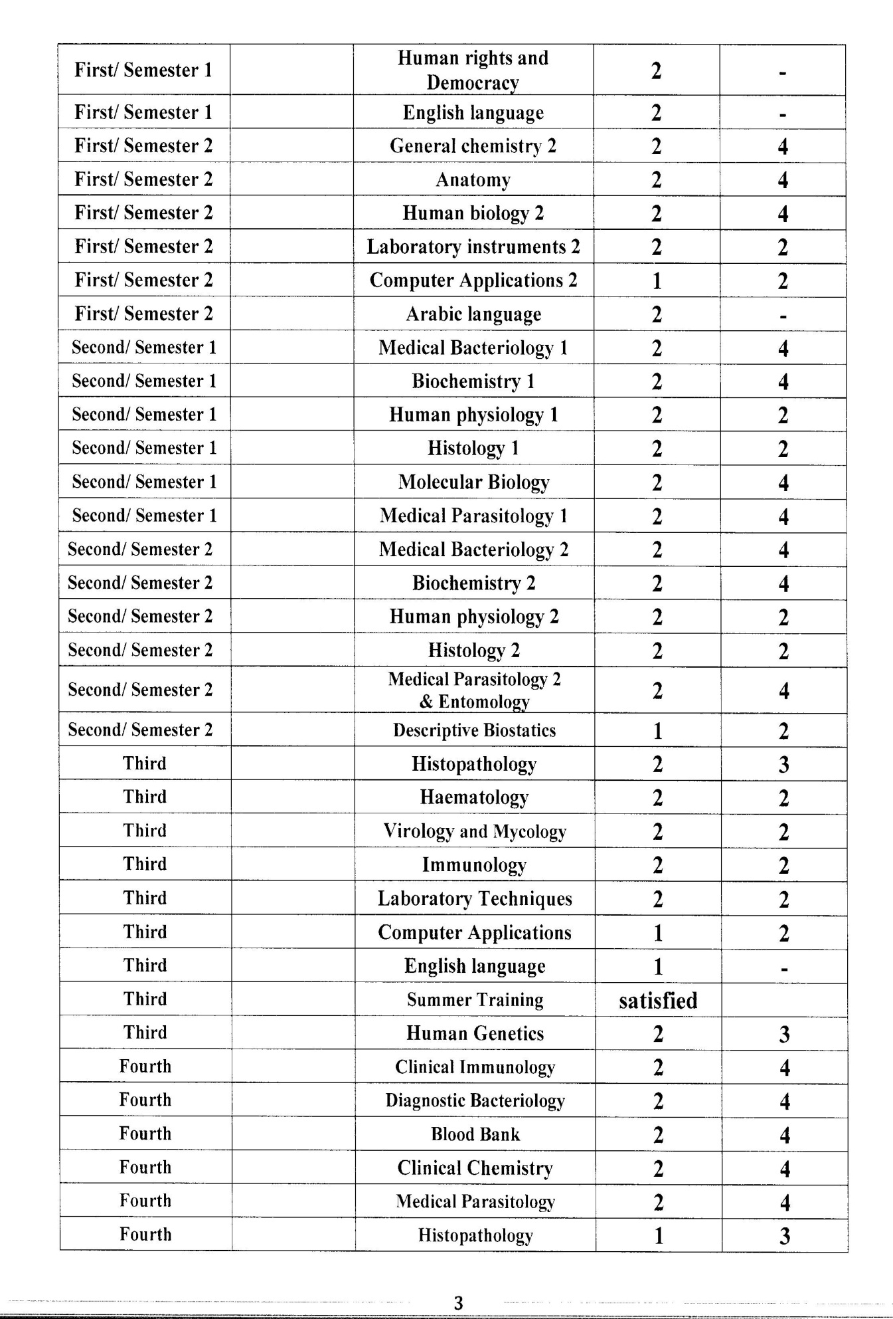

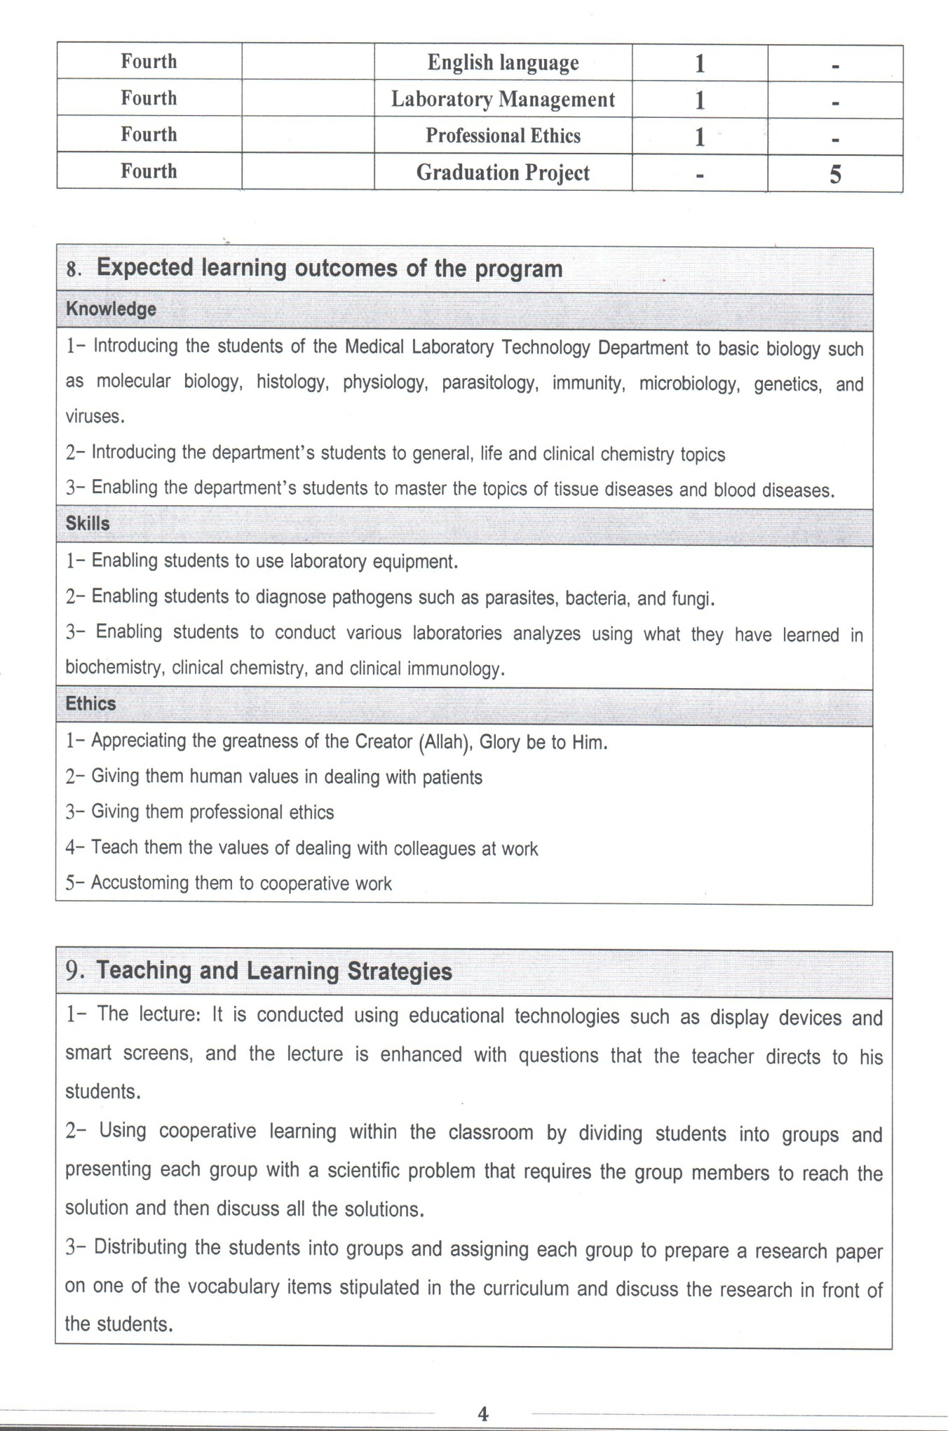

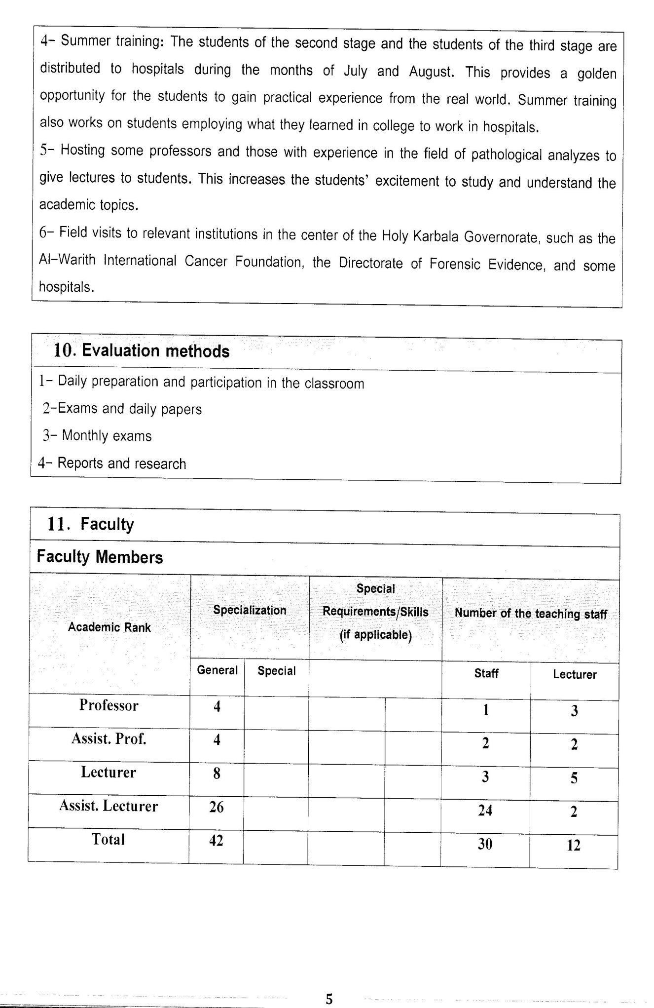

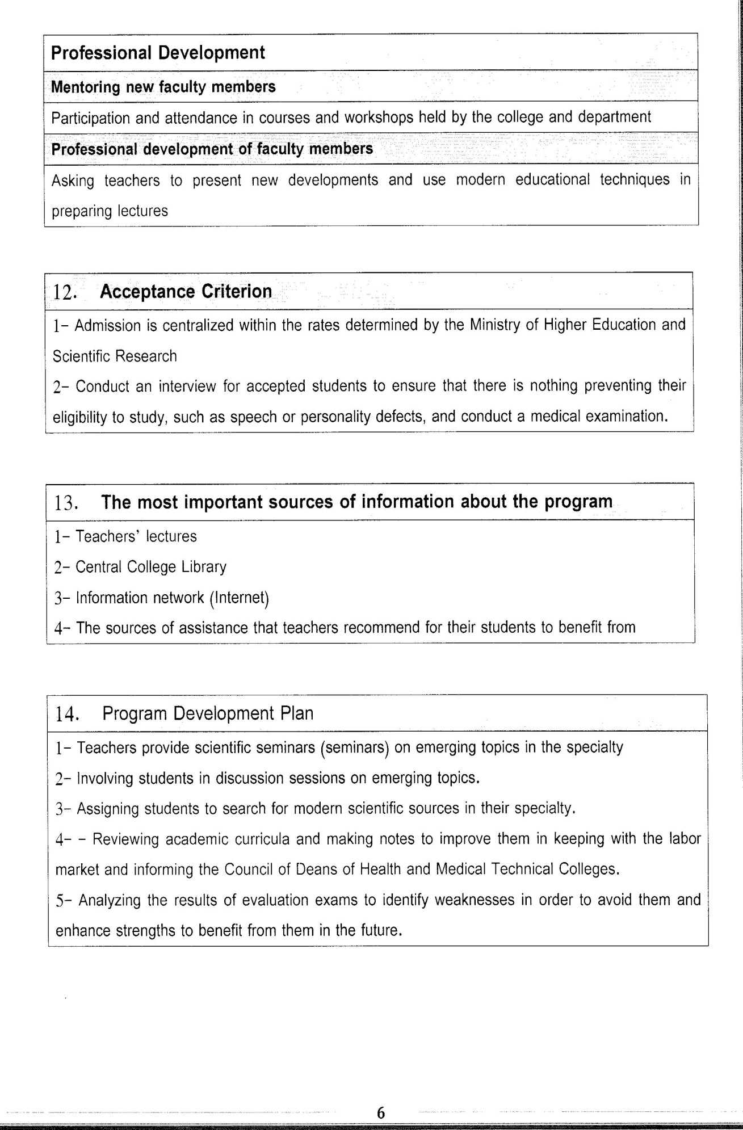

Course Description Form(2023 – 2024)
- Course Name:
Histology
- Course Code:
- Semester / 1. Course:
second year (Year)
- Description Preparation Date:
6 / 3 / 2024
- Available Attendance Forms:
- Number of Credit Hours (Total) / Number of Units (Total)
120 Hours
- Course administrator's name (mention all, if more than one name)
Name: Naser Abed Almeer Abed Alsheed
Email: naser.abed@alsafwa.edu.iq
- Course Objectives
Course Objectives
At the end of the academic year, the student should be able to:
1. Know and understand hitology .
2. Know and understand Cell structures
3. Know and understand Tissues and their classification .
4. Knowing and understanding Epithelial tissue.
5. Knowledge and understanding connective tissues
6. Knowing and understanding Bone tissue .
7. Knowledge and understanding of blood .
8. Knowing and understanding Muscle tissue.
9- Knowing and understanding Nervous tissue
- Teaching and Learning Strategies
Strategy |  | 1. Providing students with the basics and supporting topics related to the pre-skills learning outcomes.  2. Applying the topics studied in theoretical lessons on the practical level.  3. Asking students to identify the types of mutations and types of inheritance patterns.
- Course Structure
Week | Hours |  | Required Learning Outcomes | Unit or subject name |  | Learning method | Evaluation method
First Semester
1 | 2practical+2 theoretical |  | Understand  the lecture | introduction and classification of histology |  | Lecture  Laboratory | Attendance  Daily exam
2 | 2practical+2 theoretical |  | Understand  the lecture | fo overview cell sturcture and type |  | Lecture  Laboratory | Attendance  Daily exam
3 | 2practical+2 theoretical |  | Understand  the lecture | tissue and classiffication of primary tissues |  | Lecture  Laboratory | Attendance  Daily exam
4 | 2practical+2 theoretical |  | Understand  the lecture | epithelial tissue |  | Lecture  Laboratory | Attendance  Daily exam
5 | 2practical+2 theoretical |  | Understand  the lecture | glandular tissue |  | Lecture  Laboratory | Attendance  Daily exam
6 | 2practical+2 theoretical |  | Understand  the lecture | conictive and supportive tissue |  | Lecture  Laboratory | Attendance  Daily exam
7 | 2practical+2 theoretical |  | Understand  the lecture | connective tissue proper |  | Lecture  Laboratory | Attendance  Daily exam
8 | 2practical+2 theoretical |  | Understand  the lecture | cartilage, histogenesis s |  | Lecture  Laboratory | Attendance  Daily exam
9 | 2practical+2 theoretical |  | Understand  the lecture | bone and histogenesis |  | Lecture  Laboratory | Attendance  Daily exam
10 | 2practical+2 theoretical |  | Understand  the lecture | blood |  | Lecture  Laboratory | Attendance  Daily exam
11 | 2practical+2 theoretical |  | Understand  the lecture | the haemopoietic organ |  | Lecture  Laboratory | Attendance  Daily exam
12 | 2practical+2 theoretical |  | Understand  the lecture | muscular tissue |  | Lecture  Laboratory | Attendance  Daily exam
13 | 2practical+2 theoretical |  | Understand  the lecture | nervous tissue |  | Lecture  Laboratory | Attendance  Daily exam
14 | 2practical+2 theoretical |  | Understand  the lecture | nervous system |  | Lecture  Laboratory | Attendance  Daily exam
15 | 2practical+2 theoretical |  | Understand  the lecture | supporting cells of nervous system |  | Lecture  Laboratory | Attendance  Daily exam
Second Semester
1 | 2practical+2 theoretical |  | Understand  the lecture | circulatory system |  | Lecture  Laboratory | Attendance  Daily exam
2 | 2practical+2 theoretical |  | Understand  the lecture | lymphoid system |  | Lecture  Laboratory | Attendance  Daily exam
3 | 2practical+2 theoretical |  | Understand  the lecture | lymphoid organ |  | Lecture  Laboratory | Attendance  Daily exam
4 | 2practical+2 theoretical |  | Understand  the lecture | respiratory system |  | Lecture  Laboratory | Attendance  Daily exam
5 | 2practical+2 theoretical |  | Understand  the lecture | digestive system / part one |  | Lecture  Laboratory | Attendance  Daily exam
6 | 2practical+2 theoretical |  | Understand  the lecture | digestive system / part two |  | Lecture  Laboratory | Attendance  Daily exam
7 | 2practical+2 theoretical |  | Understand  the lecture | digestive system / part three |  | Lecture  Laboratory | Attendance  Daily exam
8 | 2practical+2 theoretical |  | Understand  the lecture | urinary system/ part one |  | Lecture  Laboratory | Attendance  Daily exam
9 | 2practical+2 theoretical |  | Understand  the lecture | urinary system/ part  two |  | Lecture  Laboratory | Attendance  Daily exam
10 | 2practical+2 theoretical |  | Understand  the lecture | endocrinneE  system / part one |  | Lecture  Laboratory | Attendance  Daily exam
11 | 2practical+2 theoretical |  | Understand  the lecture | endocrinne  system / part two |  | Lecture  Laboratory | Attendance  Daily exam
12 | 2practical+2 theoretical |  | Understand  the lecture | male reproductive system |  | Lecture  Laboratory | Attendance  Daily exam
13 | 2practical+2 theoretical |  | Understand  the lecture | efmale reproductive system |  | Lecture  Laboratory | Attendance  Daily exam
14 | 2practical+2 theoretical |  | Understand  the lecture | sense organ |  | Lecture  Laboratory | Attendance  Daily exam
15 | 2practical+2 theoretical |  | Understand  the lecture | skin |  | Lecture  Laboratory | Attendance  Daily exam
- Course Evaluation
The following evaluation methods are adopted:
1. Theoretical and practical tests.
2. Reports.
3. Attendance and discussion.
The grades are distributed as follows:
1- Two monthly exams with a score of 20 points.
2-5 marks for activity and attendance.
3- 15 marks for the practical part, so the pursuit mark is 40.
4- The final exam score is distributed (35) points for the theoretical part and (25) points for the practical part, so the final score is 100.
- Learning and Teaching Resources
Required textbooks (curricular books, if any) |  |  |  |  | Not found
Main references (sources) |  |  |  |  | JINCKARA
Recommended books and references (scientific journals, reports...)
Electronic References, Websites

