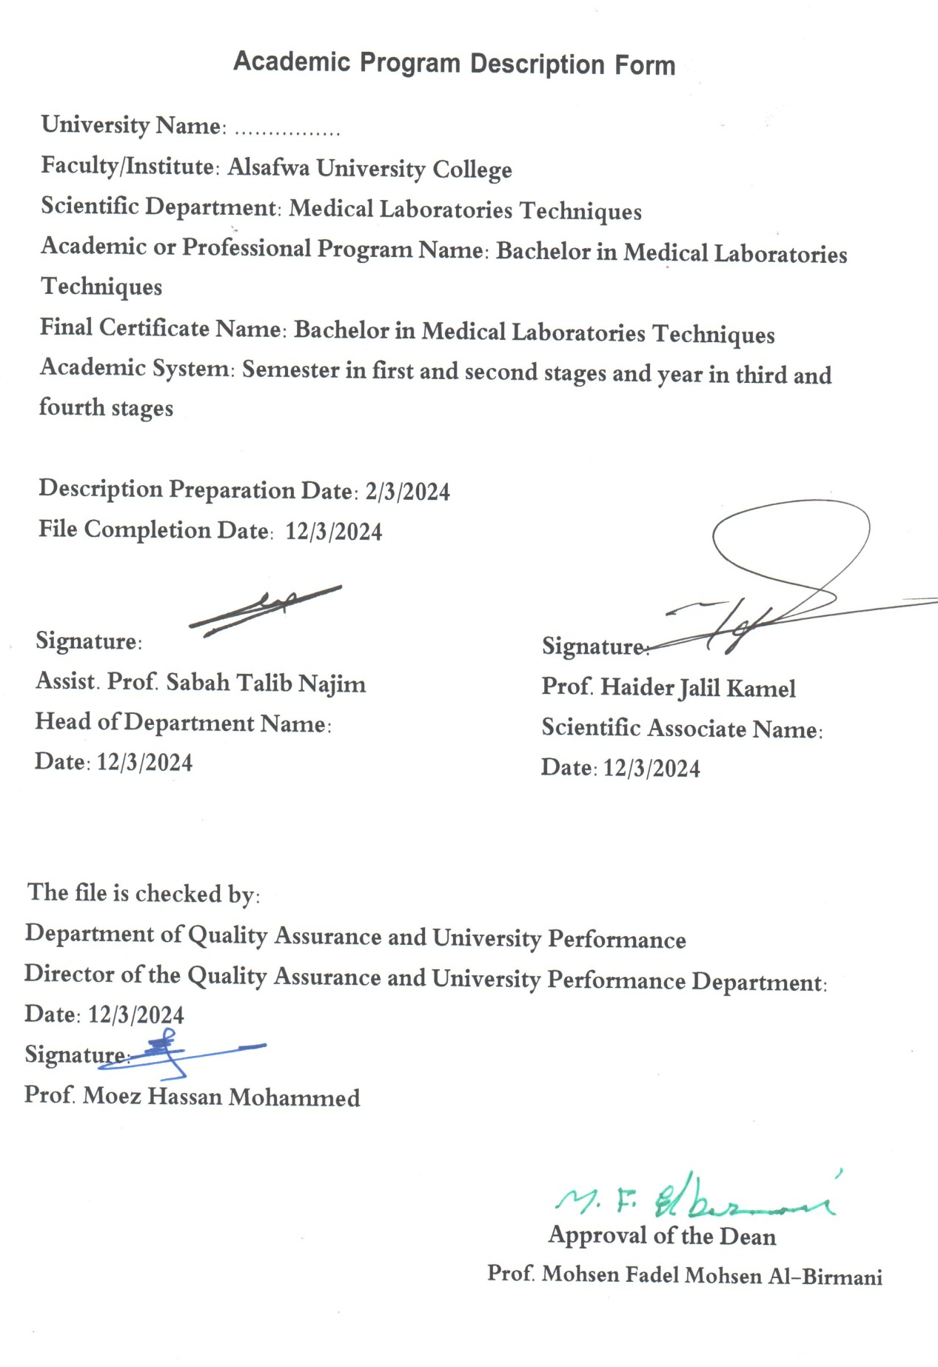

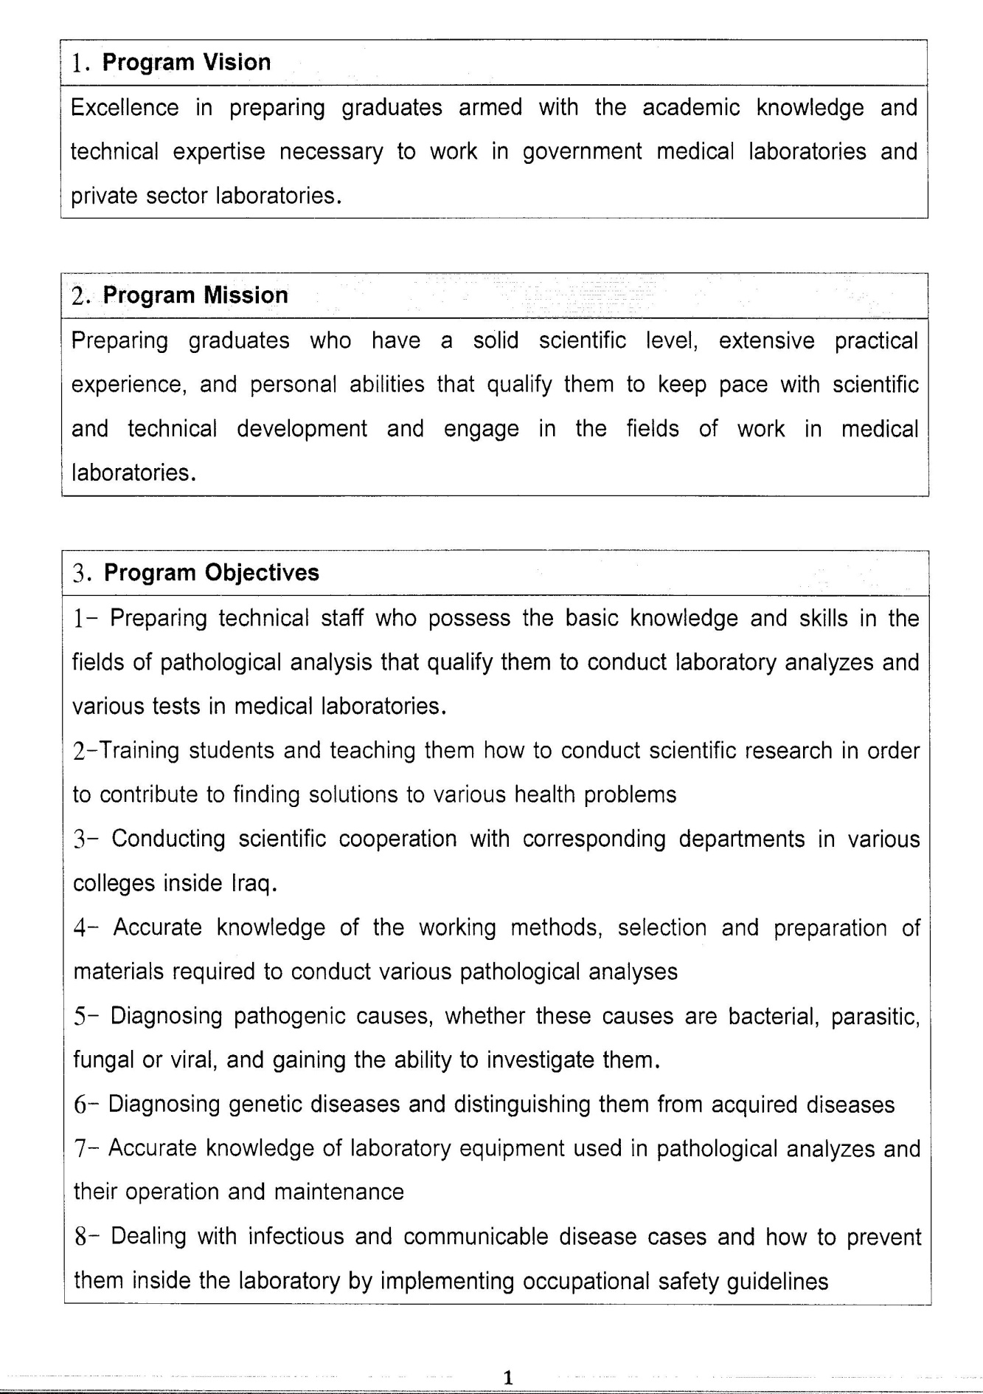

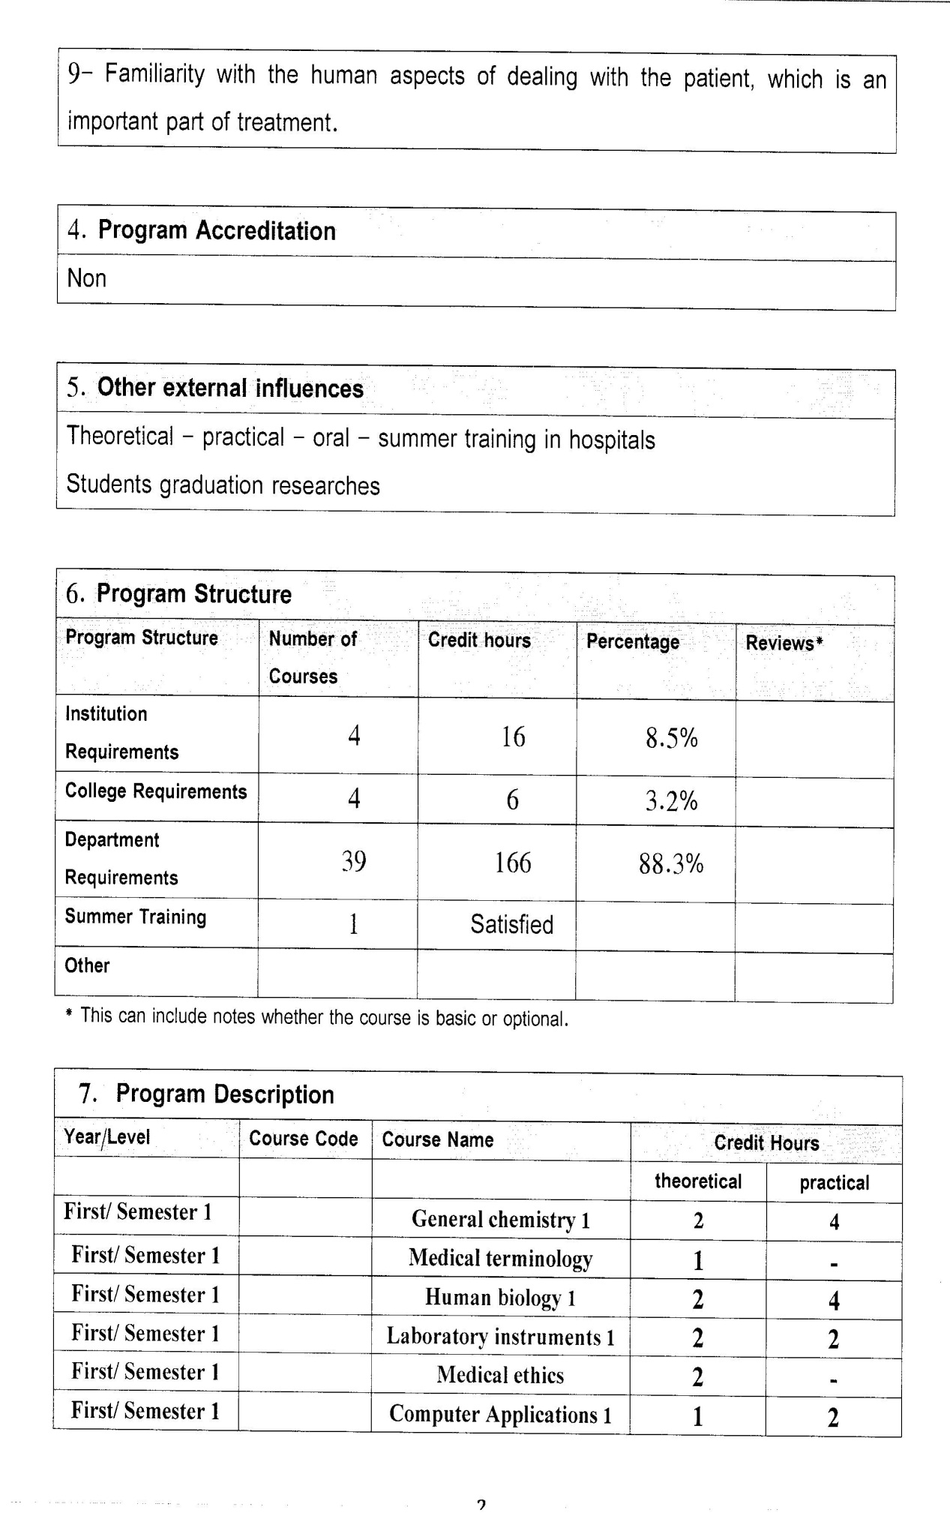

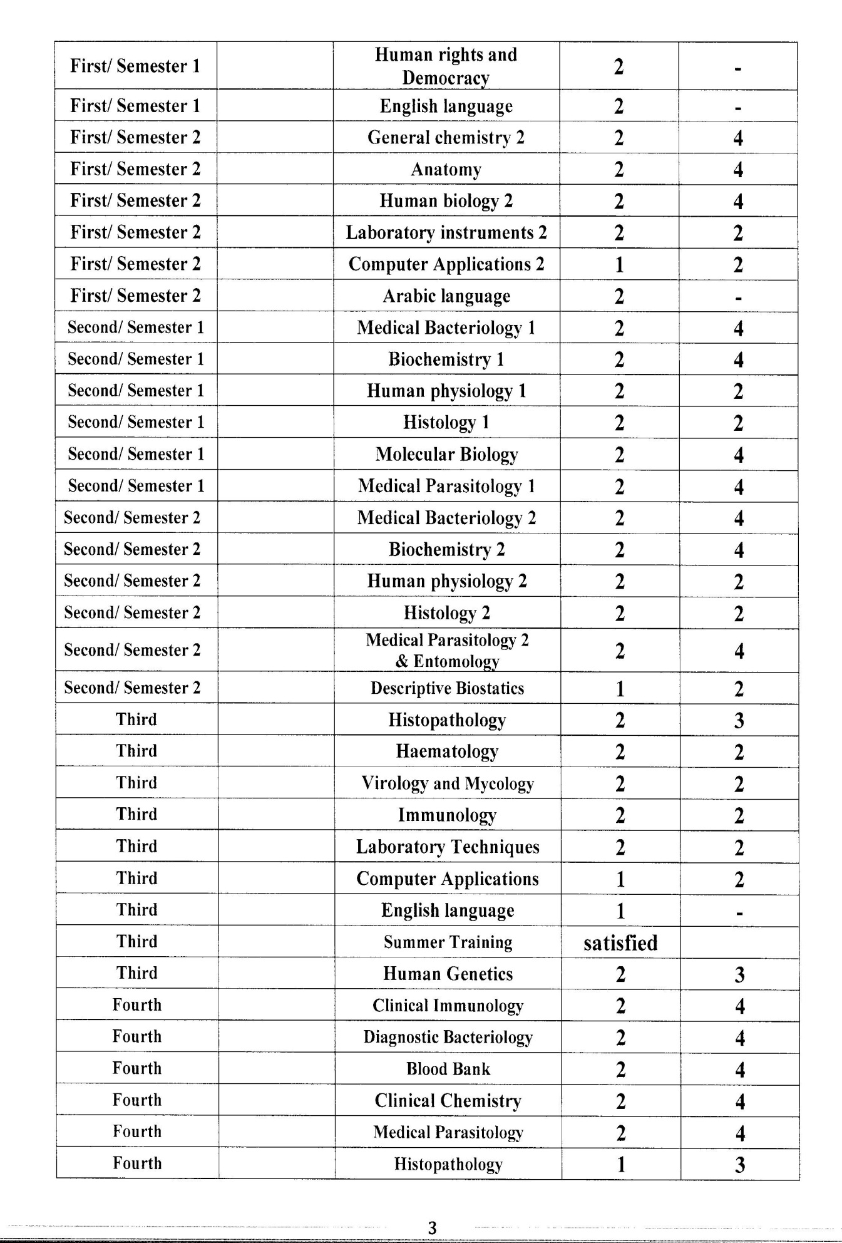

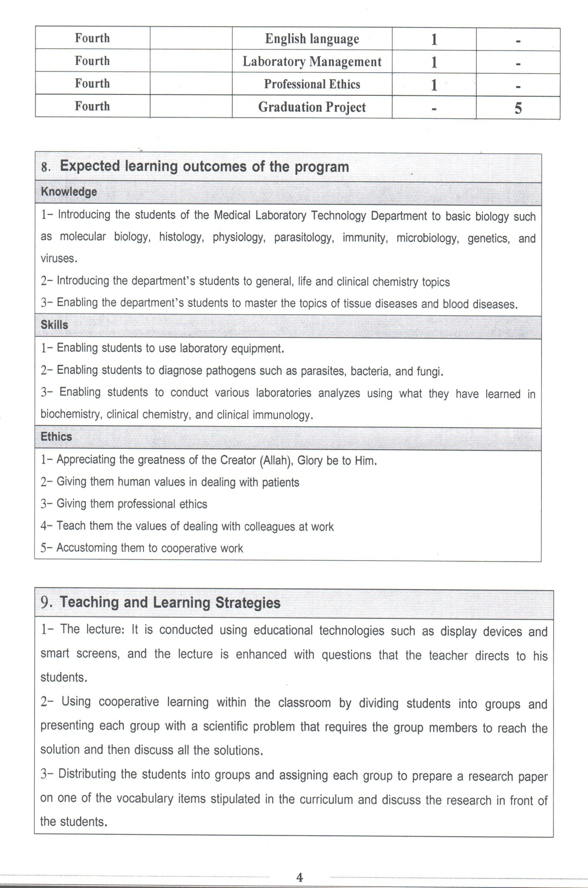

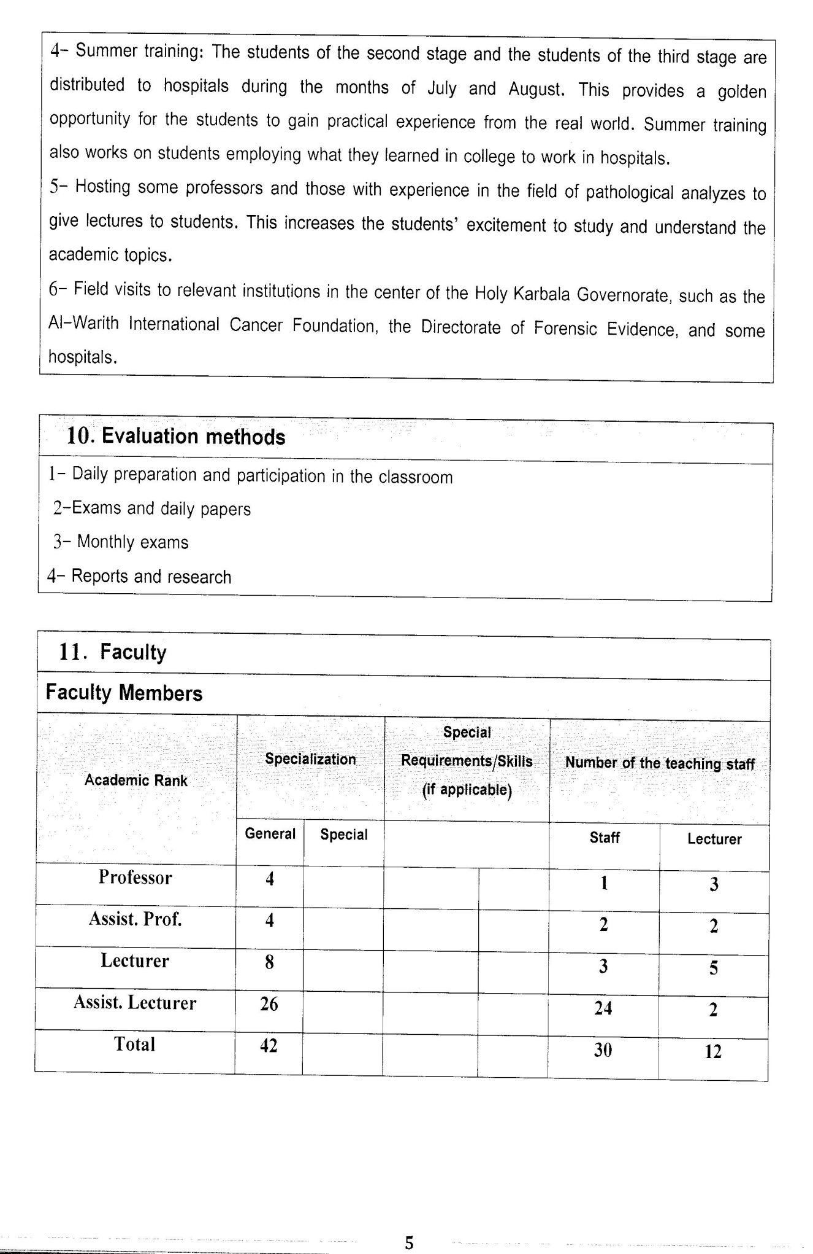

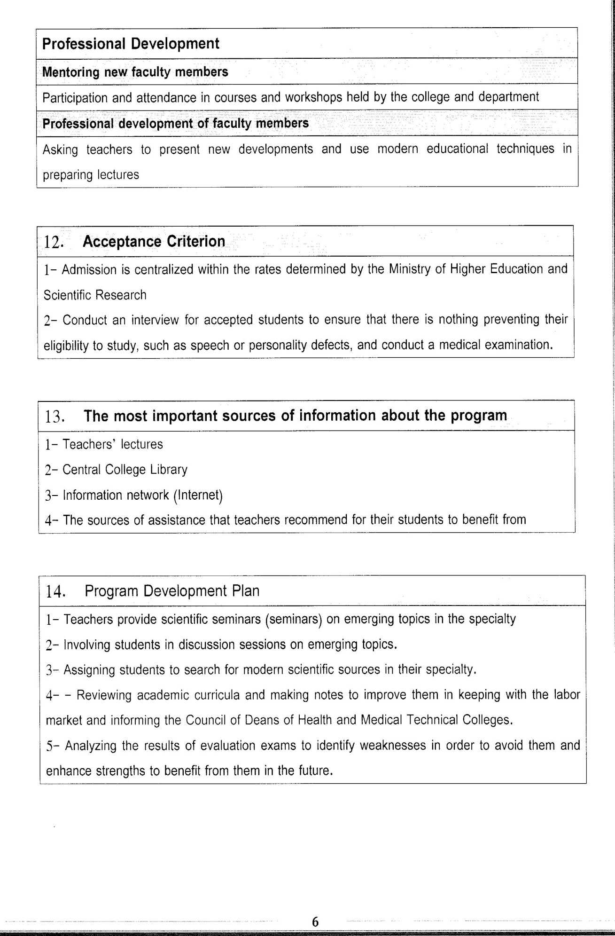

Course Description Form(2023-2024)
- Course Name:
Hematology
- Course Code:
- Semester / Year:
Third Year (Year)
- Description Preparation Date:
6 / 3 / 2024
- Available Attendance Forms:
- Number of Credit Hours (Total) / Number of Units (Total)
60 Hours
- Course administrator's name (mention all, if more than one name)
Name: Kalid Abd Alkadim Hadi
Email: abbas0591@gmail.com
- Course Objectives
Course Objectives
At the end of the academic year, the student should be able to:
1. Knowledge and understanding of the working of the diagnostic method.
2.Knowledge and understanding of diseases that affect the blood.
3. Know and understand every type of disease that is transmitted to the blood.
4. Know and understand how to count the number of red blood cells.
5. Know and understand the shape of red blood cells.
6. Know and understand the count of white blood cells.
7. Know and understand the number of each type of white blood cell.
8. Know and understand the calculation of bleeding and clotting time
9. Know and understand the coagulation mechanism.
- Teaching and Learning Strategies
Strategy |  | 1. Providing students with the basics and supporting topics related to the pre-skills learning outcomes.  2. Applying the topics studied in theoretical lessons on the practical level.  3. Asking students to identify the types of mutations and types of inheritance patterns.
- Course Structure
Week | Hours |  | Required Learning Outcomes | Unit or subject name |  | Learning method | Evaluation method
First Semester
1 | 2practical |  | Understand  the lecture | Blood collection |  | Lecture  Laboratory | Attendance  Daily exam
2 | 2practical |  | Understand  the lecture | anticoagulant |  | Lecture  Laboratory | Attendance  Daily exam
3 | 2practical |  | Understand  the lecture | Hb estimation |  | Lecture  Laboratory | Attendance  Daily exam
4 | 2practical |  | Understand  the lecture | PCV |  | Lecture  Laboratory | Attendance  Daily exam
5 | 2practical |  | Understand  the lecture | RBCs count |  | Lecture  Laboratory | Attendance  Daily exam
6 | 2practical |  | Understand  the lecture | Red cell indices MCV, MCH, MCHC |  | Lecture  Laboratory | Attendance  Daily exam
7 | 2practical |  | Understand  the lecture | Blood film preparation |  | Lecture  Laboratory | Attendance  Daily exam
8 | 2practical |  | Understand  the lecture | Study of red cell morphology |  | Lecture  Laboratory | Attendance  Daily exam
9 | 2practical |  | Understand  the lecture | Inclusion bodies in RBCs |  | Lecture  Laboratory | Attendance  Daily exam
10 | 2practical |  | Understand  the lecture | Osmotic fragility test |  | Lecture  Laboratory | Attendance  Daily exam
11 | 2practical |  | Understand  the lecture | Sickle cell test |  | Lecture  Laboratory | Attendance  Daily exam
12 | 2practical |  | Understand  the lecture | ESR |  | Lecture  Laboratory | Attendance  Daily exam
13 | 2practical |  | Understand  the lecture | Total WBCs count |  | Lecture  Laboratory | Attendance  Daily exam
14 | 2practical |  | Understand  the lecture | Absolute count of leukocytes |  | Lecture  Laboratory | Attendance  Daily exam
15 | 2practical |  | Understand  the lecture | Differential count of leukocytes |  | Lecture  Laboratory | Attendance  Daily exam
Second Semester
1 | 2practical |  | Understand  the lecture | Eosinophil count |  | Lecture  Laboratory | Attendance  Daily exam
2 | 2practical |  | Understand  the lecture | Blood collection |  | Lecture  Laboratory | Attendance  Daily exam
3 | 2practical |  | Understand  the lecture | anticoagulant |  | Lecture  Laboratory | Attendance  Daily exam
4 | 2practical |  | Understand  the lecture | Hb estimation |  | Lecture  Laboratory | Attendance  Daily exam
5 | 2practical |  | Understand  the lecture | PCV |  | Lecture  Laboratory | Attendance  Daily exam
6 | 2practical |  | Understand  the lecture | Blood film of leukemia |  | Lecture  Laboratory | Attendance  Daily exam
7 | 2practical |  | Understand  the lecture | Special stain of leukemia |  | Lecture  Laboratory | Attendance  Daily exam
8 | 2practical |  | Understand  the lecture | Platelet’s count |  | Lecture  Laboratory | Attendance  Daily exam
9 | 2practical |  | Understand  the lecture | Bleeding time |  | Lecture  Laboratory | Attendance  Daily exam
10 | 2practical |  | Understand  the lecture | Clotting time |  | Lecture  Laboratory | Attendance  Daily exam
11 | 2practical |  | Understand  the lecture | Prothrombin time |  | Lecture  Laboratory | Attendance  Daily exam
12 | 2practical |  | Understand  the lecture | Partial prothrombin time |  | Lecture  Laboratory | Attendance  Daily exam
13 | 2practical |  | Understand  the lecture | Detection of coagulation factors deficiency by coagulometer |  | Lecture  Laboratory | Attendance  Daily exam
14 | 2practical |  | Understand  the lecture | Quality control of laboratory |  | Lecture  Laboratory | Attendance  Daily exam
15 | 2practical |  | Understand  the lecture | Blood film of leukemia |  | Lecture  Laboratory | Attendance  Daily exam
- Course Evaluation
The following evaluation methods are adopted:
1. Theoretical and practical tests.
2. Reports.
3. Attendance and discussion.
The grades are distributed as follows:
1- Two monthly exams with a score of 20 points.
2-5 marks for activity and attendance.
3- 15 marks for the practical part, so the pursuit mark is 40.
4- The final exam score is distributed (35) points for the theoretical part and (25) points for the practical part, so the final score is 100.
- Learning and Teaching Resources
Required textbooks (curricular books, if any) |  |  |  |  | Not found
Main references (sources) |  |  |  |  | -Loffler, H., & Rastetter, J. (2012). Atlas of clinical hematology. Springer Science & Business Media. 2-Hoffbrand, A. V., & Steensma, D. P. (2019). Hoffbrand's essential haematology. John Wiley & Sons. 3-arabic reference: Al-shaeer, A., M., et al., (1991). book of blood science, AL-AHLYIA publisher, Jordan
Recommended books and references (scientific journals, reports...)
Electronic References, Websites

