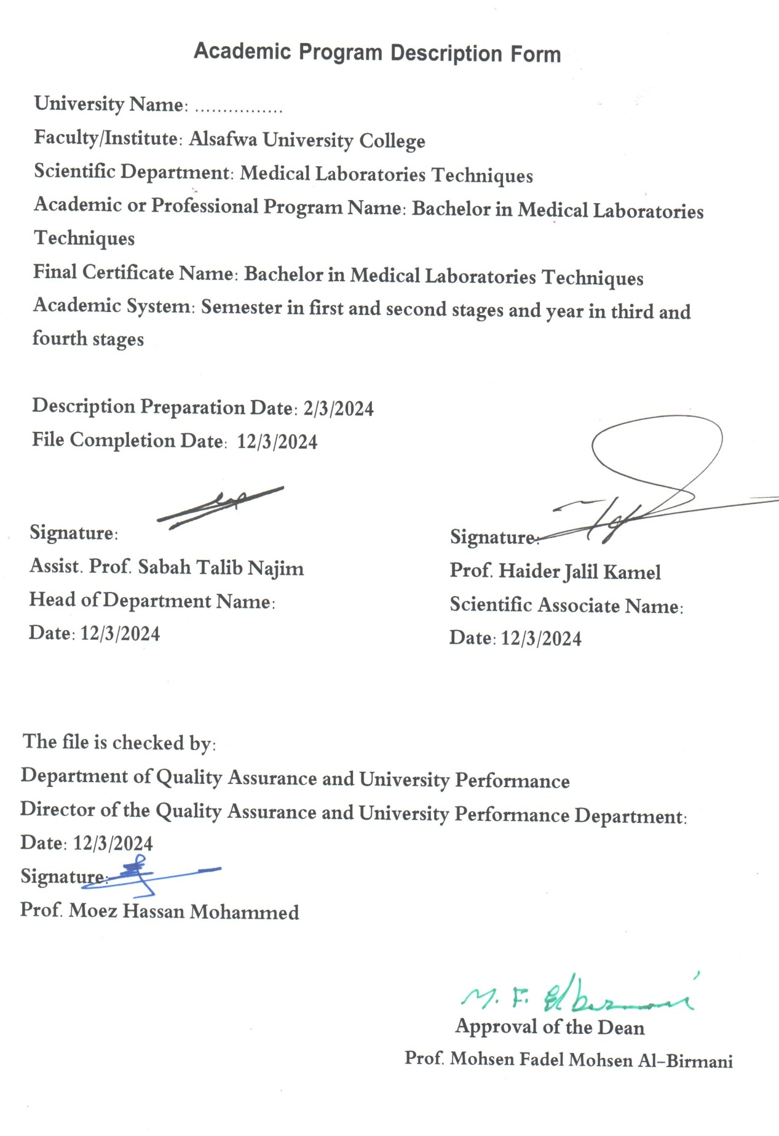

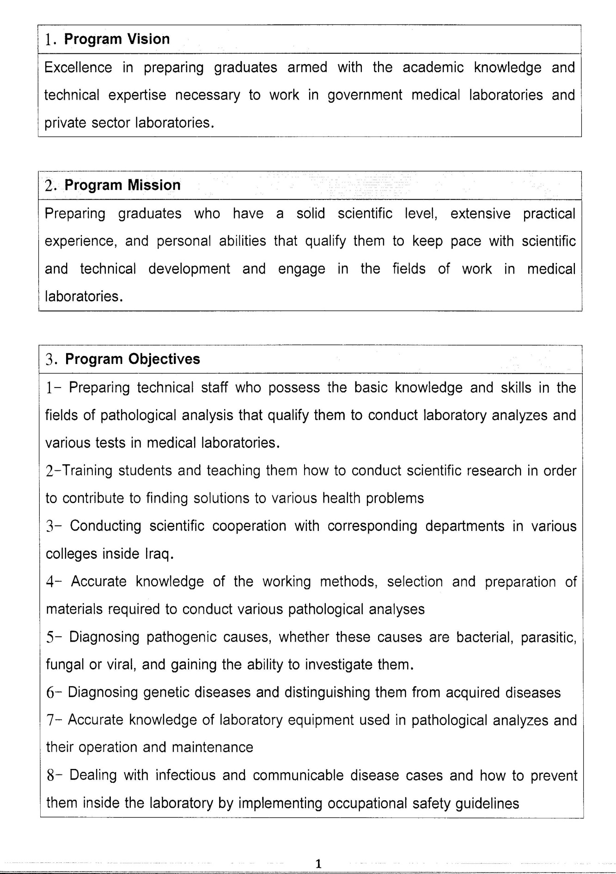

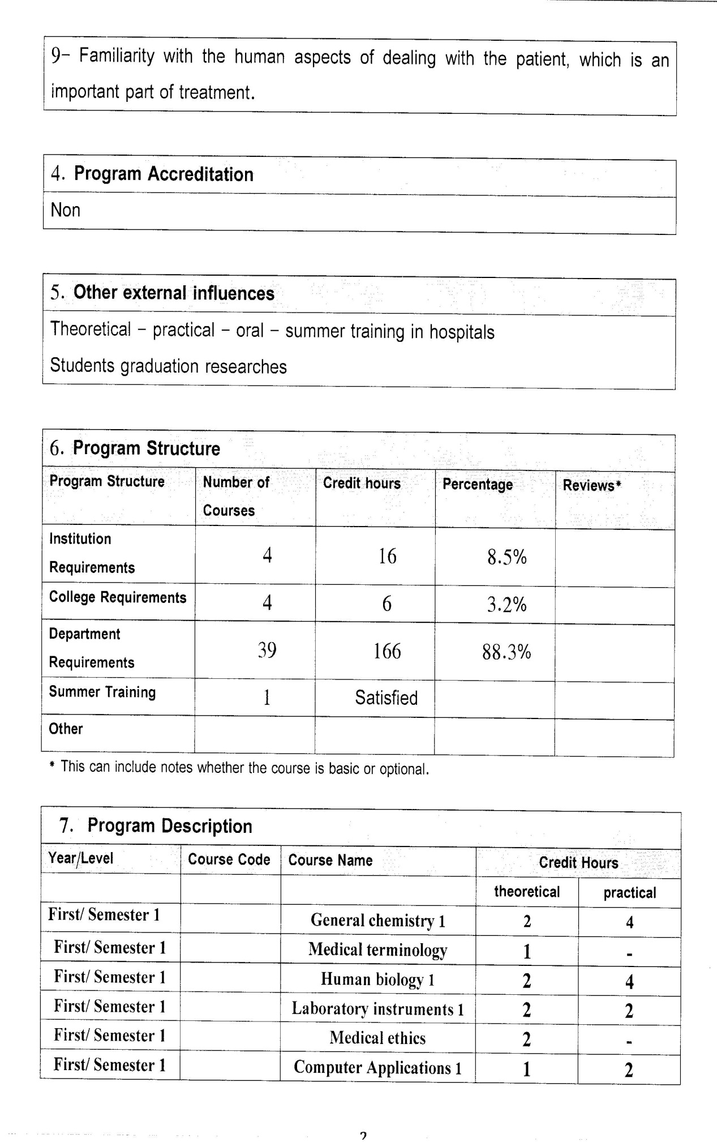

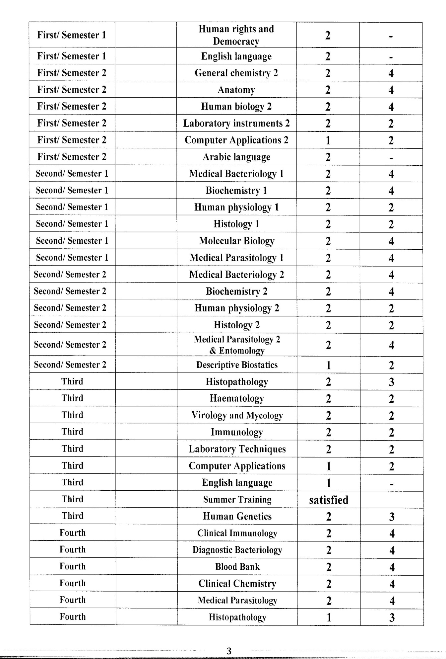



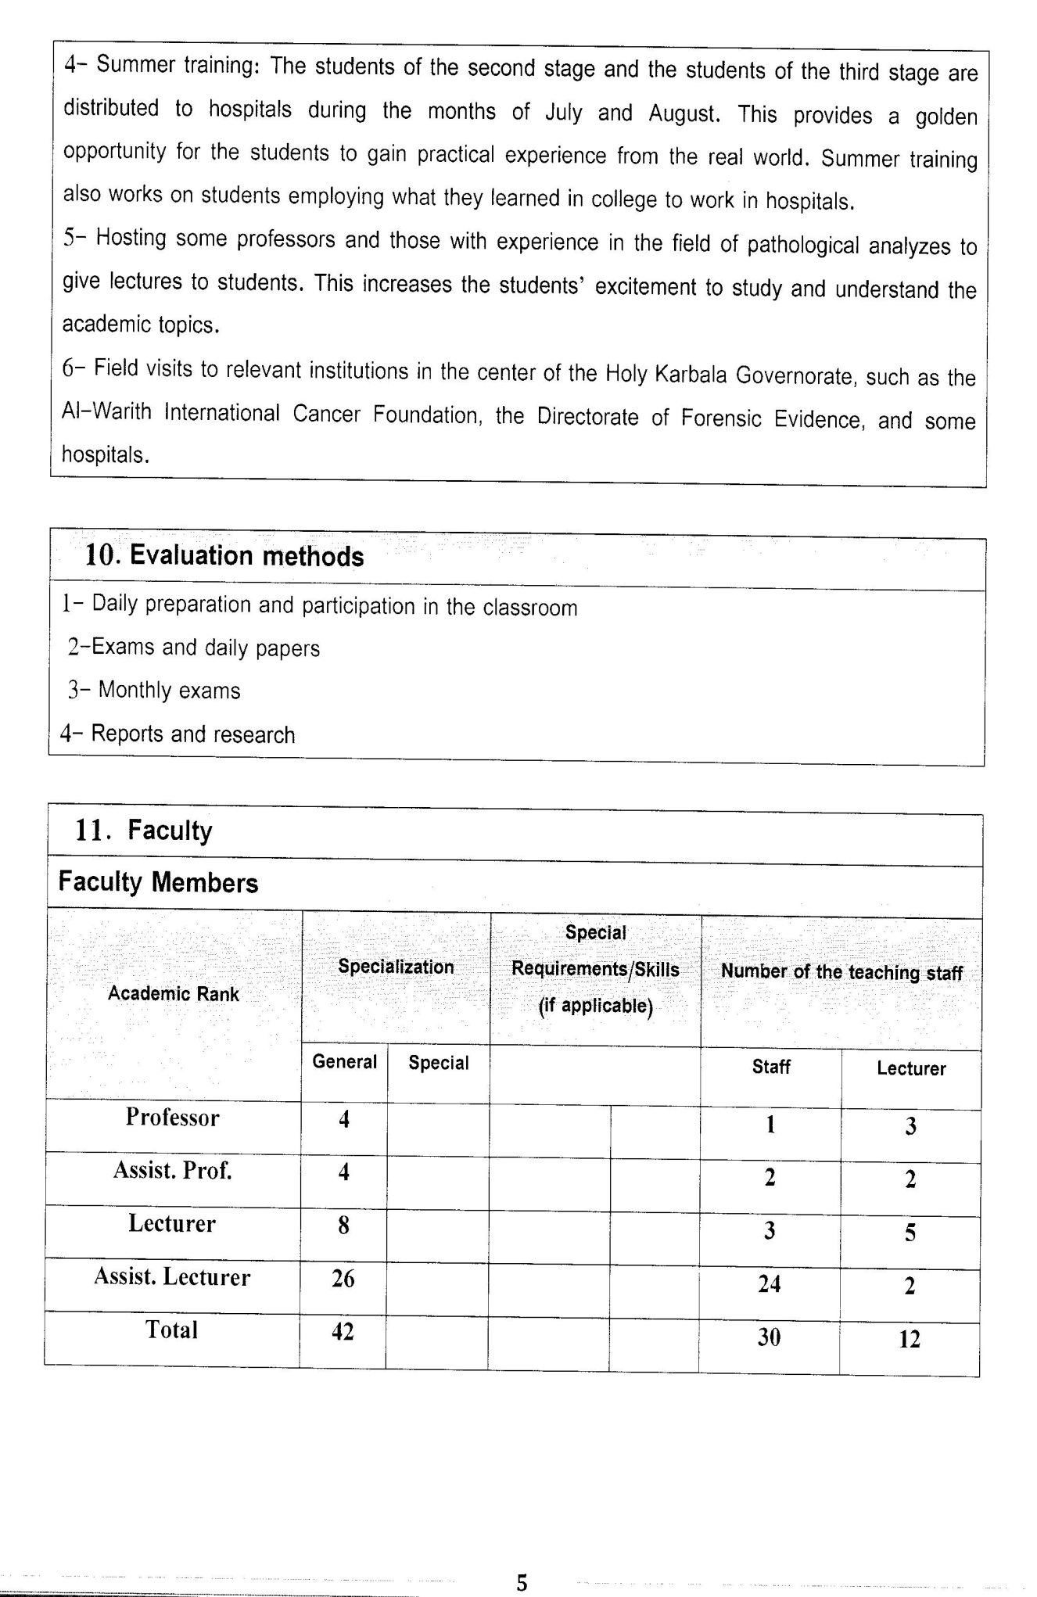

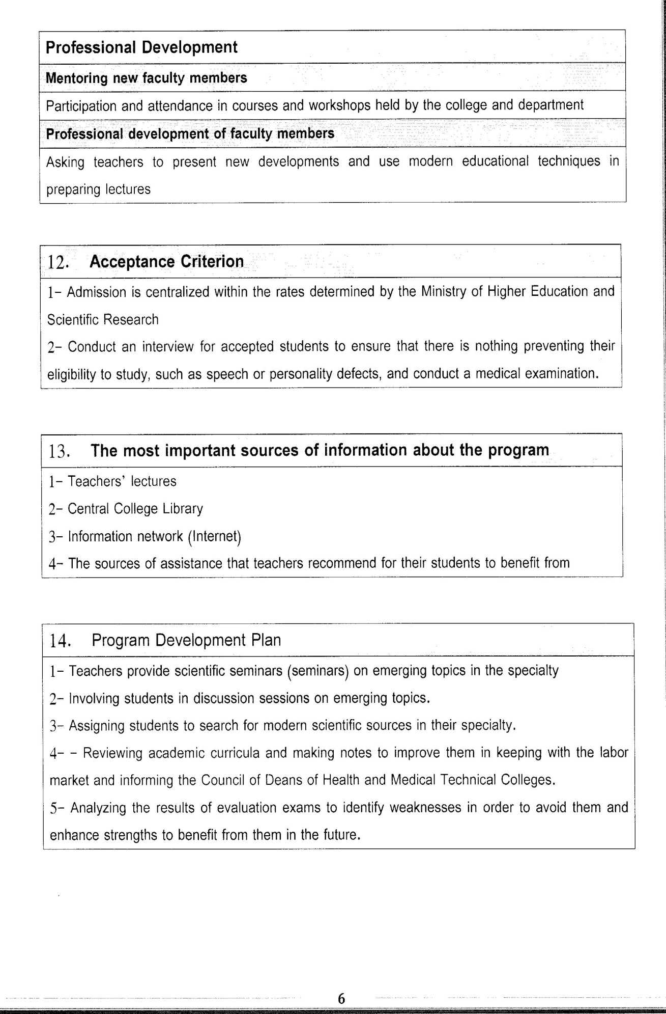

Course Description Form(2023-2024)
- Course Name:
Professional ethics
- Course Code:
- Semester / Year:
Semester
- Description Preparation Date:
6 / 3 / 2024
- Available Attendance Forms:
- Number of Credit Hours (Total) / Number of Units (Total)
15 Hours
- Course administrator's name (mention all, if more than one name)
Name: Abbas Hussein Mugheer
Email: dr.abbas.hussein@alsafwa.edu.iq
- Course Objectives
Course Objectives
At the end of the academic year, the student should be able to:
1. Know and understand the concept of ethics and moral values.
2. Knowing and understanding the sources of ethics and their importance
3. Knowing and understanding work behaviors and the importance of work
4. To compare work, profession and craft.
5. Knowing and understanding professional ethics and its characteristics
6. Knowing and understanding the steps of the acceptance level of professional ethics
7. Knowing and understanding patterns of unethical behavior in the profession
8. Knowing and understanding the means and methods of consolidating the values ​​of professional ethics.
9. Know and understand the characteristics, qualities and duties of a medical technician
10- Know and understand patient rights
11-Knowing and understanding the relationship of the medical technician with the community
12-Knowledge and understanding of ethics and scientific research

- Teaching and Learning Strategies
Strategy |  | 1. Providing students with the basics and supporting topics related to the pre-skills learning outcomes.  2. Applying the topics studied in theoretical lessons on the practical level.
- Course Structure
Week | Hours |  | Required Learning Outcomes | Unit or subject name |  | Learning method | Evaluation method
First Semester
1 | 1 theoretical |  | Understand  the lecture | The concept of morality and its origin  General rules of ethics |  | Lecture | Attendance  Daily exam
2 | 1 theoretical |  | Understand  the lecture | Sources of ethics  The importance of morals for the individual and society |  | Lecture | Attendance  Daily exam
3 | 1 theoretical |  | Understand  the lecture | Work, occupation and work behaviors  The concept of the profession and the difference between the profession and the occupation |  | Lecture | Attendance  Daily exam
4 | 1 theoretical |  | Understand  the lecture | What is professional ethics?  Characteristics and qualities of professional ethics |  | Lecture | Attendance  Daily exam
5 | 1 theoretical |  | Understand  the lecture | honesty |  | Lecture | Attendance  Daily exam
6 | 1 theoretical |  | Understand  the lecture | Advice and justice  Perfection and good handling |  | Lecture | Attendance  Daily exam
7 | 1 theoretical |  | Understand  the lecture | Administrative corruption  and its types |  | Lecture | Attendance  Daily exam
8 | 1 theoretical |  | Understand  the lecture | Bribery and fraud |  | Lecture | Attendance  Daily exam
9 | 1 theoretical |  | Understand  the lecture | Methods of establishing professional ethics  Levels of building and consolidating professional ethics |  | Lecture | Attendance  Daily exam
10 | 1 theoretical |  | Understand  the lecture | Ethical code  How to promote ethical behavior in the profession |  | Lecture | Attendance  Daily exam
11 | 1 theoretical |  | Understand  the lecture | Characteristics and prescriptions of the medical technician  Duties of the medical technician towards the profession |  | Lecture | Attendance  Daily exam
12 | 1 theoretical |  | Understand  the lecture | Duties of the medical technician towards the patient and society |  | Lecture | Attendance  Daily exam
13 | 1 theoretical |  | Understand  the lecture | Patient rights and duties |  | Lecture | Attendance  Daily exam
14 | 1 theoretical |  | Understand  the lecture | The medical technician’s relationship with his colleagues and the community |  | Lecture | Attendance  Daily exam
15 | 1 theoretical |  | Understand  the lecture | The ethics of conducting medical experiments in health institutions, and learning and teaching on patients |  | Lecture | Attendance  Daily exam
- Course Evaluation
The following evaluation methods are adopted:
1. Theoretical and practical tests.
2. Reports.
3. Attendance and discussion.
The grades are distributed as follows:
1- One monthly exam with a score of 25 points.
2-5 marks for activity and attendance.
3- 15 marks for the practical part, so the pursuit mark is 40.
4- The final exam score is distributed (70) points for the theoretical part so the final score is 100.
- Learning and Teaching Resources
Required textbooks (curricular books, if any) |  |  |  |  | Not found
Main references (sources) |  |  |  |  | Professional ethics
Recommended books and references (scientific journals, reports...)
Electronic References, Websites

