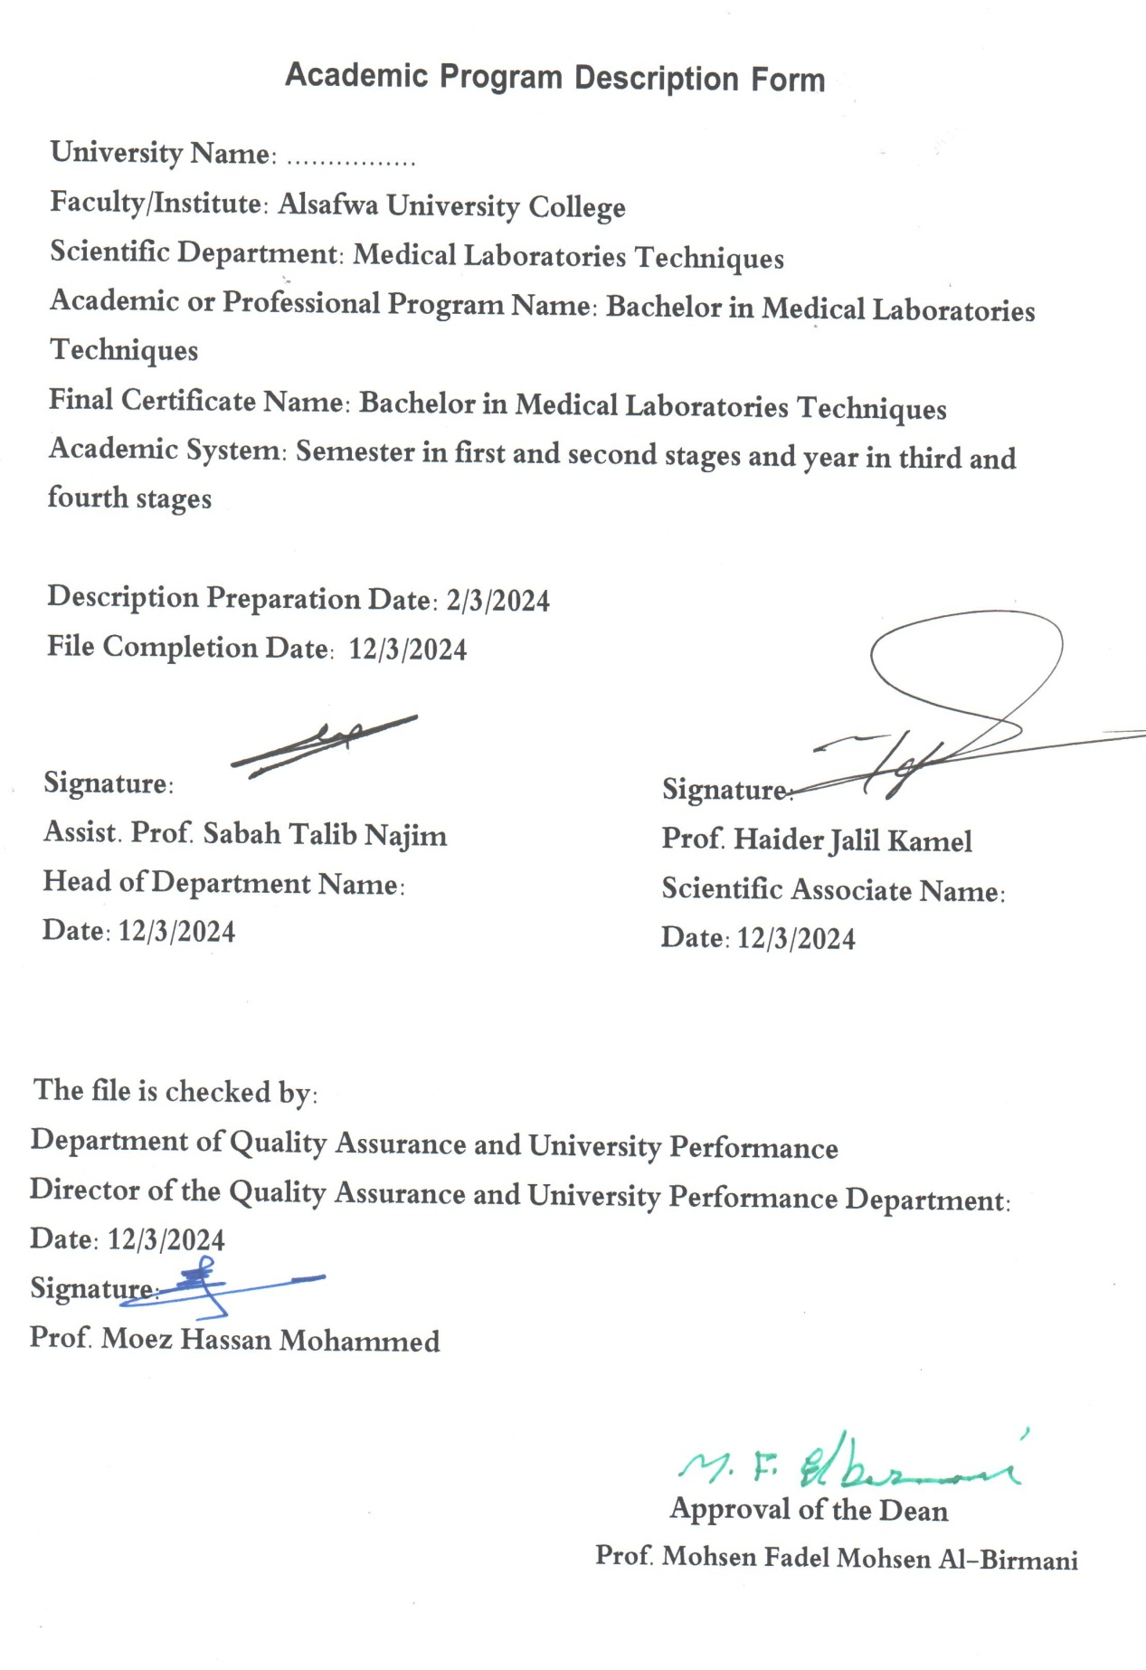

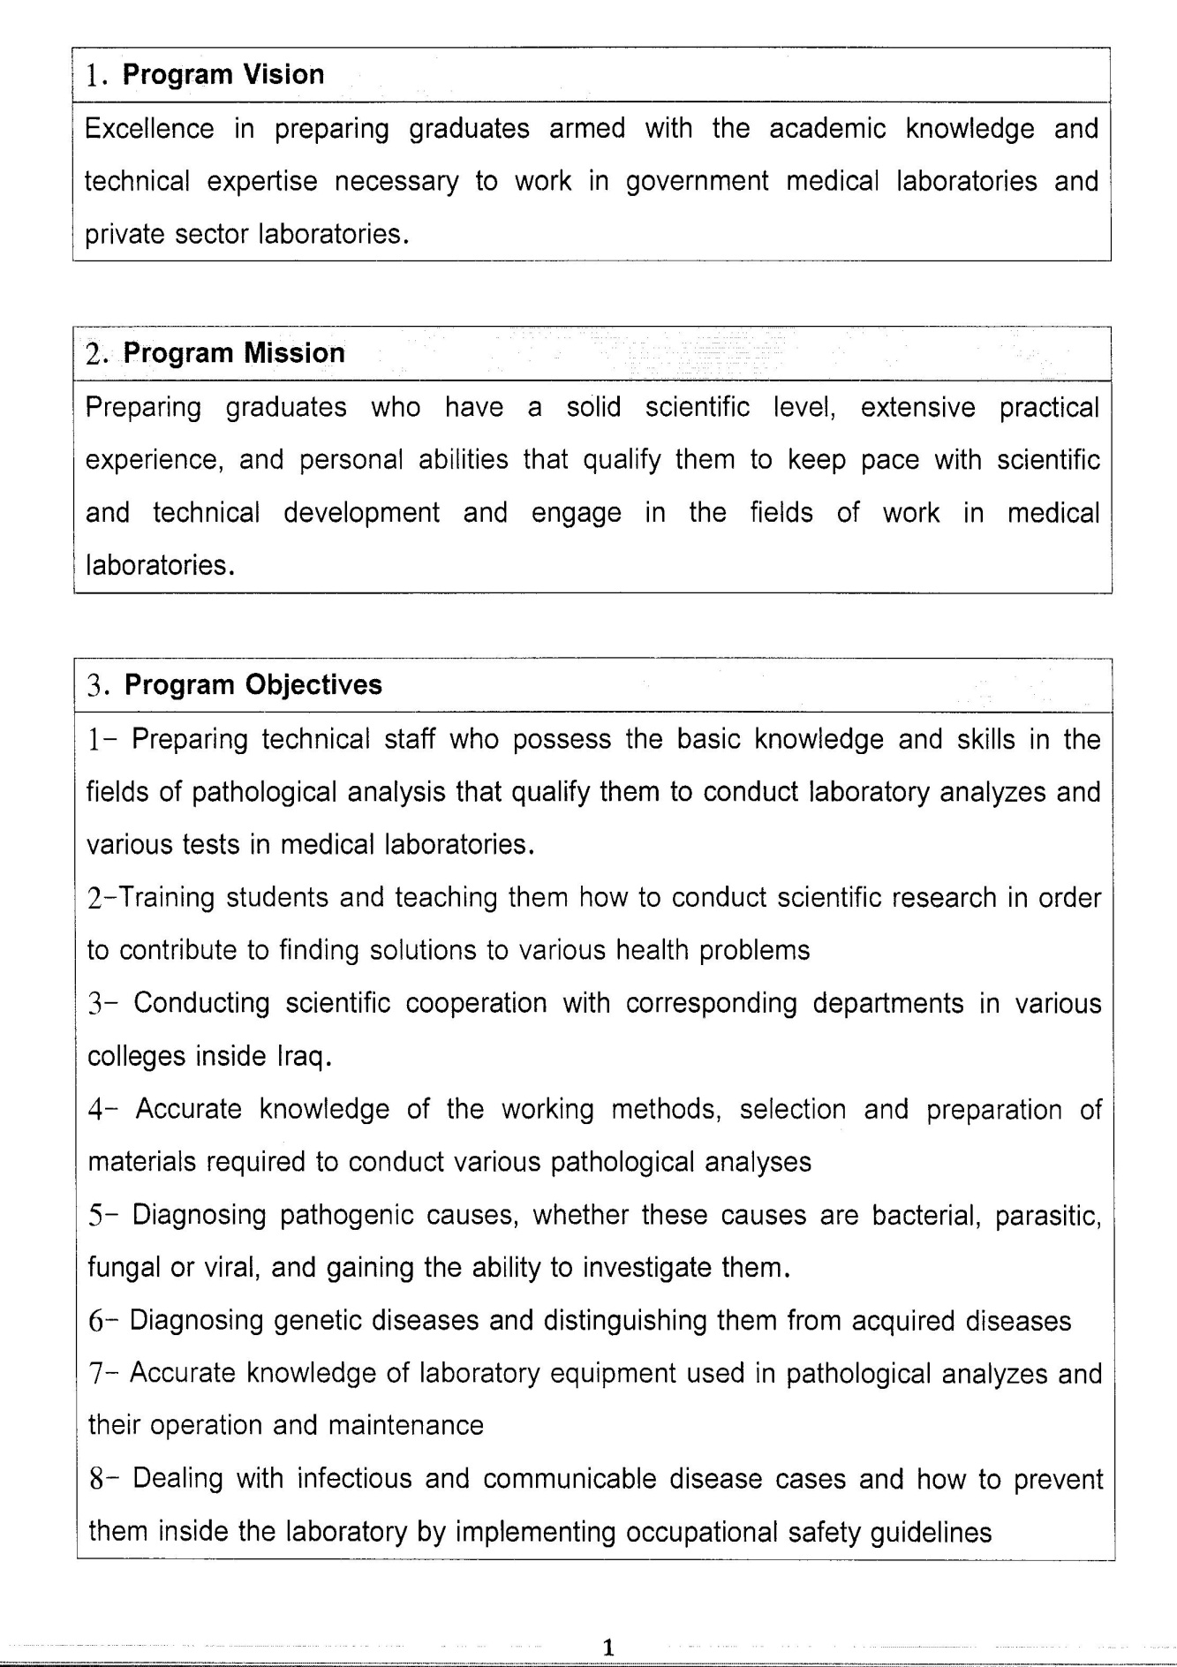

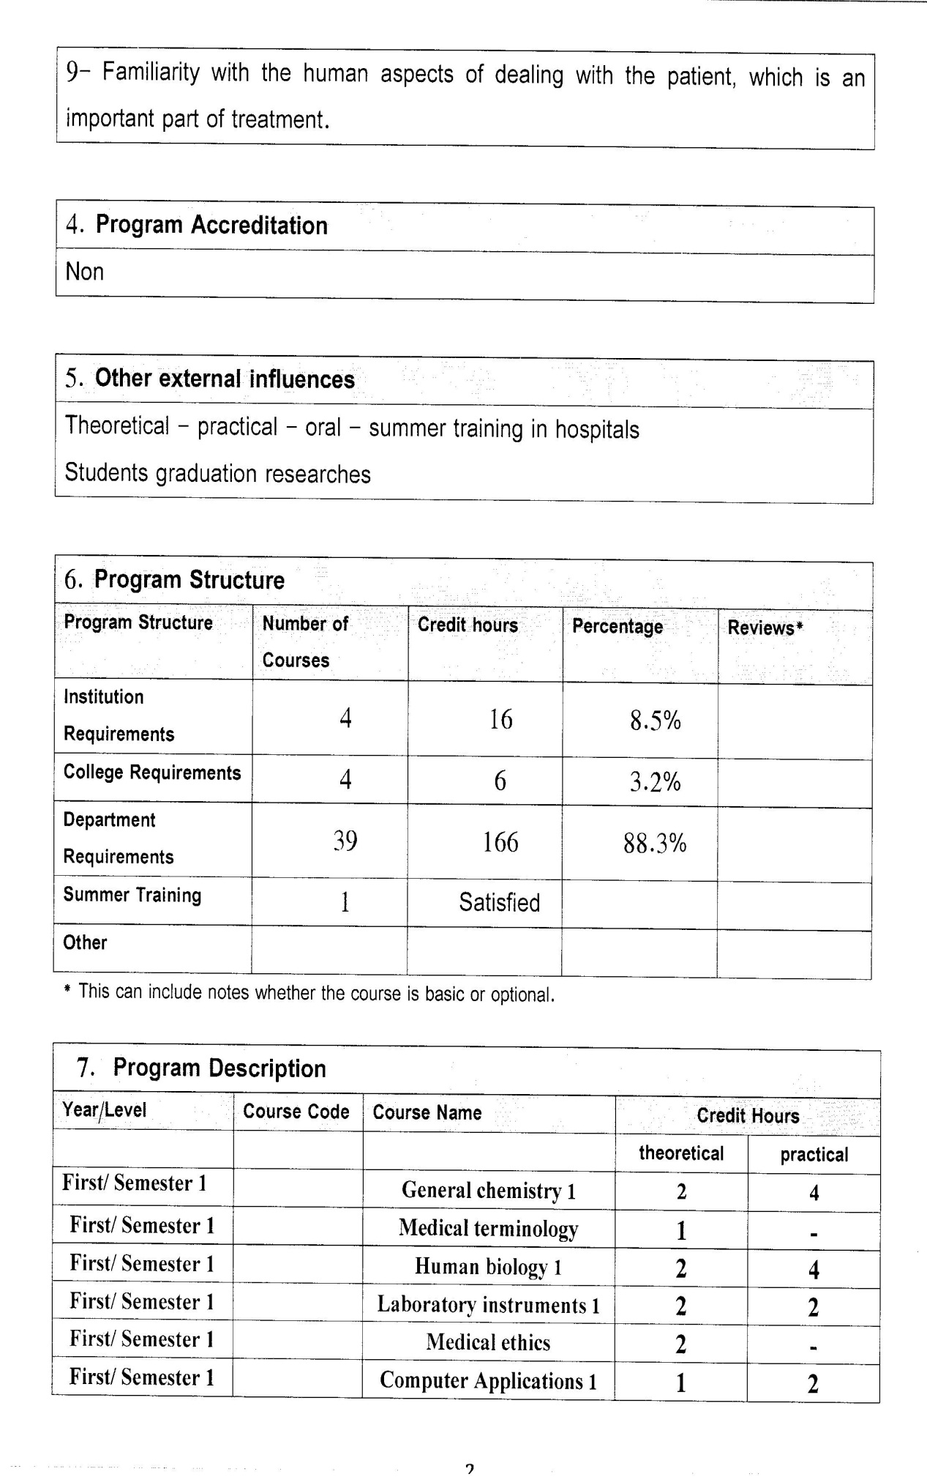

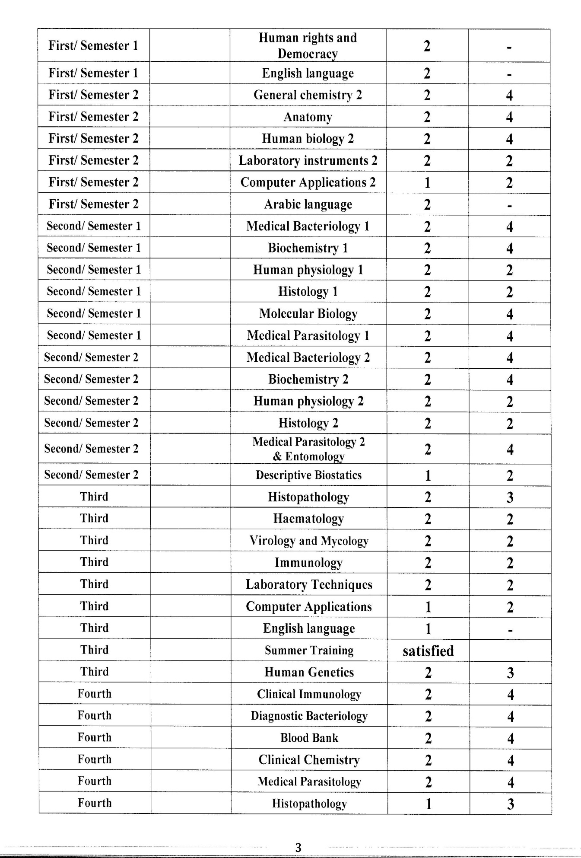

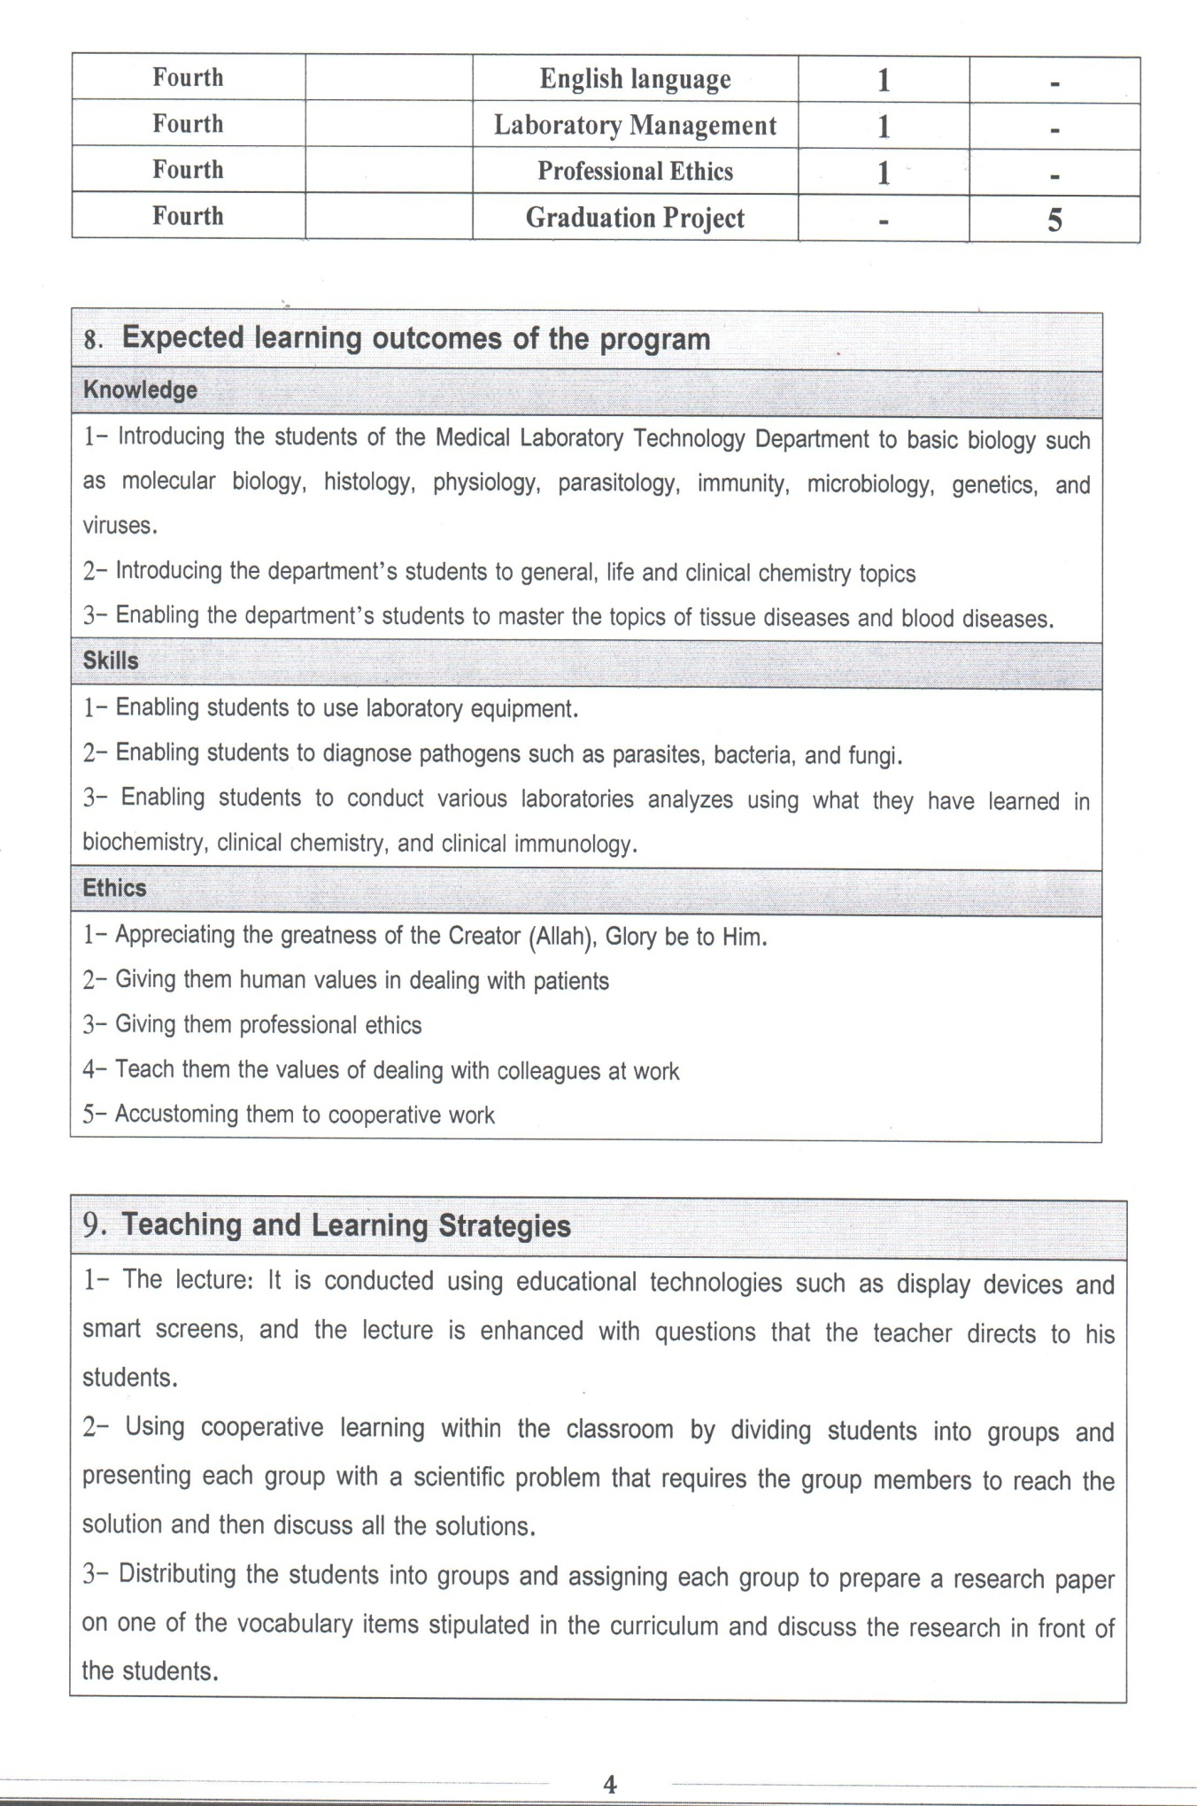

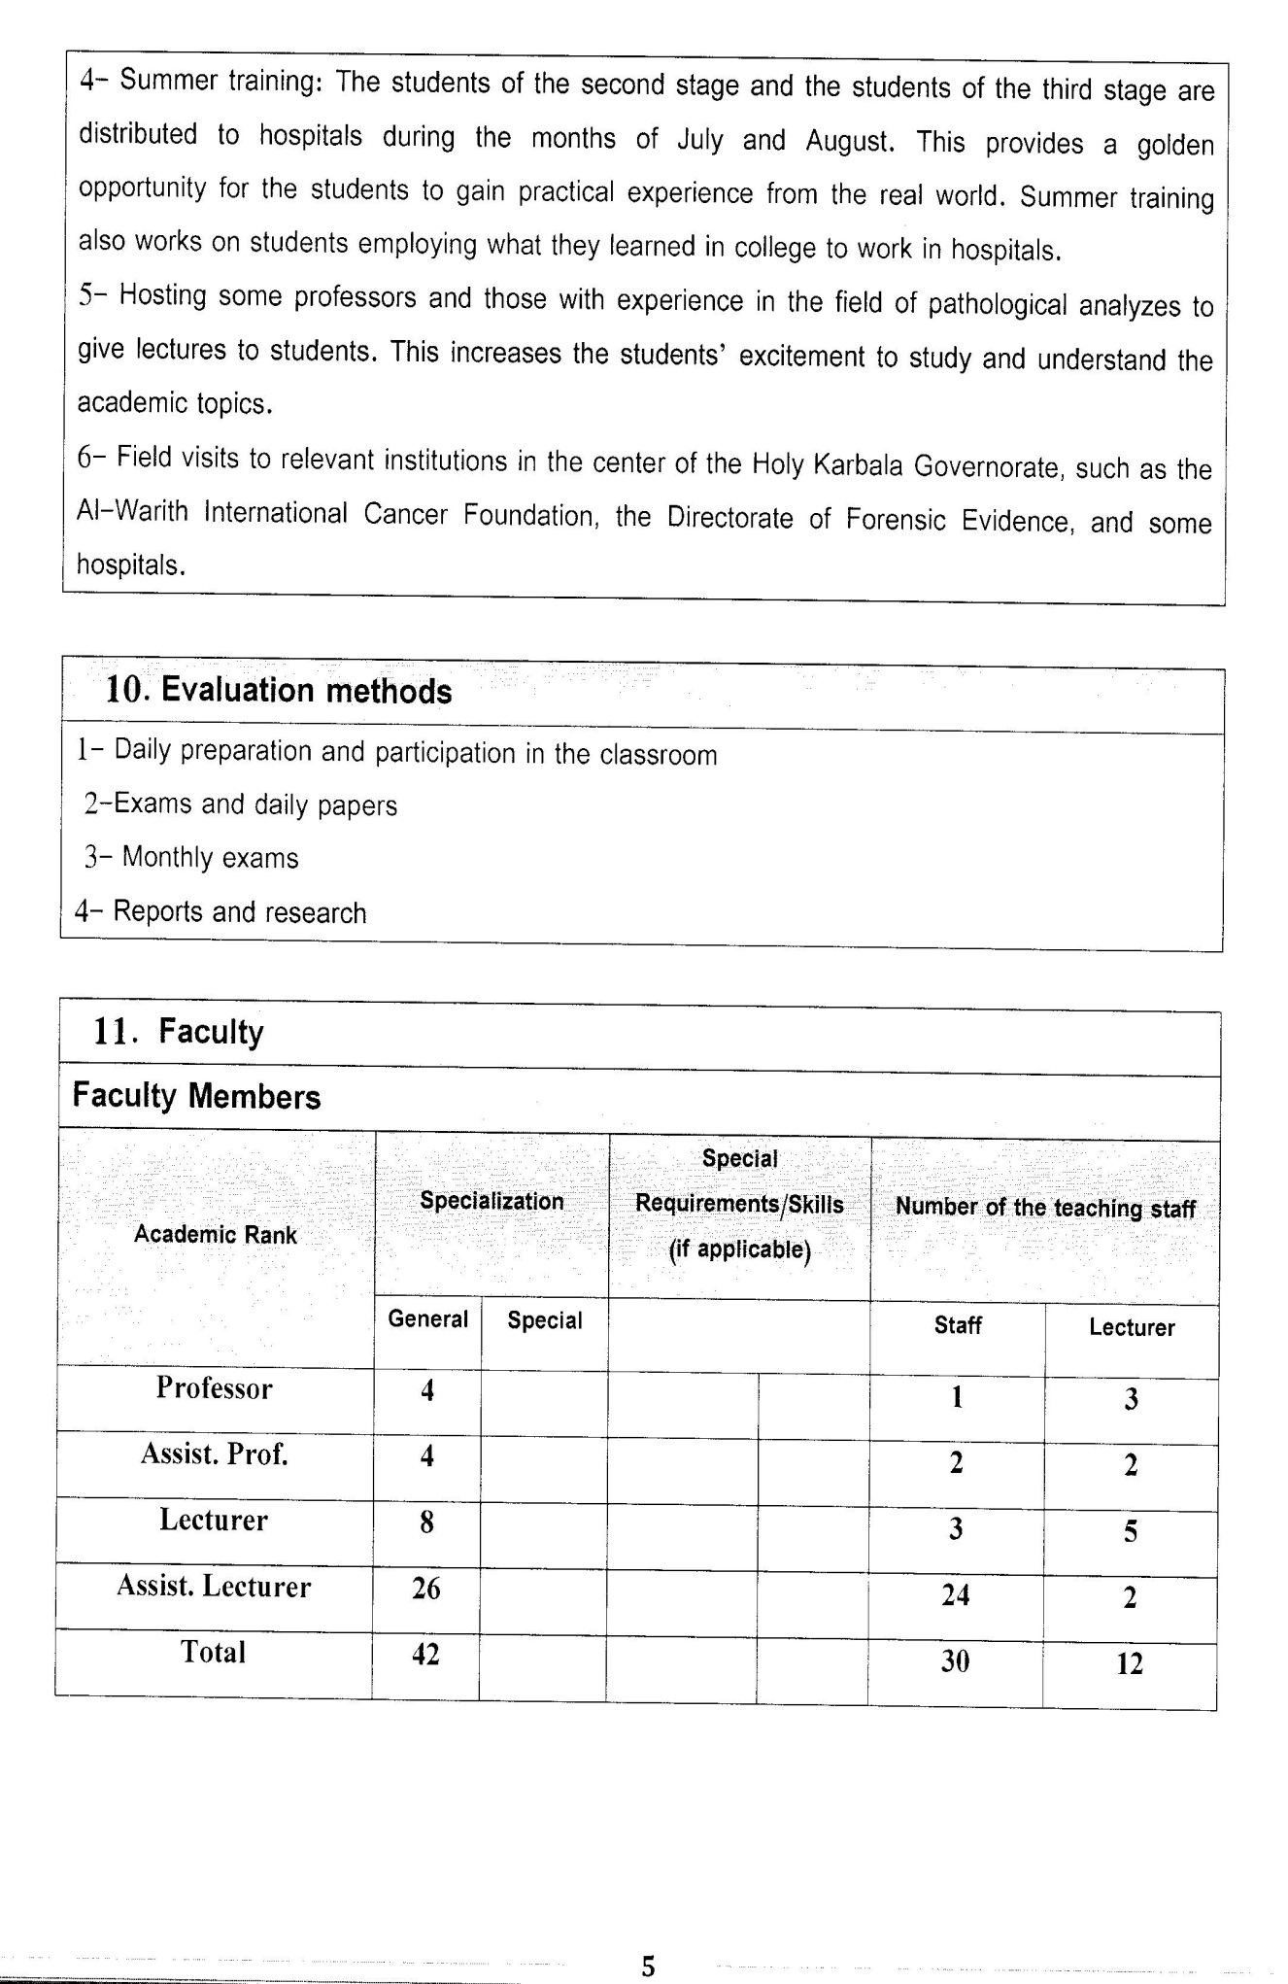

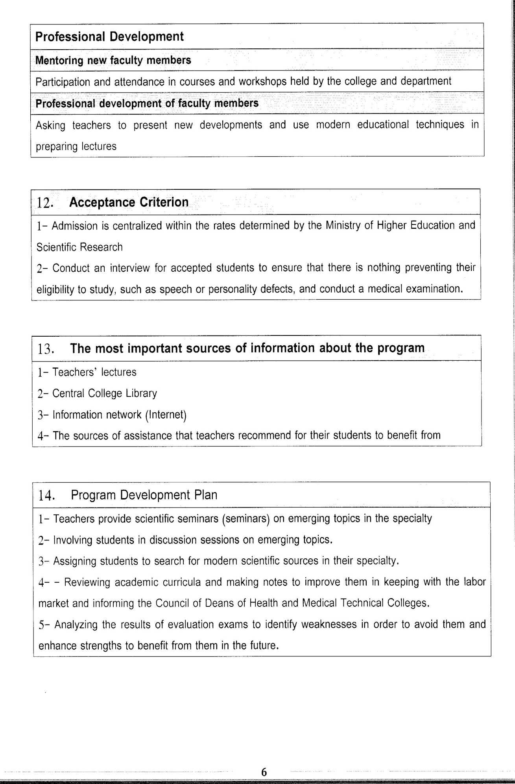

Course Description Form(2023-2024)
- Course Name:
laboratory instruments
- Course Code:
- Semester / Year:
First Year (Semester)
- Description Preparation Date:
13 / 3 / 2024
- Available Attendance Forms:
- Number of Credit Hours (Total) / Number of Units (Total)
120 Hours
- Course administrator's name (mention all, if more than one name)
Name: Dr. Entidhar Sahib Mohammed
Email: Entaly2018@gmail.com
- Course Objectives
Course Objectives
Objectives

1. Identify the basic components of the medical device.

2. Identify common malfunctions in laboratory equipment and how to maintain them

3. Identify medical devices in general.

4. Use of laboratory medical devices and their applications.

5. Learn how to maintain laboratory equipment.

6. Developing the student’s applied skills.
- Teaching and Learning Strategies
Strategy |  | 1. Providing students with the basics and supporting topics related to the pre-skills learning outcomes.  2. Applying the topics studied in theoretical lessons on the practical level.  3. Asking students to identify the types of laboratory services
- Course Structure
Week | Hours |  | Required Learning Outcomes | Unit or subject name |  | Learning method | Evaluation method
First Semester
1 | 2theoretical+ 2practical |  | Understand  the lecture | introduction |  | Lecture  Laboratory | Attendance  Daily exam
2 | 2theoretical+ 2practical |  | Understand  the lecture | Microscope |  | Lecture  Laboratory | Attendance  Daily exam
3 | 2theoretical+ 2practical |  | Understand  the lecture | centrifuge |  | Lecture  Laboratory | Attendance  Daily exam
4 | 2theoretical+ 2practical |  | Understand  the lecture | Spectrophotometer |  | Lecture  Laboratory | Attendance  Daily exam
5 | 2theoretical+ 2practical |  | Understand  the lecture | Autoclave +Hot Air oven |  | Lecture  Laboratory | Attendance  Daily exam
6 | 2theoretical+ 2practical |  | Understand  the lecture | Incubator |  | Lecture  Laboratory | Attendance  Daily exam
7 | 2theoretical+ 2practical |  | Understand  the lecture | Sensitives balance |  | Lecture  Laboratory | Attendance  Daily exam
8 | 2practical+2 theoretical |  | Understand  the lecture | introduction |  | Lecture  Laboratory | Attendance  Daily exam
Second Semester
1 | 2theoretical+ 2practical |  | Understand  the lecture | Microbiological safety cabinet |  | Lecture  Laboratory | Attendance  Daily exam
2 | 2theoretical+ 2practical |  | Understand  the lecture | Microtome |  | Lecture  Laboratory | Attendance  Daily exam
3 | 2theoretical+ 2practical |  | Understand  the lecture | Water bath |  | Lecture  Laboratory | Attendance  Daily exam
4 | 2theoretical+ 2practical |  | Understand  the lecture | PCR machine |  | Lecture  Laboratory | Attendance  Daily exam
5 | 2theoretical+ 2practical |  | Understand  the lecture | Gel Electrophoresis |  | Lecture  Laboratory | Attendance  Daily exam
6 | 2theoretical+ 2practical |  | Understand  the lecture | CBC |  | Lecture  Laboratory | Attendance  Daily exam
- Course Evaluation
The following evaluation methods are adopted:
1. Theoretical and practical tests.
2. Reports.
3. Attendance and discussion.
The grades are distributed as follows:
2-5 marks for activity and attendance.
3- 25 marks for the theoretical and 15 for practical, so the pursuit mark is 40.
4- The final exam score is35 for theoretical, and 25 for practical so the final mark is 60.
- Learning and Teaching Resources
Required textbooks (curricular books, if any) |  |  |  |  | Not found
Main references (sources) |  |  |  |  | Not
Recommended books and references (scientific journals, reports...)
Electronic References, Websites

